Math vs. IT
-
The Mathematical Approach

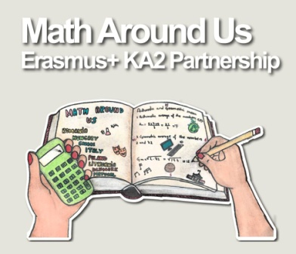
- Magic of Numbers
Task 1.
Think of a number.
Double it.
Add 10.
Halve it.
Take away your original number.
Your result is: _______
Find the math behind...

- Role of numbers
In fairy tales, in folklore and in mythology there are some numbers that have their magical meanings, such as 3 – like in the tale of The Three Bears, or 7 – like in Seven Dworfs .
In life the Fibonacci numbers and Φ have special meaning. In the construction of several musical instruments, Φ is also really important.
And what about the world of math?
Maybe $π$or e?
Or any other symbols?
It is hard to define...
- How math works in the Hungarian folk tales
Once upon the time there was a King with three beautiful daughters.
Each of the three daughters has three lords claiming their hands, but all of them had their favourite admirers.
The King gave the following task for the lords to have the princesses as their fiancées:
„There are goldfishes in the Big Lake at the border of the country. Thy trial is to collect three goldfishes for your beloved lady. The fastest three lords can take the hands of my daughters.” […]
Task 2: The Tale Problem
If all of the lords could fulfill the task properly as it had been told - to fish three gold fishes -, what number of wishes would be satisfied in the end?
(Note that each goldfish makes three wishes come true.)

The true end of the story:
[…] Let us mention, each lord was sly as a fox! So in the end all lords fished only one gold fish and had their wishes to be the first one in finishing the task. The King could not handle this equality in time, so let her daughters choose from the lords, who obviously chose their favourite ones. The three couples had a wonderful wedding that lasted for 7 years and they lived happily ever after...

- Forget the Head Slicing Thing
Task 3.
Hercules fighting against Hydra and try to kill him by cutting his heads off. Unfortunately after cutting one head of, three new heads emerge. Hercules is so good with the sword that he can slice each neck by once!
Give the number of heads after 2, 3, 10 or n slicing movements!
(The video: https://www.youtube.com/watch?v=hRNvoxxSNsY)
- Powers - Exponentiation
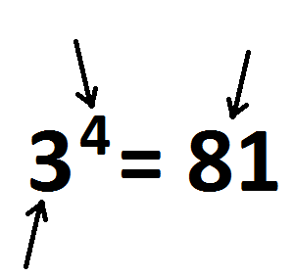
exponential expressions on math lessons:

exponential expressions in IT (calculator, computer):

- How to calculate?
Task 4.
In financial calculations the following formula is used
$$T_{n}=T_{0}∙{\left(1+\frac{p}{100}\right)}^{n}$$
T_{n} – the accumulated money
T₀– the investment
p – the interest rate
n – number of years for deposition

Bea deposited 1000 euros in the bank for a period of three years. The annual interest rate is 5%. How much money will accumulate after 3 years?

Task 5.
A study, made at the end of 2014, predicts that the number t of tigers living in India (at the end of each consecutive year) will approximately follow the formula
$t\left(x\right)=3600∙{0,854}^{x}$, where x refers to the number of years passed since 2014.

Based on the above prediction, calculate the percentage loss in the number of tigers by the end of the year 2016, as compared to the number at the end of 2014.

