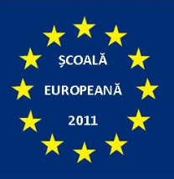  

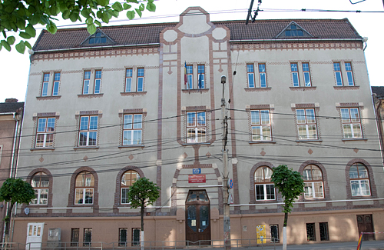

**Welcome to Ana Aslan Technical College**

**in Cluj-Napoca, Romania**

**Colegiul Tehnic ANA ASLAN** is a Technical Secondary School located in Cluj-Napoca, the largest city in Transylvania and the economical and cultural capital of the North-West region. We have grades 1-12 with classes of primary, secondary and Technical secondary on Environmental protection, Chemistry and Hairstyling. We have a total of 600 students and 55 teachers. Our students age is 6 to 19 years old; more than 20% of them come from rural areas surrounding Cluj, being daily commuters.

We have a 13 years experience in European projects (Socrates, Phare, Comenius, leonardo da Vinci, Erasmus+) and in the last five years we have experienced many positive changes: in September 2010 we were awarded the title of ***College***; in April 2011 and May 2014 we were awarded two times in a row the title of ***European School*** by the Ministry of Education; we were European Coordinators for the Comenius Project *Training For LIFE: Leadership Initiative For Europe* and we were partners in three other Lifelong Learning partnerships – a Comenius Multilateral and two Leonardo da Vinci - a great opportunity for our teachers and students to get into contact and interact with different European cultures and educational systems.

We are the European Coordinator for the **Math Around Us** project that will run in the 8 partner schools for the next two years (2015-2017) and which is co-funded by the European Comission through the Erasmus+ Programme.

To find out more about who we are, please visit our website: <http://colegiulaslancluj.ro/>

**AGENDA**

**SHORT-TERM EXCHANGE FOR STUDENTS**

**Cluj-Napoca, 26-30 October 2015**

|  |  |
| --- | --- |
| **DAY** | **Short-Term Exchange For Students** |
| **SUNDAY**  **25 October, 2015** | **ARRIVAL DAY**  ***Avram Iancu International Airport***  Hosting Families meet the delegations at Hotel Ary and take the students  Poland arrives by bus, Hungary by train |
| **MONDAY,**  **26 October** | **DAY 1 - INDUCTION SESSION & PROJECT CONFERENCE** |
|  | **9.00 – Induction Session in school**  Welcoming meeting, discussing practical issues (transport, meals, costs, cultural activities, issuing financial documents, etc.)  **10.00 – Ice breaking & Teambuilding activities in school**  **11.00 - Conference in school**  **Plenary Session**: 15 minutes/school  **Logo Competition:** Exhibition & Voting  **2.00**  – **Lunchtime** (Cappriccio Restaurant)  **3.00 - Free time** |
| **TUESDAY**  **27 October** | **DAY 2 - TEACHING ACTIVITIES AT SCHOOL & STUDY VISIT at THE PHYSICS RESEARCH INSTITUTE** |
|  | **9-12.00 Application classes** for students in which the HOST COUNTRY presents the new Topic **"Math in  the Science Lab"**  (the 21 students will be split in 3 multinational groups, each group will assist in turns, a Biology, a Physics and a Chemistry class/workshop together with Romanian students)  **12.00- WORKSHOP: DISSEMINATION BROCHURE (**in the ICT Lab)  **1.00** -  **Lunch time (catering)**  **2.00 - Study Visit at The Physics Research Institute in Cluj-Napoca t**hat has a partnership with our school  **4.00 – Free time** |

|  |  |
| --- | --- |
| **WEDNESDAY 28 Oct** | **DAY 3 – CLASS ASSISTANCE & STUDY VISIT at FARMEC** |
|  | **9-12 – Class assistance in Math classes**  Students assist Math classes with applications on the “Math in the science Lab” Topic.  **12.00 – Class Assistance in Chemistry & EP**  Students assist a Science class on Chemistry and Environmental Protection  **1.30 - Lunchtime** at Farmec Canteen  **2.30 – Study Visit** at FARMEC Company, our industrial partner  **4.00 – Free time** |
| **THURSDAY 29 October** | **DAY 4 – eTwinning Platform, BROCHURE WORKSHOP & STUDY VISIT at Salina Turda** |
|  | **9.00 Class Assistance in ICT class**  **10.00 - eTwinning Workshop “TwinSpace – My Playground”**  **11.00 – Workshop Dissemination Brochure**  **1.00 Lunchtime (catering)**  **2.00 - STUDY VISIT at Salina Turda**  **5.00 – Free time** |
| **FRIDAY**  **30 October** | **DAY 5 – BROCHURE WORKSHOP & EVALUATION** |
|  | **9-12 – Class assistance**  **12.00 EVALUATION SESSION**  **1.00- CERTIFICATES AWARD**  **2.00 - CLOSING LUNCH (Hotel Ary)**  **4.00 – Free time** |
| **SATURDAY**  **31 October** | **DEPARTURE DAY** |
|  | ***Avram Iancu International Airport Cluj-Napoca:*** [***http://airportcluj.ro/?id_limba=2***](http://airportcluj.ro/?id_limba=2%20)  ***Poland leaves by bus***  ***Hungary leaves by train*** |

**Useful information for students:**

1. The hosting families will provide **Breakfast** and **Dinner**
2. We will all have **lunch** together (students and teachers) and you will have 3 options to choose from for each day
3. After lunch, during your free time, there will be different cultural events to attend. Make sure you wear comfortable shoes and adequate clothes.
4. In case you get lost from the group, call your teacher or your host student or the European Coordinator

**Contact info:**

COLEGIUL TEHNIC ANA ASLAN [**http://colegiulaslancluj.ro/**](http://colegiulaslancluj.ro/)

HOTEL ARY Tel:  +40 264 538 863 Str. Magaziei 19

**Phone numbers:**

Mrs Andreea Suciu +40 75128 22 30

Mrs Mariana Szenkovits +40 747 75 85 83

**HOST**: ___________________________ (student)

_____________________________ (parent)

**INFORMAL AGENDA**

|  |  |
| --- | --- |
| **DAY** | **Short-Term Exchange For Students** |
| **MONDAY**  **26 October, 2015** | **3.00 – CULTURAL AGENDA**  **City tour in English, guided by the host students**  **Meeting point: Cappriccio Restaurant**  **5.00 FREE TIME**  **IULIUS SHOPPING MALL, etc** |
|  |  |
| **TUESDAY**  **27 October, 2015** | **4.00 – CULTURAL AGENDA**  **Freshmen’s Ball** |
|  |  |
| **WEDNESDAY**  **28 October,**  **2015** | **4.00 – FREE TIME**  **6.30 – NATIONAL OPERA HOUSE**  **European Dance Schools Festival** |
|  |  |
| **THURSDAY**  **29 October**  **2015** | **2.00 – VISIT to Turda Salt Mine**  **7.00 – FESTIVE DINNER + CERTIFICATES** |
|  |  |
| **FRIDAY**  **30 October**  **2015** | **3.00 - FREE TIME WITH THE HOSTING FAMILIES** |

**SCHEDULE FOR TUESDAY & WEDNESDAY**

|  |  |  |  |  |
| --- | --- | --- | --- | --- |
| **DAY** | **TIME** | **CHEMISTRY** | **PHYSICS** | **BIOLOGY** |
| **T**  **U**  **E**  **S**  **D**  **A**  **Y** | ***9:00*** | XII A  **+ group A** | X B  + **group B** | XI A  **+ group C** |
| ***10:00*** | XI B  **+ group B** | XII A  **+ group C** | X B  **+ grupa A** |
| ***11:00*** | XI A  **+ group C** | XI B  **+ group A** | XII A  **+ group B** |

|  |  |  |  |  |
| --- | --- | --- | --- | --- |
| **DAY** | **TIME** | **CIOROSLAN ELENA** | **COPACIU EMILIA** | **GALEA SORIN** |
| **W**  **E**  **D**  **N**  **E**  **S**  **D**  **A**  **Y** | ***9:00*** | **XI B**  **+ group A** | **XII A**  **+ group B** | **XI A**  **+ group C** |
| ***10:00*** | **XI A**  **+ group B** | **X B**  **+ group C** | **X A**  **+ group A** |
| ***11:00*** | **XII A**  **+ group C** | **XI B**  **+ group A** | **X B**  **+ group B** |

Meeting Point: Monday – Festive Hall, 8.45 am

Tuesday & Wednesday – Multimedia Room, 1st Floor (Decebal Street), 8.45 am

Thursday - Multimedia Room, 1st Floor (Decebal Street), 8.45 am

Friday - Multimedia Room, 1st Floor (Decebal Street), 8.45 am

**GROUP A – Tutors: ARIS & BETTY**

1. Kamila Sałata 14, female POLAND
2. Katarzyna Kycińska 14, female POLAND
3. Norbert Białek 14, male POLAND
4. Zafeiriou Aikaterini, 15, Female, GREECE
5. Mpampali Christina, 15, Female, GREECE
6. Miliordos Dimitris ,15, Male, GREECE
7. Ricardo Estevens, male, 16 PORTUGAL

**GROUP B – Tutors: ANA & OANA**

1. Benedetta Bruni, female ( 18 yrs old) ITALY
2. Benedetta Novelli, female ( 18 yrs old) ITALY
3. Alessandro Sacchini, male ( 18 yrs old) ITALY
4. Marijus Jacevicius , Male (16 years old) LITHUANIA
5. Mantvyas Kazlas, male –boys 16 years old LITHUANIA
6. Evaldas Morkvenas, 16, Male LITHUANIA
7. Petra Kolnhófer, 17, female HUNGARY

**GROUP C – Tutors: NORBERT & HOREA & RAZVAN**

1. Hannah Engmose Johansen, Female, 16 years DENMARK
2. Malte Jensen Nolsøe, Male, 17 years, DENMARK
3. Karoline Roskjær Normann, Female, 16 years DENMARK
4. Attila Szabó, 17, male HUNGARY
5. Zsolt Mihályi, 16, male HUNGARY
6. Raquel Simão,female, 16 PORTUGAL
7. Daniela Costa, female, 16 PORTUGAL

**MATH IN THE SCIENCE LAB**

|  |  |  |
| --- | --- | --- |
| **Biology** | **Physics** | **Chemistry** |

**BIOLOGY**

**NUMBERS IN NATURE**

**WORKSHEET 1 – The Number of the Flower Petals**

1. Please observe the flowers in the pictures. Count the petals of each flower and write its number next to the picture. Does the number of petals belong to the Fibonacci sequence?

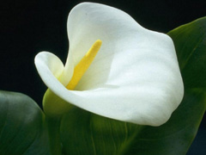_______ 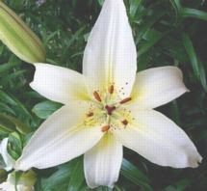 _______

CALLA - Zantedeschia aethiopiea LILY- *Lilium Candidum*

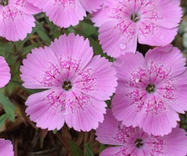 ________ 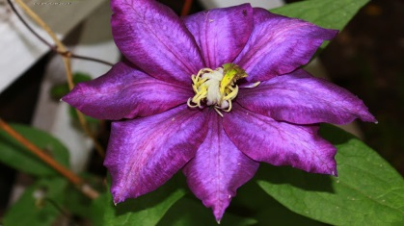 _____ Piatra Craiului CARNATION CLEMATIS sp.

**(Dianthus callizonus)**

** _______**

DAISY – Chrysanthemum leucanthemum

1. Observe the living material (flowers) on your desk. How many petals? Does the number of petals belong to the Fibonacci sequence?

**WORKSHEET 2 – The Pine cone**

1. Observe the images below. Color it using crayons of different colours for each spiral from the image. Write next to the image, the number of the resulted spirals.

Number of spirals on the **left** side image ___________

Number of spirals on the **right** side image ___________

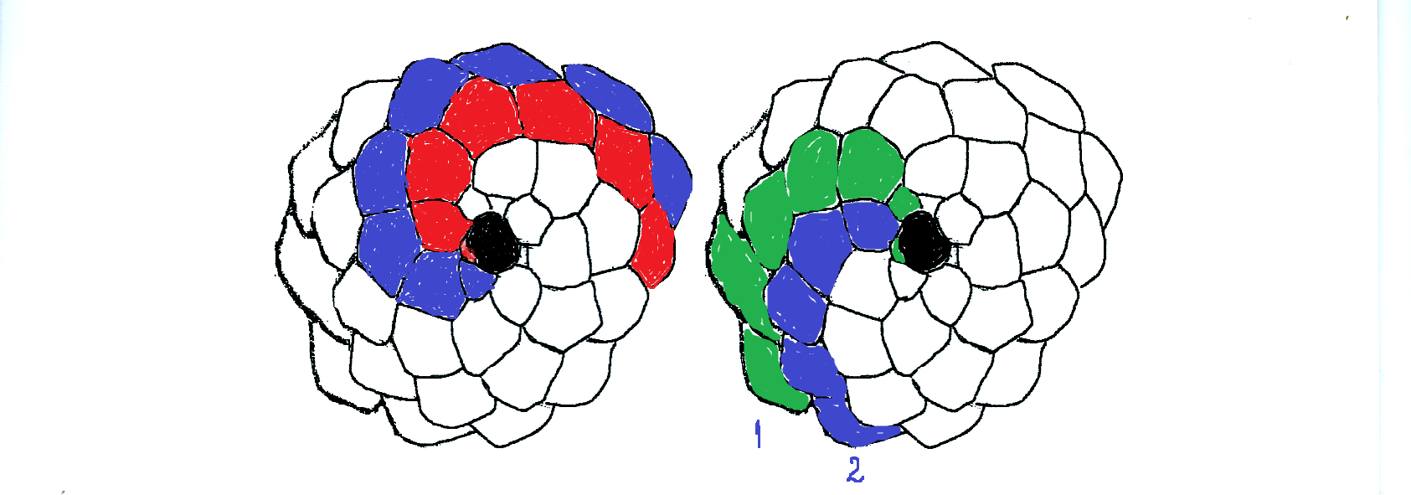

1. Please observe the pinecone located on the desk in front of you.  
   How many spirals does it present, counting from left to right?

Answer: ________

How many spirals does it present, counting from right to left?

Answer: ________

Count the seeds from one spiral. How many are there? ________

Do all these numbers belong to the Fibonacci sequence? _________

**WORKSHEET 3 – Branches And Leaves**

1. Observe the first image. Count and record on its left side the number of branches and on its right side the number of leaves on each of the six levels represented in the picture.

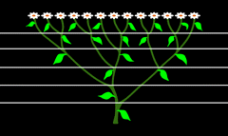

1. Observe the second image. Write down the number of branches at each level. Do these numbers belong to the Fibonacci sequence?

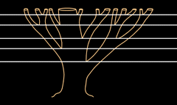

**WORKSHEET 4 – Sunflower**

1. Carefully observe the image below. Notice image on the left and starting from its centre, count the spirals **from right to left**. Write down the number you discovered: ___

Now count the spirals **from** **left to right and** write down the number: ____

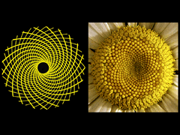

1. Observe the natural teaching material (the sunflower head) on the desk in front of you. Count the number of spirals and discover if it represents a number in the Fibonacci sequence.

Answer: _____

**WORKSHEET 5 – The Fibonacci Spiral**

In order to create the Fibonacci spiral you will need a sheet of graph paper, a ruler, a pair of compasses, a pencil. To draw Fibonacci spiral follow the following guidelines:

1. Draw in the middle of the graph sheet, a small square, side= 1 cm. Draw a second square of 1 cm on the left side of the first square.
2. Draw another square, of 2 cm above the 2 squares drawn before.
3. Draw a square of 3 cm to the right, against the 3 smaller squares.
4. Draw a square of 5 cm below the square of 3 cm and of the 2 squares of 1 cm.
5. Draw a square of 8 cm to the left of the 5 squares drawn before.
6. Draw a square of 13 cm above the 6 squares drawn before.
7. In order to finish the design you'll need a pair of compasses. In every square that you draw, you will draw an arc from one corner to the opposite corner of the square. Each arc will be connected to the next one. To begin, place the compass leg that holds the pencil in the top right corner of the first square and then draw an arc towards the bottom left corner of the first square. Then, draw an arc from the bottom right corner of the second square towards the upper left corner. Continue to draw arcs in every drawn square, starting the arc from the point in which you end the preceding one. Continue up to the last square.
8. What is the name of the resulted geometric shape? Give some examples from nature that follow this spiral.

**PROJECT ASSIGNMENT/COUNTRY: Each school will propose 3 exercises/problems, based on this lesson, to be included in the Mobile App.**

**PHYSICS**

**Centre of Gravity**

**Q: What is the Center of Gravity (CG)?**

A solid state can be considered as consisting of a large number of particles, each of which is drawn from the ground with a force that is just the weight of the respective particle, body weight representing the result of all of these forces of attraction.

The center of gravity is the application point of mass.

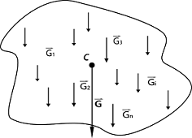

Q: How do we determine the centre of gravity of a body?

Determining the center of gravity can be achieved experimentally using equilibrium conditions, or theoretically, by using mathematical modeling and analytical tools. The use of one method or the other depends on the complexity of the modeling and of the mathematical calculation implied or on the difficulty of the experiment and the errors occurring.

1. Applying equilibrium conditions leads to the following conclusions:

• A body found on a plane is in equilibrium when the vertical lowered from its centre of gravity falls within the base of support.

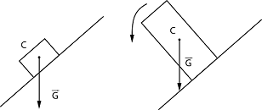

• a suspended body is in balance if the center of gravity is located on the same vertical of the point of attachment, below it.

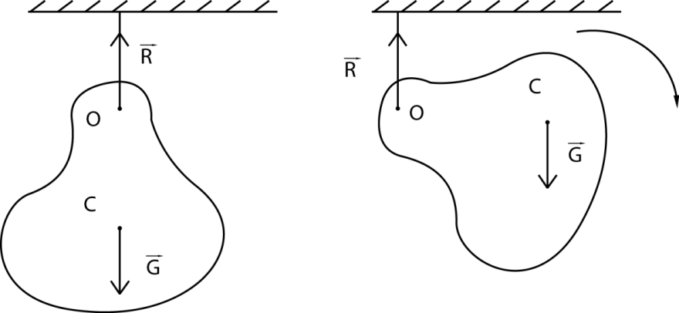

If these conditions are not met the two forces cause a moment of the resultant force different from zero and thus the body rotates, it being no longer in balance.

b. Mathematically, for a mechanical system consisting of *n* objects with masses *m1, m2, ...., mn* or considering that a body is made up of *n* objects, the position of the centre of gravity is obtained by vector composition of masses of all n objects is given by the relations:

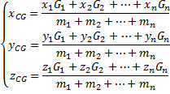

If gravitational acceleration is constant, as it is for a place on the Earth's surface, the centre of mass and centre of gravity coincide.

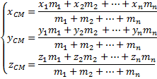

If a homogeneous body has a center, an axis or a symmetry plane, then its center of gravity is in that point, on the axis or in that plane.

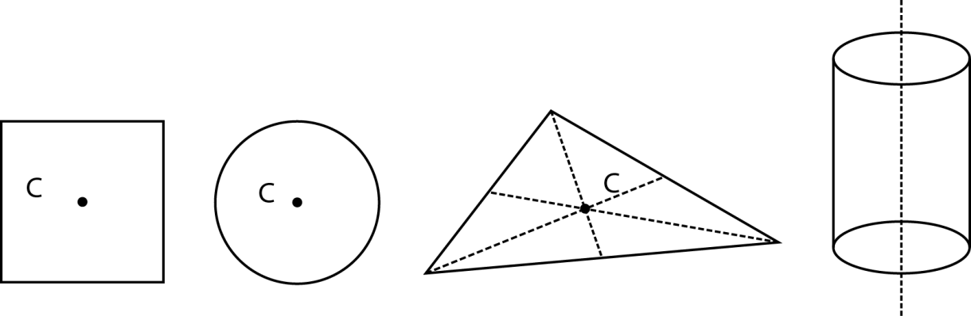

**Students activities:**

Students are asked to try to maintain their balance in situations where the vertical lowered from the centre of gravity of their body doesn’t fall into the base of support (getting up from a chair with the back straight, without bending, when their feet are outside the support base of the seat; standing on the tiptoes while facing the wall and the tiptoes touch the wall; bending the body forward while the legs and buttocks are in contact with a vertical wall)

• Students are asked to give examples that show what can be done in certain situations in order to maintain balance easier

1. **Experimental determination of the centre of gravity of some bodies with a regular or irregular shape.**

Each group of students will determine the center of gravity of the bodies found on the desk. For this, the body is suspended in a point with the help of a pin and a thread/line with plumb and we draw the vertical from the suspension point. Then the suspension s changed point and the vertical is drawn again. The intersection point of the two straight lines is the centre of gravity of the body.

Note: If we want to increase the precision, the body is suspended in several points.

1. **Experimental determination and calculation of the centre of gravity of a given body.**
2. **Experimental determination of the centre of gravity**

Determine experimentally the center of gravity by suspending the body in at least three points and then measure $x_{C}=$

$$x_{C}=$$

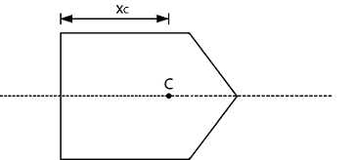

1. Determination of the center of gravity by using **mathematical** **calculations**

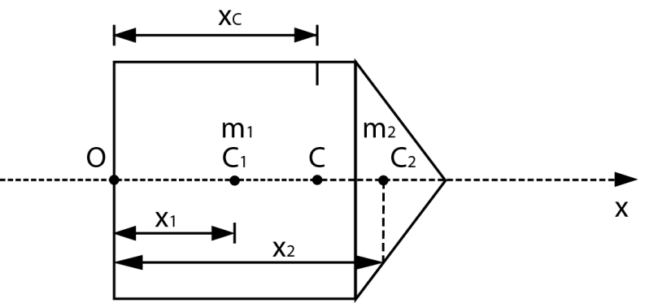

We observe that we can consider the body as consisting of two geometric shapes, a square and a triangle, for which we know the CG (centre of the square C1 and the triangle intersection medians C2). We can also observe that our figure has an axis of symmetry, so the center of gravity must be on the axis.

  We can thus reduce the body to a system of two bodies of mass m1 and m2 situated at the distance x1, respectively x2, from the origin of the coordinate axis and the position of the centre of gravity / mass can be determined from the relation:



Given the fact that we have a homogenous body (density ρ = const.) And expressing: mass m = ρ · V

volume V = S · h S-surface area

h-body thickness

for determining the position of the centre of gravity we obtain the relation:



S1 square area, S = side2

S2 triangle area

**Procedure**:  
1. Measure the side of the square and determine x1 and S1.

L=

x1=

S1=

1. Determine x2, knowing that the intersection of medians is situated on any median at 2/3 from the tip and 1/3 from the base (corresponding side of the median) and the triangle area S2

x2=

S2=

1. Calculate the center of gravity position:

xC =

1. Check if the position of the CG resulted from the experiment coincides with the one you calculated. If there are differences try to explain what the cause may be.

**III. The importance of the center of gravity in a body**

Centre of gravity of a body (system) determines its balance. One of the main personalities who distinguished in the equilibrium research was Archimedes: he determined the centre of gravity for bodies, he established laws for levers, he invented the compound pulley.

The following experiments highlight the connection between the CG and the equilibrium of the bodies.

**STUDENTS ACTIVITIES**

**Group 1**

You have the following material: needle, candle, two glasses, matches. Insert the needle in the middle of the candle and support the needle in equilibrium between the two glasses. Light up both ends of the candle

.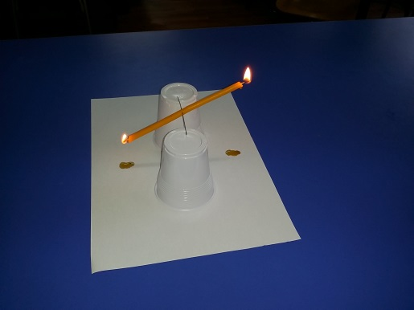

*Attention! Keep away from the candle flame! Risk of injury!*

• What do you observe? How do you explain that the candle swings while it burns?

**Group 2**

Check the equilibrium of the scheme through the following experiment:

Materials: two forks that you insert symmetrically into a cork. At the bottom of the cork insert a sewing needle.

*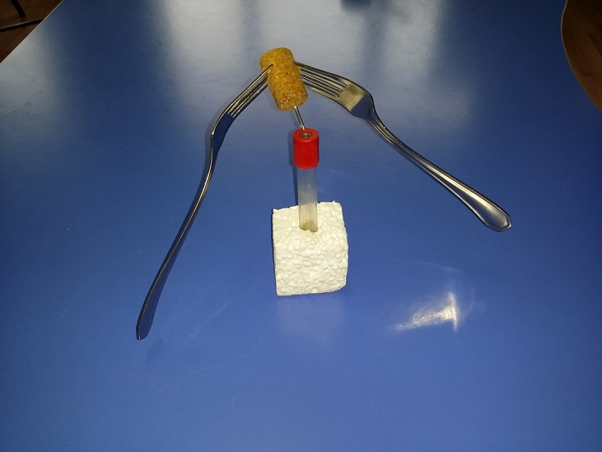  
Caution when handling sharp objects! Risk of injury!*

Support this assembly on the edge of the stand.

• What do you observe? How do you explain the fact that the whole assembly is in equilibrium?

**Group 3**

Check the equilibrium of the assemble through the following experiment:

Take a metal can of 250ml. Fill a third of the dose with water. Place it on a horizontal support, inclined from the vertical position, trying to get it in an equilibrium position.

• Did you make it? How do you explain that the metal can is in equilibrium?

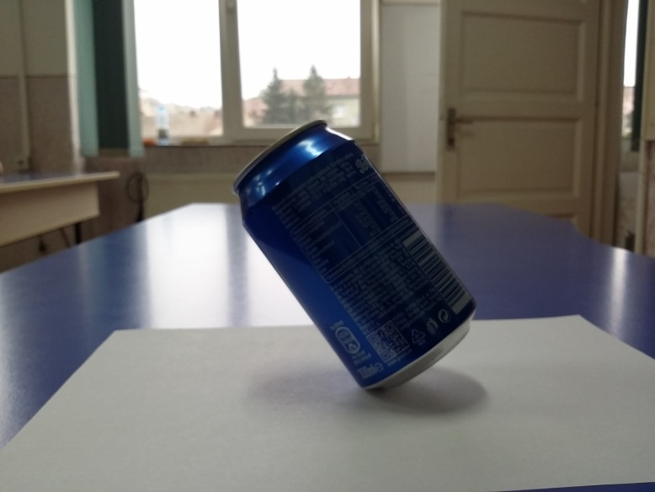

**Home Assignment**: Try to assemble a well-balanced set of different objects, as cleverly as possible.

**PROJECT ASSIGNMENT/COUNTRY: Each school will propose 3 exercises/problems, based on this lesson, to be included in the Mobile App.**

**notes**

**notes**

**CHEMISTRY**

**Perfume Preparation**

A perfume is a liquid mixture of aromatic oils or aromatic compounds, fixatives and solvents to be used to give the human body, objects or a living space a pleasant smell.  
The history of perfume is linked to the history of civilization; we do not know the precise date of its invention.  
Starting with the **Antiquity**, perfume is, in turns, an instrument of worship, a therapeutic method, a hygiene or beauty habit, but in the same time, a pleasure for both body and spirit. Egyptians already knew the art of mixing fragrances to create complex perfumes.  
  
In the **Middle Ages** perfumes were considered a cure for different diseases, and the rich people used to carry with them bottles with amber, musk and aromatic resins to protect themselves against epidemics.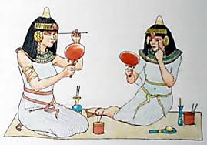  
In **Renaissance** Europe, the art of mixing fragrances often belonged to the alchemists. Alcohol and distillation process are discovered, thus allowing the extraction of perfumes. In the same time, new raw materials are discovered: cocoa, vanilla, tobacco, Peru balsam and pepper.  
At the end of the sixteenth century up until the eighteenth century, alcoholic perfumery develops: at the royal court people did not use to wash, but they used to wear very much perfume - Cologne, toilette vinegar, powders and scented pomade.

**Today** the perfume industry is one of the most powerful, evolving continuously, marked by a strong and tough competition among manufacturers, with a market constantly growing and new invented formulas every year.  
**Famous perfumers:** Yves Saint Laurent, Helena Rubinstein, Helene Rochas, Robert Ricci, Charles Revson, Francisco Rabaneda, Manolo Pertegaz, Antonio Puig, Dr N.G. Payot, Estee Lauder, Germaine Monteil, Yves Lavin, Jean Paul Guerlain, Hubert de Givenchy, Max Factor, Christian Dior, Gabrielle Chanel, Pierre Balmain.

**Perfume composition.**Every fragrance is composed of three types of notes constituting an olfactory pyramid:  
**Top notes**  
They are the most volatile notes, those which you sense the first time you smell a fragrance.  
These notes only last a few minutes, maximum a few hours. However, they are crucial in choosing a perfume, as they provide you with the first impression.  
Top notes are mainly fresh and tonic notes (citrus, green, aromatic) like cedar, cinnamon, ginger, sandalwood, vanilla, myrrh.  
  
**The middle notes**  
These notes start to be sensed when the top notes attenuate.  
Consisting of medium volatility components, they are generally very present in terms of smell, for example floral notes of jasmine and violet, and the spicy or fruity notes, middle notes of a fragrance carry the identity and strength of a perfume and thet can last for several hours. (Cloves, anise, bay leaf, jasmine, chamomile, oregano, mint, rosemary, thyme, violet, sage).

**The base notes**  
The base notes are less volatile, with consistent odor, made up of heavy scent components, such as sandalwood and patchouli. These notes last longer, especially on the clothes, up to several days in a row. (Eucalyptus, lavender, orange, lemon, rose).

**Fragrance Classification**   
• Different types of perfume, according to their concentration:  
Concentrated perfume 20 -40% aromatic compounds; the smell lasts one to several days.  
Eau de Perfume: 10-20% aromatic compounds; it lasts for several hours  
Eau de Toilette (EDT): 5-10% aromatic compounds; it lasts between 2 and 3 hours  
Eau de Cologne: less than 5% aromatic compounds; it lasts for 1-2 hours

**Perfume Preparation:**

Tools needed:

|  |  |  |  |
| --- | --- | --- | --- |
| http://www.ld-didactic.de/phk/images/150dpi/664252.jpg | Imagini pentru cantar laborator | Imagini pentru masurare volum | Imagini pentru pipeta |
| **Erlenmeyer flask** | **Lab Scale** | **Graded cylinder** | **Pipette** |

Substances needed:  
• perfume essence  
• Absolute Alcohol   
• double-distilled water

Procedure:  
• Choose a perfume essence that you like.  
• Weigh X g of essence in an Erlenmeyer flask (using the technical scale)  
• Measure Y cm3 of absolute alcohol using the graded cylinder.  
• Stir with the rod and add Z cm3 of double-distilled water, using a pipette.  
      Amounts used:

|  |  |  |  |
| --- | --- | --- | --- |
|  | X (g)  essence | Y (cm3)  absolute alcohol | Z ( cm3 )  double-distilled water |
| Group 1 | 1 | 22 | 7 |
| Group 2 | 2 | 22 | 6 |
| Group 3 | 3 | 22 | 5 |
| Group 4 | 4 | 22 | 4 |
| Group 5 | 5 | 22 | 3 |
| Group 6 | 6 | 22 | 2 |
| Group 7 | 7 | 22 | 1 |

• Pour the scented liquid into a perfume bottle  
• calculate the concentration of the fragrance and establish the perfume category it belongs to  
• Label the bottle (you may also choose a name) and write the concentration on the label.

**Calculations:**

Perfumes are solutions of different concentrations.

The percent concentration is the mass of solute per 100 g of solution.

**C % =** 

+ = the mass of solute essence;

= mass of solution.

where mass of solution is essentially equal to the mass of essence added to the mass of water and mass of alcohol:

**ms = me+ mwater+malcohol**

Transforming volume in mass using the density formula:  
       The density (ρ) of a body is defined as the ratio of the mass (m)  
  and the volume (V) of the body.

**ρ = **

Unit of measurement: [ρ] = g/cm3 (in CGS system, i.e. Centimetre-Grame-Second);

[ρ] = kg/m3 (in IS- International System);

The following densities are given: **ρwater= 1000** kg/m3

**ρethyl alcohol = 784k**g/m3

Measure units transformations:

1 kg= 1000 g =103 g

1 m3= 1000000 cm3 =106 cm3

ρwater= 1000 kg/m3 = 1 g/ cm3

**ρethyl alcohol= 0,784 g/ cm3**

## Calculation of mass components:

## ρapa = mwater/Vwater → mwater= ρwaterx Vwater = 1x Vwater =............... g

## ρalcohol = malcohol/Valcool → malcohol= ρalcoholx Valcohol = 0784x Valcohol = ……g

**Calculation of mass solution**:

**ms = me+ mwater+malcohol =................ g**

## Calculating the concentration of the perfume:

**C % =**  **= ..................**

Class Assignement: Depending on the concentration of perfume obtained, please determine the category your substance belongs to.

 **Health Impact:**  
Among the most frequently encountered conditions:  
• contact allergy - skin irritation accompanied by itchyness and / or swelling.  
People with skin diseases (psoriasis, eczema) are advised to avoid contact with perfumery products.  
• triggers for asthma attacks - alongside pollution, dust, pet fur and cigarette smoke, fragrances and air fresheners are among the most common triggers for asthma attacks

**PROJECT ASSIGNMENT/COUNTRY: Propose 3 exercises/problems based on this lesson that you wish to be included in the Mobile App.**

**notes**

**notes**

**notes**

**Math Applications to**

**Biology, Chemistry and Physics**

**Centroid problems**

**Refreshing our knowledge:**

* **The centroid** of a triangular figure is at the junction of the triangle medians
* **Median** - is the segment that connects the apex of a triangle with the midpoint of the opposite side

The centroid is denoted by G and is positioned on each median peak at ⅔ from the apex and ⅓ from base

[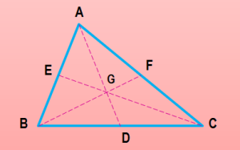](https://iubescmatematica.files.wordpress.com/2014/10/mediana.png)

* If ▲ ABC has apexes A($x_{1}$, $y_{1}$), B($x_{2}$, $y_{2}$), C($x_{3}$, $y_{3}$) then the coordinates of the centroid are:

G $\left(\frac{x_{1}+x_{2}+x_{3}}{3},\frac{y_{1}+y_{2}+y_{3}}{3}\right)$

* The centroid of a figure in a square, rectangle, parallelogram or diamond form has the centroid at the intersection of its diagonals.

**Practical problem**: Given a piece of paper with a triangle shape (square, parallelogram, rectangle). Find the centroid without using any geometry tool, only by bending the piece of paper.

**Proposed problems:**

1. Let AM be a median of ▲ ABC (M $∈$ BC) and G the centroid. Learn the length of AG and MG segments, knowing that AM = 12 cm.

2. Let ▲ ABC be an equilateral triangle with a side of 10 cm and G the centroid. Determine the length of the AG segment.

3. Let A (-2,0), B (4.0) C (0.6) be a triangle. Determine the coordinates of the centroid (in two ways).

4. Given ▲ ABC with A (4,3), B (8.5). If G (10.7) is the centroid of this triangle, then determine the coordinates of point C

5. The points A(2,2), B (1,6), C (5.3), D (-2, -1) are apexes of a square. Calculate the coordinates of the centroid.

6. Let the straight variable: x + y + 1 of (2x-y) = 0, a $∈$ R. Specify which straight passes through the centroid of ▲ ABC where A (-2,3), B (3.3 ), C (1 -4).

7. In the Cartesian plane xOy, consider the points A (1,3), B (4.6) and C (5,7). Learn the coordinates of the centroid and those of D, knowing that ABCD is a parallelogram.

**Worksheet**

1. Let M be the midpoint of BC of ▲ABC and G the centroid. Learn the length of median AM, knowing that MG = 4 cm.
2. Let ▲ ABC have m (<A) = 90 and BC = 18 cm. If G is the centroid of ▲ ABC, determine the length of AG segment.
3. Let M be the middle of BC side of ▲ ABC and G its centroid. Find the length of median AM, knowing that MG = 4 cm.
4. Prove that the centroid of the square with A (3,4), B (-4,3), C (-3, -4), D (4, -3) apexes is the point O (0,0) .
5. The sides of a triangle are:

(AB) x + 2y-1 = 0; (BC): 5x + 4y-17 = 0; (AC): x-y + 11 = 0. Determine the coordinates of the centroid.

1. In the Cartesian plane consider the points A (12.0) and B (0.5). Determine the coordinates of the centroid of ▲OAB.
2. a) Let A (1.5), B (-3,2). Find coordinates of point C so that it'll be at the centroid of ▲ ABC.

b) Let A (2,4), B (1, -4). Learn coordinates of point C so that G (-2,1) is the centroid of ▲ ABC.

1. For the following triangles with the apexes at points A, B, C find the centers of gravity (in two ways).

a) A (1,4), B (2,3), C (-1, -4)

b) A (4.0) B (0.5) C (-1, -8)

c) A (2.3) B (-9, -8), C (1, -1)

1. Consider the points A (m + 2, n-1), B (2 m + 2, n + 1), C (2n-1, m + 1), m, n $∈$ R. Determine m and n so that the centroid of triangle ABC be the origin O (0,0).
2. Given points A (1,4), B (2.5) C (4.2) D (-5, -1). Compute the coordinates of G1, G2 that are centers of gravity of the triangles ABC and BCD.
3. Given the points A (4 a), B (8.6), C (b, -7). Determine a, b $∈$ R so that point G (2,5) be the centroid of ABC.

**FIBONACCI’S SEQUENCE**

You are given a pair of rabbits. It is known that each pair of rabbits produces every month a new pair of rabbits, which becomes productive after one month. Determine how many pair of rabbits will exist after ***n*** months.

Initially we’ll see the history of this problem and it’s solution, with other issues related to it.

Talking about antique mathematicians everyone would name Euclide, Pytagoras, Heron etc. One of the best mathematicians of the Middle Ages is Leonardo from Pisa, known as Fibonacci (*Son of Bonacci*).

Fibonacci, born in Italy in 1175 was educated in Northen Aftrica, where his father owned a diplomatic position. Coming back to Italy in 1202, he publishes a math treaty entitled “Liber abaci.” This treaty contains almost every piece of information of that time, talking about aritmetics and algebra, which had an important role over the upcoming centuries under the development of mathematics around Europe. Particularry, based on this treaty, Europeans took notice of Arabic writing of numbers, i.e. positional numeration Arabic system. Similarly, in 1220 he published "Geometry Practice," in 1225 "Free Quadratorum". The treaty "Liber Abaci" was reissued in 1228. One of the issues discussed in "Liber Abaci" is exactly the "rabbit problem" (p. 123-124, 1228 edition) presented earlier in this material.

Let’s get to solving this problem.

Let *fn* be the number of pairs of rabbits after ***n*** months. The number of pairs of rabbits after n + 1, denoted by *fn*+1 is the number of pairs in month n, i.e. *fn*, plus the number of newborn rabbits. As rabbits are born by pairs of rabbits older than one month, the newborn rabbits will be *fn*-1 pairs.

Therefore one gets:

*fn*+1 = *fn* + *fn*-1. The recurrence Formula of the sequence.

In addition,

*f*0 = 0     si     *f*1 = 1.

So we got a numeric sequence defined recurrently. By writing the terms of this sequence, we use the descriptive method: 0, 1, 1, 2, 3, 5, 8, ...

called the Fibonacci sequence.

Each term of the sequence, starting with the third, is the sum of the preceding two terms. The first two terms are considered as being given *f*0 = 0, *f*1 =1.

Another formulation of the same series is the general term formula:

http://www.math.md/school/competitiva/fibonacci/fibo11x.gif

Which we can demonstrate by using mathematical induction.

Verification: n = 1 It is true.

Induction: We have shown that if  and

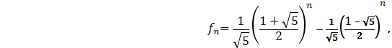

that is real and true



But we know the relation:



It remains to check that: 

Which is true.

**Properties of the Fibonacci Sequence**

|  |
| --- |
| **P1. *f*1 + *f*2 + ... + *fn* = *fn*+2 - 1.** |

**Demonstration**

|  |
| --- |
| *f*1 = *f*3 - *f*2 |
| *f*2 = *f*4 - *f*3 |
| ... |
| *fn*-1 = *fn*+1 - *fn* |
| *fn* = *fn*+2 - *fn*+1. |

Adding side-by, the following equalities are obtained

*f*1 + *f*2 + ... + *fn* = *fn*+2 - *f*2,

if *f*2 = 1 we obtain the equality.

**P2. *f*1 + *f*3 + *f*5 + ... + *f*2*n*-1 = *f*2*n*.**

**P3. *f*2 + *f*4 + ... + *f*2*n* = *f*2*n*+1 - 1.**

Properties of 2 - 3 demonstrated similar to 1.

|  |  |
| --- | --- |
| **P4. *f*12 + *f*22 + ... + *fn*2 = *fn* · *fn*+1.** |  |

**Demonstration** We easily observe the relation that takes place

*fn*·*fn*+1 - *fn*-1*fn* = *fn*(*fn*+1 - *fn*-1) = *fn*2     (*n* ∈ **N*)**.

From this relation, we deduce the equalities

|  |
| --- |
| *f*12 = *f*1·*f*2, |
| *f*22 = *f*2·*f*3 - *f*1·*f*2, |
| *f*32 = *f*3·*f*4 - *f*2·*f*3, |
| ... |
| *fn*2 = *fn*·*fn*+1 - *fn*-1·*fn*. |

Summarizing, the previous side by side, the equalities are obtained ([9](http://math.ournet.md/competitiva/fibonacci/fibonacci.html#ec9#ec9)).

|  |
| --- |
| **P5. Demonstrate that:  *fn*+*m* = *fn*-1 · *fm* + *fn* · *fm*+1,** |

where *fn* is the term of rank n of Fibonacci.

Demonstration: We will demonstrate using mathematical induction method. We write the induction for *m* ∈ **N**.

For m = 1, equality becomes

*fn*+1 = *fn*-1·*f*1 + *fn*·*f*2,

For m = 2 formula (10) is verified. Indeed,

*fn*+2 = *fn*-1*f*2 + *fnf*3 = *fn*-1 + 2*fn* = *fn*-1 + *fn* + *fn* = *fn*+1 + *fn*.

Thus the basis of induction is checked (m = 1, m = 2). We will suppose it is true for m = k and m = k + 1 and we will prove that it is true for m = k + 2.

So, assuming that the equalities are true

|  |
| --- |
| *fn*+*k* = *fn*-1*fk* + *fnfk*+1, |
| *fn*+*k*+1 = *fn*-1*fk*+1 + *fnfk*+2. |

Adding up side by side, at last the equality is obtained

*fn*+*k*+2 = *fn*-1·*fk*+2 + *fn*·*fk*+3,

which is equal to m = k + 2.

**P6. f2n = fn-fn • fn + 1fn + 1.**

The equality results from **P5** by writing m = n.

**P7.** The term ***f*2*n* is** divided by ***fn***

Demonstration: Of P6 results

*f*2*n* = *fn*(*fn*-1 + *fn*+1),

It results that ***f*2*n* is** divided by ***fn***.

**P8. **

**P9. **

Properties 8-9 are direct consequences of the P6 equality.

**P10**. ***fn*2 = *fn*-1*fn*+1 + (-1)*n*+1**

Demonstration: We prove the equality by induction on n.

For n = 2 equality becomes

*f*22 = *f*1·*f*3 - 1,

that is true.

We suppose that it is true and we will prove that it is true for n + 1. Suppose that equality holds

*fn*2 = *fn*-1·*fn*+1 + (-1)*n*+1.

Gathered at both sides of the last equality . As a result, the equality

*fn*2 + *fn*·*fn*+1 = *fn*-1·*fn*+1 + *fn*·*fn*+1 + (-1)*n*+1 is obtained

or the equivalent

*fn*(*fn* + *fn*+1) = *fn*+1(*fn*-1 + *fn*) + (-1)*n*+1,

and as *fn*+2 = *fn* + *fn*+1 is true (see the definition of Fibonacci Sequence) we deduce

*fnfn*+2 = *fn*+12 + (-1)*n*+1

or *fn*+12 = *fn*·*fn*+2 + (-1)*n*+2 So it is true for n + 1.

**P11.** Demonstrate that, if ***n* is divisible by *m* then *fn* is divisible by *fm***

Demonstration: may it be  ** , that is *n* = *mk*. We prove property (11) by induction on k. For k = 1, n = m, and therefore, obviously divisible by *fn*. Suppose *fmk* is divisible by *fm*. Let's examine *fm*(*k*+1). As *fm*(*k*+1) = *fmk*+*m* using **P10** we obtain the equality

*fm*(*k*+1)2 = *fmk*-1*fm* + *fmk*·*fm*+1.

The first term of the sum on the right isobviously divisible by *fm*.. The second term is divisible by *fm* under inductive assumption. Therefore the sum of these terms is divisible by *fm*, thus the **P11** is proved true.

[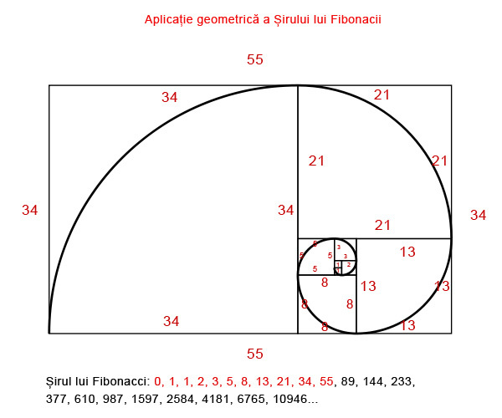](https://matematicasiteologie.files.wordpress.com/2012/09/aplicatie-geometrica-sirul-lui-fibonacci.jpg)

[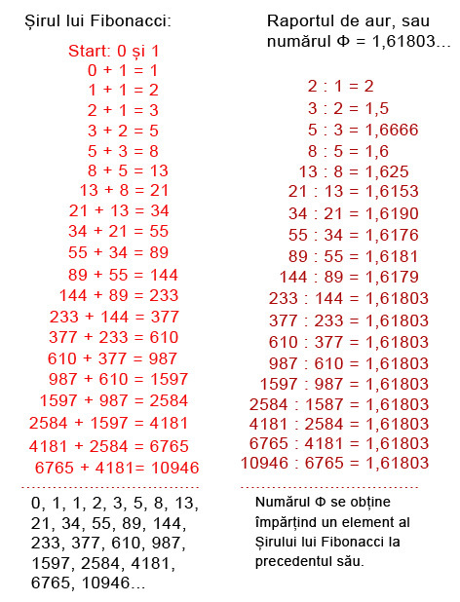](https://matematicasiteologie.files.wordpress.com/2012/09/sirul-lui-fibonacci.jpg)

**WORKSHEET 1**

**Percentages**

To know how to calculate percentages is a must nowadays. Without accurate knowledge of basic concepts in this field, various information that assails us constantly cannot be interpreted properly. Some examples would refer to banking information (interest rates), to the economy (productivity, profit, taxes), to the social sciences (population, unemployment, inflation) etc.  
Definition: A percentage means a fraction denominator 100, so percentage means a percent reported to 100 p% = $\frac{p}{100}$

Finding out the percentage ratio of a number

P% din a= $\frac{p}{100}$ xa

Example: According to the latest statistics, Cluj county population is 691,100 people, including 341,823 women and 349,277 men. The active population is 410,923 and the unemployment rate is 3.66%. They live in cities and towns - 64.97% of men and 66.67% women, the rest living in rural areas, about a third of the county population They work in agriculture and animal farms.

1. A rectangular land is arranged as shown in Fig. 1 below. The perimeter of the field is equal to 40 m and the width is 66,(6)% in length. Determine the size of the land and its surface S.

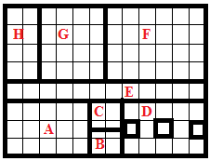 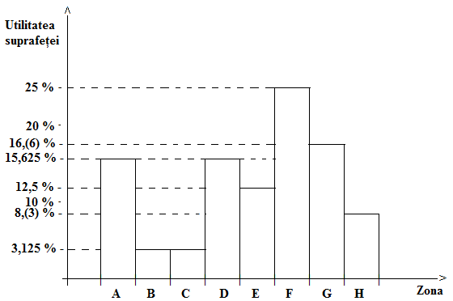

Fig. 1 Fig. 2

**2.** Learn how much wire net -1.05 m wide - is needed to surround the land area with a fence, ( height of the fence is 2.10 m).

**3.** Complete the table in figure Fig. 3 below the land surface areas given in Figure Fig. In the diagram of Figure 1 and Fig. 2.

|  |  |  |  |  |  |  |  |  |
| --- | --- | --- | --- | --- | --- | --- | --- | --- |
| **Zona** | **A** | **B** | **C** | **D** | **E** | **F** | **G** | **H** |
| **Culture** | **Greenhouse**  **(solar)** | **Cucumbers**  **(Castraveți)** | **Pumpkins**  **(Dovleci)** | **Trees (Pomi**  **Fructiferi)** | **Path**  **(Cale**  **de acces)** | **Vegetables**  **(Zarzavat)** | **Potatoes**  **(Cartofi)** | **Corn**  **(Porumb** |
| **p %**  **of S** | **15,625 %** | **3,125 %** | **3,125 %** | **15,625 %** | **12,5 %** | **25 %** | **16,(6) %** | **8,(3) %** |
| **Area in m** |  |  |  |  |  |  |  |  |

Fig. 3

**4.** Determine how much glass is needed for the construction of the Greenhouse zone A knowing that has the shape of a cuboid, with the height of 2 m.

**5.** Find out what are the total costs for the land development,if we need to buy 10 m plastic pipe for greenhouse (7.5 lei / m), 89.4 m wood pieces (6 lei / m), glass (4.5 lei / m) and wire net ( 5 lei / m).

**WORKSHHET 2**

**FINDING OUT A NUMBER BASED ON ITS PERCENTAGES ( P% OF IT)**

P% of X=a is $\frac{P}{100}$ ×X=a so, X=a: $\frac{P}{100}↔$ X=a× $\frac{100}{P}$

Problem: It is known that 21% of the amount of milk is cream and 25% of the amount of cream is butter. Find out the amount of milk we need to obtain 52,5 kg butter?

**Finding the percentage ratio**

$\frac{P}{100}×a=b↔\frac{P}{100}$**= $\frac{b}{a}↔p=\frac{100×b}{a}$**

**Problem: Grandma's chocolate recipe contains the following ingredients: milk powder, cocoa, sugar, rum. Calculate the percentage of each ingredient knowing that for 400g homemade chocolate grandma used 220g of milk powder, 60g of cocoa, 100g sugar and 20g rum.**

**WORKSHEET 3**

**STRENGTH OF SOLUTIONS**

Definition: It's called a solution concentration the ratio between the mass and the mass of the substance that dissolves the obtained solution.

**Concentratia= $\frac{mass of soluted substance}{mass of the solution}$**

Problem 1- In a solution weighing 120 g was dissolved 9.6g of salt. Determine the concentration of the solution.

Problem 2 In a bowl we have sugar-water solution. The solution concentration is 8%, and the mass of sugar is 120g. Calculate how many milliliters of water are in the bowl.

Problem 3. The salt concentration of a solution is 15% .What amount of salt is found in 2540kg of solution?

**WORKSHEET 4**

For the preparation of a perfume substance we use perfume essence, ethyl alcohol and doubly distilled water. Calculate how many g of essence of perfume should be added to a solution of 20 g ethanol and 50 g of doubly distilled water to get a perfume concentration of 30%?

FORMULAS: Concentration= $\frac{mass essence}{mass solution}$

We note the mass of the solution $→$ C= $\frac{X}{X+20+50}$ C= $\frac{X}{\begin{aligned}X+70 \\ \end{aligned}}$

Based on the proportions propriety, we have: Cx(X+70)=X $\frac{30}{100}$ (X+70)=X $↔$ 30 (X+70)=100X

X=...............g

We determine the volume of water and alcohol using the relation between density, mass and volume.

$$ρ=\frac{m}{V}↔V=\frac{m}{ρ}$$

$ρ$ water=1000kg/m3 OR, 1g/Cm3

$ρ$ ethyl alcohol=0,784g/cm3

**APPLIED CHEMISTRY & ENVIRONMENTAL PROTECTION:**

**BIODEGRADABLE FOIL**

**The purpose of the work:** Obtaining the biodegradable foil out of gelatin and glycerin

**Needed tools:** palette, Berzelius beakers, graduated cylinder, funnel, glass, shaker wand, pipettes, scales, watch glasses

**Needed raw materials:** gelatin, glycerin, natural dye from beetroot, distilled water

**Work Procedure:**

* in a beaker introduce 4 grams of gelatin and 50 ml glycerin solution 1%
* shake the mixture obtained
* heat the mixture obtained to 95°C
* shake again to complete the solubilizing of gelatine
* slowly pour the solution obtained on a tray
* color with the natural dye from beetroot
* dry at room temperature
* observe the biodegradability of the film compared to the non-degradable films

**CONCLUSIONS:**

The Biodegradable Film was prepared in the laboratory from natural raw materials: gelatin, glycerin natural dye from beetroot, distilled water.

We monitored the level of degradation of biodegradable film for over 150 days. Degradation of biodegradable film was observed after 60, 90, 120 daysl. After 150 days the degradation was total.

The experiment demonstrates the opportunity of using biodegradable made materials from renewable raw materials, such as polymers to reduce environment pollution.

These materials either dispersed or they degraded in the environment under the action of external agents: light radiation, absorbtion of water, oxygen, enzymatic attack or they were decomposed by microbial degradation into their basic elements: CO2, H2O and biomass in a global cycle without creating any environmental problems and without requiring high costs.

**notes**

**notes**

**notes**

**notes**