Utenos Dauniškio gimnazija

Vaižganto g. 48, 28185 Utena Tel./Fax +370 389 61719
www.dauniskis.utena.lm.lt
dauniskis@dauniskis.utena.lm.lt

Erasmus+KA2 Strategic Partnership for School Education
2015–2017

Short-term exchanges of groups of pupils
Utena, 3-7 October 2016

This publication is in the copyright of its authors under the Creative Commons Licensing. Any reproduction of any part of this publication may be made without the written permission of its authors as long as it is properly acknowledged.
AUTHORS:
MATHEMATICS TEXTS:
Rima Jackūnienė, Violeta Mikulėnienė
ASTRONOMY TEXTS: Loreta Tarvydienė
TRANSLATION: Inga Tutkienė, Ramūnas Musteikis
EDITOR: Violeta Gužienė
GRAPHIC DESIGN: Gražina Žalienė
COVER: Gražina Žalienė, Giedrė Sudniutė
PHOTOS: Loreta Tarvydienė
More information on:
https://twinspace.etwinning.net/9782/home
https://www.facebook.com/MathAroundUs

This project has been funded with the support from the European Commission. This publication reflects only the views of its authors and the Commission cannot be held responsible for any use which may be made of the information contained therein.

ACKNOWLEDGEMENTS

Loreta Tarvydienė, Project Coordinator, warmly thanks all who have contributed to realize and develop the Erasmus+KA2 Strategic Partnership for School Education project "Math Around us" to:
Edgaras Zaronskis, educator of Ethnocosmology museum
Evaldas Kaminskas, guide of Ethnocosmology museum

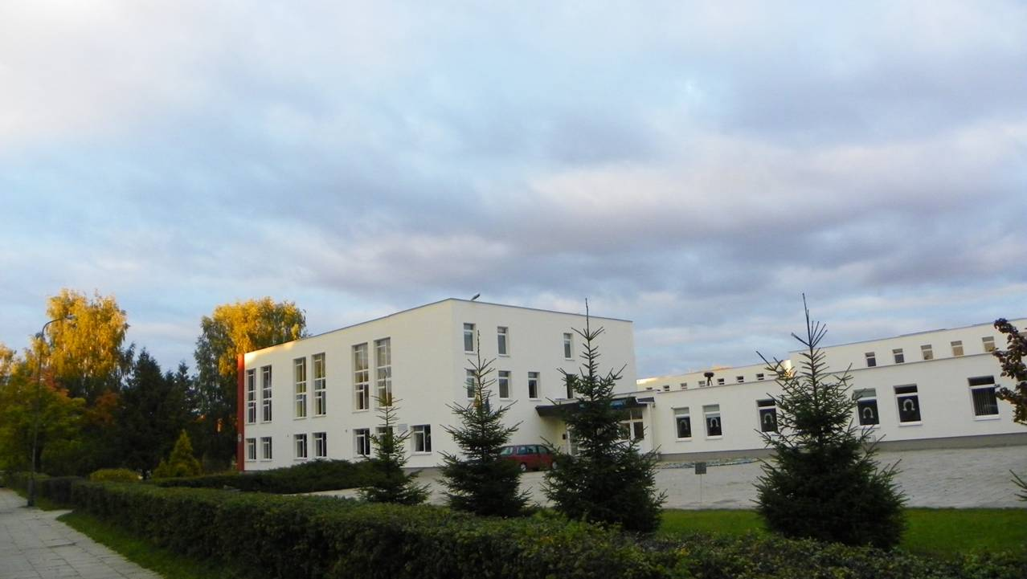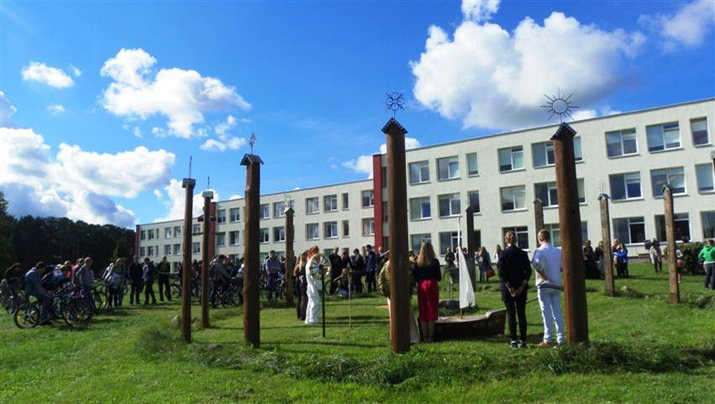
UTENA DAUNISKIS GYMNASIUM
Our school opened its doors for the first time in 1971. In 2003, after an accreditation procedure, the school became a gymnasium. At present, 532 pupils are enrolled in the gymnasium: 499 in the full-time day section (students aged 15 to 19) and 33 in the adult-learners section. For the past several years, 60-80% of our graduates have continued their education in university-level post-secondary institutions of learning. 53 teachers, work at the gymnasium, as do social pedagogues, a special-needs pedagogue, and a psychologist’s assistant. Of all these staff members, 11 have two specialities, and 12 have earned a master’s degree.
Since 2000, the gymnasium’s teachers and pupils have been actively engaged in activities of international projects. We participated in Socrates (Comenius 2 projects and Grundtvig 1 project) and LLP (Comenius 3 projects and Grundtvig 1 project) programmes administered by the Education Exchanges Support Foundation (Lithuania). We have participated in eTwinning virtual programme with 15 projects. Two of them were awarded with European Quality Label. Five of them were awarded with National Quality Label. In 2012, Utena Dauniskis gymnasium was awarded as the best eTwinning school in Lithuania. Also, we have worked on district-level as well as republic-wide projects.
Now we are involved in a new ERASMUS+ programme and in ERASMUS +KA2 Strategic Partnership for School Education project "Math around us".
In 2008, the gymnasium earned the status of an Elos school (a network of European schools working to implement a European and international orientation in education). We are quite proud of this accomplishment, because only 6 schools throughout Lithuania have earned this status!
The gymnasium cooperates with Mykolas Romeris University, the Department of Quantum Electronics and the Faculty of Physics at Vilnius University, the Kaunas University of Technology, the Lithuanian University of Educational Sciences, the Institute of Mathematics and Informatics at Vilnius University, Utena University of Applied Sciences, Algirdas Brazauskas gymnasium of Kaišiadorys, the Utena Labour Market Training Centre, and others.
Pupils have the opportunity to participate in various extracurricular activities. Pupils actively work in the Council of Pupils and the Gymnasium Council. There are 20 extracurricular groups, the creative pupils of which have won prizes and recognition in academic competitions. The gymnasium’s name is also well-known thanks to its artistic groups and its athletes.
Since 1996, the folk music group Untyte has been active in the gymnasium. The ensemble is composed of two groups: instrumentalists and a traditional choir. Untyte performs at the events in the gymnasium and in the city, in republic-wide song festivals, and in international festivals in Hungary, Russia, Belarus, Latvia, and Italy.
In 1998, the pop group Vivo was founded. During the past 13 years, it has performed at many concerts in Utena and other cities in Lithuania as well as in Hungary, Ukraine, Poland, Latvia, and Spain. Vivo has won 26 prizes at republic-wide and international competitions.
In 2016 our gymnasium has gained a very important evaluation among the schools of Lithuania. It was ranked as the School of the Year for its innovative and modern approach to the learning process and the students as well as the promotion of tolerance, citizenship and sociality.

HINC ITUR AD ASTRA
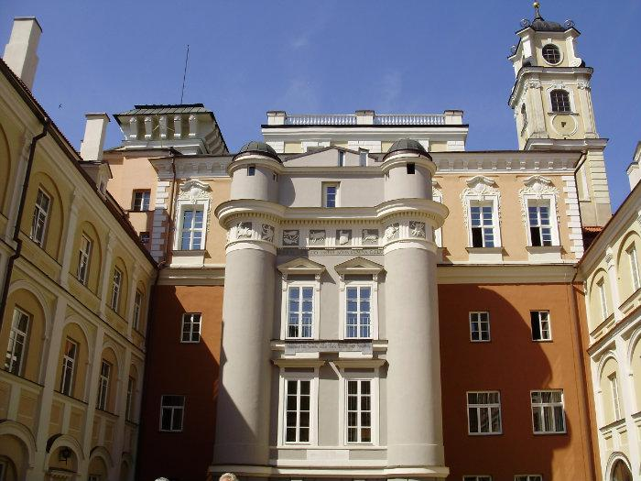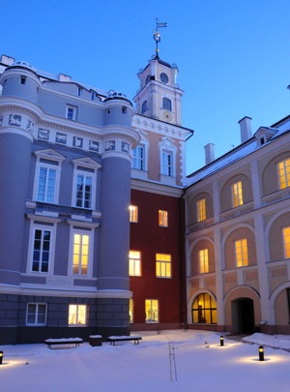
Astronomy is the oldest of the natural sciences, dating back to antiquity, with its origins in the religious, mythological, cosmological, calendrical, and astrological beliefs and practices of pre-history. The artifacts demonstrate that Neolithic and Bronze Age Europeans had a sophisticated knowledge of mathematics and astronomy.
Astronomers use maths all the time. One way it is used is when we look at objects in the sky with a telescope. Another way that astronomer’s use maths is when forming and testing theories for the physical laws that govern the objects in the sky. Theories consist of formulas that relate quantities to each other.
First mathematical composition, known as the Almagest was written by an ancient astronomer Ptolemy. The Almagest is a colossal work on astronomy. It contains geometrical models linked to tables by which the movements of the celestial bodies could be calculated indefinitely. In an ancient astronomy there was close relationship between mathematics and astronomy such as use of numerical and graphical methods, the linear methods and spherical trigonometry.
Observational astronomy depends on mathematical theories. In fact, the end of the 18th century was the golden age for the Lithuanian Astronomical Observatory. One of the most important persons is Poczobut. He was a very diligent and skilful observer and left a large body of observational data. He carried out the measurements of the positions of asteroids, planets and comets. He also observed lunar and solar eclipses. The most important data of that period was collected through the observations of Mercury. Later on, these observations were used by other observers in Europe.
Lithuanian observers have achieved high results in astronomy and maths: photometric and spectrophotometric observations of stars. It is important to note that a group of astronomers developed the so-called Vilnius photometric system which was effectively applied for the study of physical properties of stars, interstellar matter and galactic structure.

ACUTE ANGLE SINE OF A RIGHT - ANGLED TRIANGLE
LESSON 1 OBJECTIVES
- will be able to explain what we call the acute angle sine of a right-angled triangle;
- will be able to calculate the acute angle sine of a right-angled triangle when the lengths of two sides of a triangle are known;
- will solve 4 problems.
EXERCISE 1
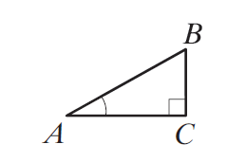
- Each pupil draws in his/her notebook a right-angled triangle ABC, in which angle C = 90⁰ and angle A = 40⁰.
- Each pupil measures the length of the side opposite angle A.
- Each pupil measures the length of the hypotenuse.
- Each pupil divides the length of the side opposite angle A by the length of the hypotenuse.
- Each pupil compares the result obtained.
- The results of all pupils should be similar: ≈ 0.6
Conclusion: The ratio between the lengths of sides BC and AB of the right-angled triangle ABC does not depend on the size of the triangle.
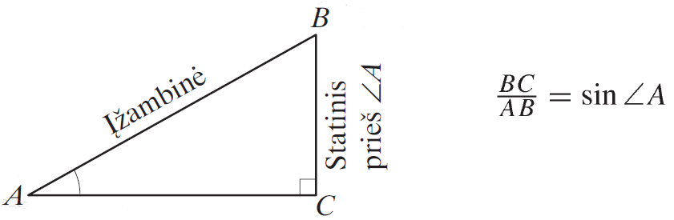
We call the number obtained by dividing the length of the side opposite the acute angle by the length of the hypotenuse the sine (written: sin) of that acute angle.
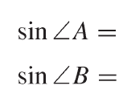
EXERCISE 2
- Write the sine of acute angle B of the triangle ABC.
sin∠A =
sin∠B =
- Calculate the values of acute angles A and B of the right-angled triangle ABC, if BC = 3 cm, AB = 5 cm.
EXERCISE 3
- Draw right-angled triangles Δ ABC (angle C = 90°), for which: angle A = 20°; 40°; 60°; 80°.

- By measuring and calculating, determine the approximate values (to an accuracy of hundredths) of the sine’s of angles A and B of those triangles.
EXERCISE 4
Calculate the sines of the acute angles of the pictured right-angled triangles.
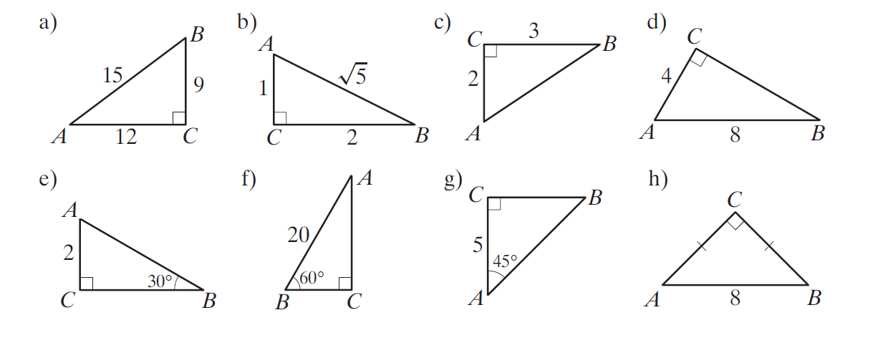

ACUTE ANGLE COSINE OF A RIGHT-ANGLED TRIANGLE
LESSON 2 OBJECTIVES
- will be able to explain what we call the acute angle cosine of a right-angled triangle;
- will be able to calculate the acute angle cosine of a right-angled triangle when the lengths of two sides of a triangle are known;
- will solve at least 3 problems.
EXERCISE 1
- Each pupil draws in his/her notebook a right-angled triangle ABC, in which angle C = 90⁰, angle A = 40⁰.
- Each pupil measures the length of the side adjacent to angle A.
- Each pupil measures the length of the hypotenuse.
- Each pupil divides the length of the side adjacent to angle A by the length of the hypotenuse.
- Each pupil compares the result obtained.
- The results of all pupils should be similar: ≈ 0.8.
Conclusion: The ratio between the lengths of sides AC and AB of the right-angled triangle ABC does not depend on the size of the triangle.
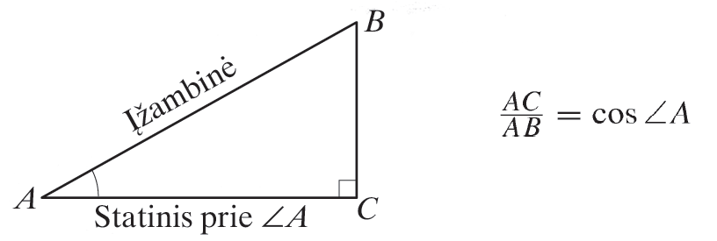
We call the number obtained by dividing the length of the side adjacent to the acute angle by the length of the hypotenuse the cosine (written: cos) of that acute angle.
EXERCISE 2
- Write the cosine of acute angle B of the triangle ABC.
cos∠A =
cos∠B =

- Calculate the values of acute angles A and B of the right-angled triangle ABC, if AC = 4 cm, AB = 5 cm.
EXERCISE 3
Draw right-angled triangles ΔABC (angle C = 90°), for which:
a) cos of angle A = 2/3;
b) cos of angle B = 2/5;
c) cos of angle A = 0.4.
EXERCISE 4
Calculate the cosines of the acute angles of the pictured right – angled triangles.
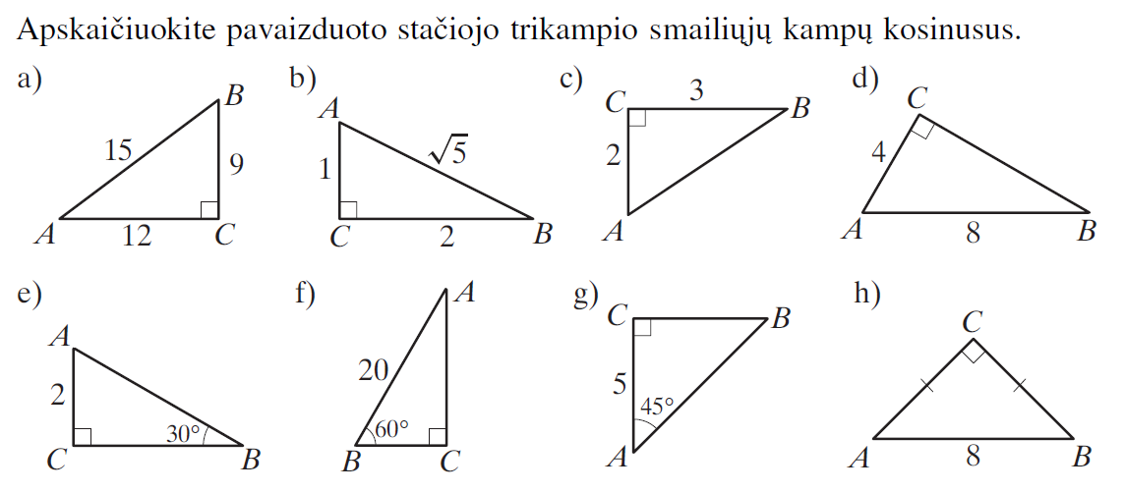

STATISTICS
LESSON 3 OBJECTIVES
- To handle the sample data and to summarize the sample in different ways in calculation of numerical characteristics of the data.
- Systematize and summarize the students' knowledge of statistics.
1. GENERAL SET AND SAMPLE
Every one of us every single day faces the numerical information, tables, diagrams. It is interesting for people to know whether prices of the goods increase or decrease, as well as to know what is the population in the country/city/region. Numeric value – is the data. The study of the collection, analysis, interpretation, presentation, and organization of data is called statistics.
Statistics helps to collect the data, analyze it and draw reliable conclusions. Every research examines particular individuals or a group of actually existing objects, which in statistics is called general set or population. For example, if we are investigating our schools‘ students health indicators, therefore, the population is all students in our school. The population selected for this particular investigation is called sample.
2. FREQUENCY AND RELATIVE FREQUENCY TABLES
While performing statistical experiment we collect the data, which is also called sample, while the number of samples is called – sample size. All collected data can be written in variation, or frequency table.
Variation – is the sequence of numbers, which every number, starting with the second one, is not smaller than the one before it. The simplest method of handling collected data is – making the frequency table. In one line of the frequency table it is written different variation numbers (data), and in the other line – those numbers‘ frequencies (number of repetitions). In statistics relative frequencies are calculated as – frequency is devided by frequency size (Number of data).
EXAMPLE
In the “Shoe” store was performed the investigation - what size of men shoes were sold the most. 20 people were randomly selected, who bought men shoes. Randomly selected men shoe sizes were: 41, 39, 41, 40, 41, 40, 42, 40, 42, 40, 41, 44, 40, 44, 43, 42, 41, 42, 43, 41.
Now we have to make this sample into variation (from smallest to highest number): 39, 40, 40, 40, 40, 40, 41, 41, 41, 41, 41, 41,42, 42, 42, 42,43, 43, 44, 44.
Now we have to make frequency and relative frequency table:
Shoe size | 39 | 40 | 41 | 42 | 43 | 44
Frequency | 1 | 5 | 6 | 4 | 2 | 2
Relative frequency | 1/20 | 5/20 | 6/20 | 4/20 | 2/20 | 2/20

3. DIAGRAMS
Plot shows better sample features than the table, for example: scatterplot, polygon, column chart, bar graph, pie chart.
In scatterplot, in one of the coordinate axis (usually the Ox axis) we set aside data and in the other (Oy axis) - the frequencies. To get the polygon, we connect a finite chain of straight line segments of scatterplot. If we draw rectangular on the scatterplot we get the collumnchart. If we draw rectangulars in contact, which heights are equal to freqencies (relative freqeuncies), then it is called a histogram. While portraying the pie chart, the pie is devided into cuts, which area is proportional to data frequencies.
EXAMPLE
John picked ten of his friends birth month numbers and got this sample:
1, 2, 1, 3, 4, 6, 3, 1, 6, 11.
Now we have to make a variation:
1, 1, 1, 2, 3, 3, 4, 6, 6, 11.
Now we make a table:
Month | 1 | 2 | 3 | 4 | 6 | 11
Frequency | 3 | 1 | 2 | 1 | 2 | 1
One of the simplest way to show graphical data is – column chart. Now we make a column chart using the data from the table above:

Now we have to draw the piechart using the sample above. Since there are 10 numbers in total, one of the numbers is equal 360°/10 = 36° cut edge. Before making the pie chart it is easier to make a table like that:
Month | 1 | 2 | 3 | 4 | 6 | 11
Frequency | 3 | 1 | 2 | 1 | 2 | 1
Cut egde size | 36° ∙ 3 = 108° | 36° ∙ 1 = 36° | 36° ∙ 2 = 72° | 36° ∙ 1 = 36° | 36° ∙ 2 = 72° | 36° ∙ 1 = 36°

4. NUMERICAL DATA CHARACTERISTICS
Sample data can be described when showing mean, median and mode.
Example. During the physical education boys were pulling-up to the bar. Teacher gave results as follows: 4, 8, 9, 8, 5, 5, 8, 9, 8, 10. What is the mean, median and the mode of these results?
Mean – sample data amount, devided by the number of data.
Add each value of each observation and then devide by total number of observations. Therefore, the mean is: (4+5+5+8+8+8+8+9+9+10) / 10 = 7,4.
Sample width – the difference between the largest and the smallest sample data.
Sample data is written in variation: 4, 5, 5, 8, 8, 8, 8, 9, 9, 10. This is sample width: 10 – 4 = 6.
Median (Md) – it is the middle number of variation, when sample size is uneven number, or the arithmetical average of two middle numbers, when sample size – is even number.
Given sample size – is even number, that is why median will be equal to the arithmetical avarage of two middle numbers: (8+8) / 2 = 8.
Mode (Mo) - Any value that appears more than once will be the mode. If there are no duplicate values in the sample, so there is no mode for that data set.
EXERCISES
1. The survey was conducted on 30 students and the results were that: 12 of them attending basketball; 3 – football; 6 – swimming; 3 – light athlete; and the rest of the students do not excersize at all. Using these results you have to make a respective diagram.
2. Students were asked how many hours do they exercise a day, and the results were as follow: 1; 0,5; 2; 1; 0; 1,5; 1,5; 1,5; 0; 0; 1,5; 1.
a) Make a frequency table
b) What is the mean, median and mode?
3. Odeta was observing the decrease of the currency for the entire week. What kind of diagram would be most respective in this case?
4. 30 people of different age gatherd for John‘s family celebration. Children made one quarter of all people. Draw the pie chart of how many children and how many adults were in this event?

Workshop 1. SOLAR GEOMETRY
OBJECTIVES
- Determine the elevation angles at which the sun’s rays reach the surface of the Earth in Utena, Lithuania, at solar noon at the times of an equinox and a solstice.
- Determine the elevation angles at which the sun’s rays reach the surface of the Earth in your town, (country), at solar noon at the times of an equinox and a solstice.
STEPS
- Find latitudes
- of Utena, Lithuania φ₁=
- of your town φ₂=
with google maps MONDECA. Go to http://mondeca.com/index.php/en/any-place-en
- Calculate these latitudes at the Vernal and the Autumnal Equinox using the formula:
α_{v} = 90º - φ₁ = and α_{a} = 90º - φ₂ =
- Calculate the elevation angles of these latitudes at the Summer and Winter Solstice using the formula:
α_{s} = 90º - (φ₁ - δ) = and α_{w} = 90º - (φ₁ - δ) = ,

α_{s} = 90º - (φ₂ - δ) = and α_{w}= 90º - (φ₂ - δ) = ,

The Sun‘s declination angle δ=23,5° on the day of the Summer Solstice, the sun is above the horizon for the longest period of time in the northern hemisphere.
The Sun‘s declination angle is δ = – 23.5° on the day of the Winter Solstice.

α_{summer} = 90º - (φ₁ - 23,5º) =

α_{winter} = 90º - (φ₁+ 23,5º) =

- Create a Sun path diagram for Utena, Lithuania and for your town using programme:
http://solardat.uoregon.edu/SunChartProgram.html
In the diagram below, the azimuth and solar elevation angles are the coordinates of an observer's local horizon system in any specified location on Earth at any specified time of the year.
Save this diagram to your setting.

- Conclusions:

Workshop 2. SOLAR SHADOW GEOMETRY
The azimuth is the local angle Α between the direction of due North and that of the perpendicular projection of the Sun down onto the horizon line measured clockwise. Thus, we have the azimuth values: 0° = due North, 90° = due East, 180°= due South, and 270° = due West.
The angle of solar elevation, α is defined as before, to be the angular measure of the Sun’s rays above the horizon. Equivalently, it is the angle between the direction of the geometric center of the Sun and the horizon.
OBJECTIVES
Determine the tip of the 3 pillars of the shadows at the point P = (x_{o}, y_{o}). That is x_{o} (m) Eastward and y_{o} (m) Northward of the base of the post.
STEPS
- Identify use a compass North-South.

- Estimate:
- the solar elevation α_{ο}

- h (m) height of the pillar h=

- azimuth Α =
- Calculate the shadow of the pillar OP by formula OP = h/tan α_{ο}.
- By analyzing the right triangle, △ORP, we find the points of the x_{o} (m) and y_{o}(m) using the formulas as well:

sin (Α_{ο} – 180° ) = x_{o} /| OP |
x_{o} = |OP| ⋅ sin( Α_{ο} – 180° ) m.
cos (Α_{ο} – 180° ) = y_{o} / OP
y_{o} = | OP | ⋅ cos (Α_{ο} – 180° ) m.

Results

P1 = (......, .......)
P2 = (......, .......)
P3 = (......, .......)
- Look at these pictures. What is the difference between them?
- Calculate the shadow of the pillar OP by formula OP = h/tan αο.
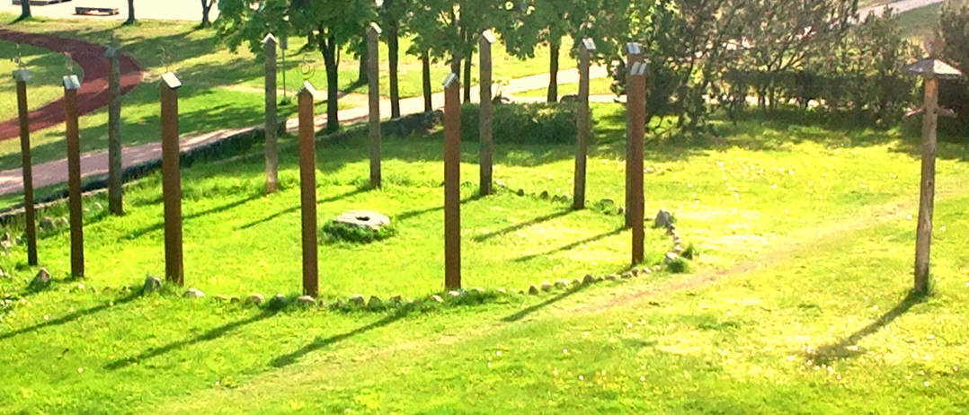
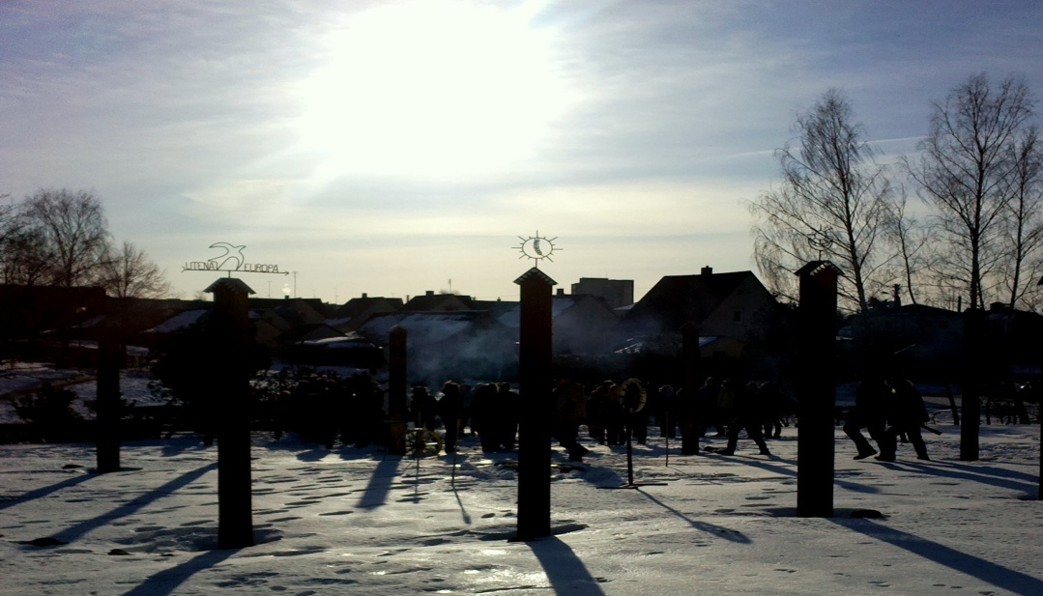
- Measure the length of the shadow using a ruler. The results are:

1OP = … 2OP= ……..

- What is the approximate time in the pictures below according to the angle of solar elevation? Remember that the hour angle increases by 15 degrees every hour.

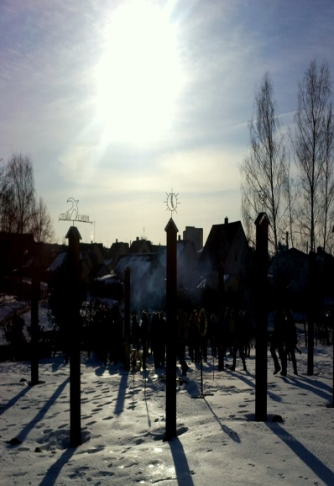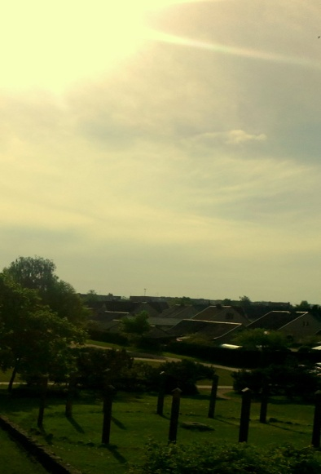

- Conclusions. Answer and finish: why are the solar shading measurements important?
- The position of the sun in the sky is determined……………
- Shadow thermometer serves as a………………………………….
- The length of the shadow can be set……………………………..
Workshop 3. SUNSPOTS ESTIMATION ON ASTRONOMY & STATISTICS
PROBLEM

Solar activity affects the Earth in many ways: damage to 21st-century satellites and other high-tech systems in space can be caused by an active Sun, radiation hazards for astronauts and satellites can be caused by the quiet Sun, weather on Earth can also be affected. We must observe activity on the surface of the Sun every day.

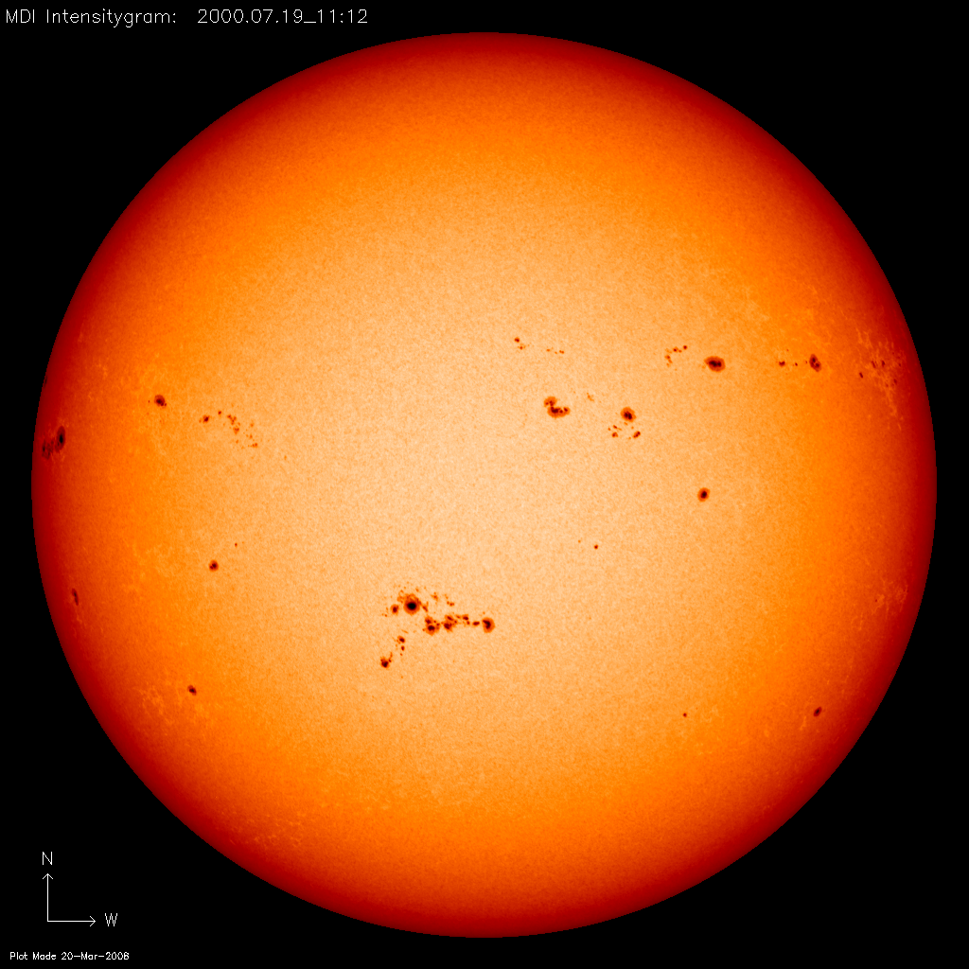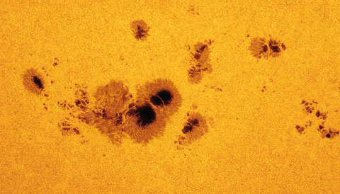
OBJECTIVES
- Create graphs of sunspots data for diffeent periods of time using statistics of math.
- Make predictions on the future solar activity using data sets recorded over the time scales.
STEPS
- Find out about the Sunspot Number at sunspotshttp://www.sidc.be/silso/datafiles
- Open the link Daily Estimated Sunspot Number CSV file nameEISN_current.txt.

EISN_current.txt Contents:

Column 1: Gregorian Year
Column 2: Gregorian Month
Column 3: Gregorian Day
Column 4: Decimal date
Column 5: Estimated Sunspot Number
Column 6: Estimated Standard Deviation
Column 7: Number of Stations calculated
Column 8: Number of Stations available

- At the Column 5 you will find estimated sunspot number.
- Make a table:
Sunspots numbers per month
Frequency of sunspots
- Make a column chart using the data from the table above: x (Frequency) and y (Sunspots numbers per month)
- Create graphs of data sets for different periods of time: one week, one month, one year
http://www.sidc.be/silso/eisnplot
and five years http://www.sidc.be/silso/IMAGES/GRAPHICS/prediSCCM2.png
- Measure and Record: pick data sets for each range from periods during the solar minimum, maximum and at some point mid-cycle for one week, one month, one year, five years.
- Where can you see the mean, median and mode in graphs of sunspots data for different periods of time: one week, one month, one year?
- Make predictions on future solar activity from 2017 to 2020.
- Open the link http://www.sidc.be/silso/monthlyssnplot and make a conclusions:
- about Sunspots Cycles,
- about Solar Activity forecasts for 2016;
- about Solar Activity Effect on Weather and Earth for 2016.
- Can we make predictions on future solar activity using the data sets recorded over the smaller time scales (i. e. one week, one month, one year)?
- Can we make predictions on future solar activity using the data sets recorded over larger time scales (i.e. fifty years, one hundred years)?
- Using the whole data set predict when the next maximum will occur.
- Investigating solar variability can:
- Enable the prediction of ......................................
…………………………………………………………………………
…………………………………………………………………………
- Help us understand how solar variability ...........
…………………………………………………………………………
…………………………………………………………………………
- Protect ................................................................
…………………………………………………………………………
………………………………………………………………………..

CUBIC MILE UTENA
The main purpose is: Get to know Utena city better while visiting famous places.
Visit particular objects, take a picture or make a video of it to proof that you were there (>1,5 min), and on Tuesday 9am there will be a presentation (Kizoa or MovieMaker etc. program):
- Go to “Vyzuonos” park:
- When Utena was built?
- Go to art school:
- Why this building used to be important a long time ago?
- Which famous places the road next to art school connected couple centuries ago?
- Go to “Utenis” square:
- Name all the main objects in Utenis square.
- What events take place in this square?
- Go to “Maironis” street:
- Name the main objects in this street
- Find the café next to the place you are right now and order something delicious.
DO NOT FORGET TO SAVE THE OBJECTS THAT YOU WILL SEE IN THE FORM OF PHOTO OR VIDEO AND DO NOT FORGET TO ANSWER THE QUESTIONS!
REFERENCES
http://www.schoolsobservatory.org.uk/activ/sunspots
http://mypages.iit.edu/~maslanka/SolarGeo.pdf
http://www.sidc.be
http://www.etnokosmomuziejus.lt/en/
www.vu.lt

NOTES

NOTES

Romania
Colegiul Tehnic "Ana Aslan" Cluj-Napoca
Denmark
Borupgaard Gymnasium
Greece
Geniko Lykeio Agrias
Hungary
Petrik Lajos Két Tanítási Nyelvu Vegyipari, Környezetvédelmiés Informatikai Szakközépiskola
Italy
Liceo Scientifico Statale "B. Rosetti"
Poland
Zespół Szkół w Głogowie Małopolskim
Portugal
Agrupamento Escolas Anselmo de Andrade
Lithuania
Utenos Dauniškio gimnazija

