Feedback, observations and comments on ‘Digital Europeans’ meeting between IIS Panzini, Italy, OSAO Finland and Vrij Technisch Instituut Voorzienigheid, Belgium
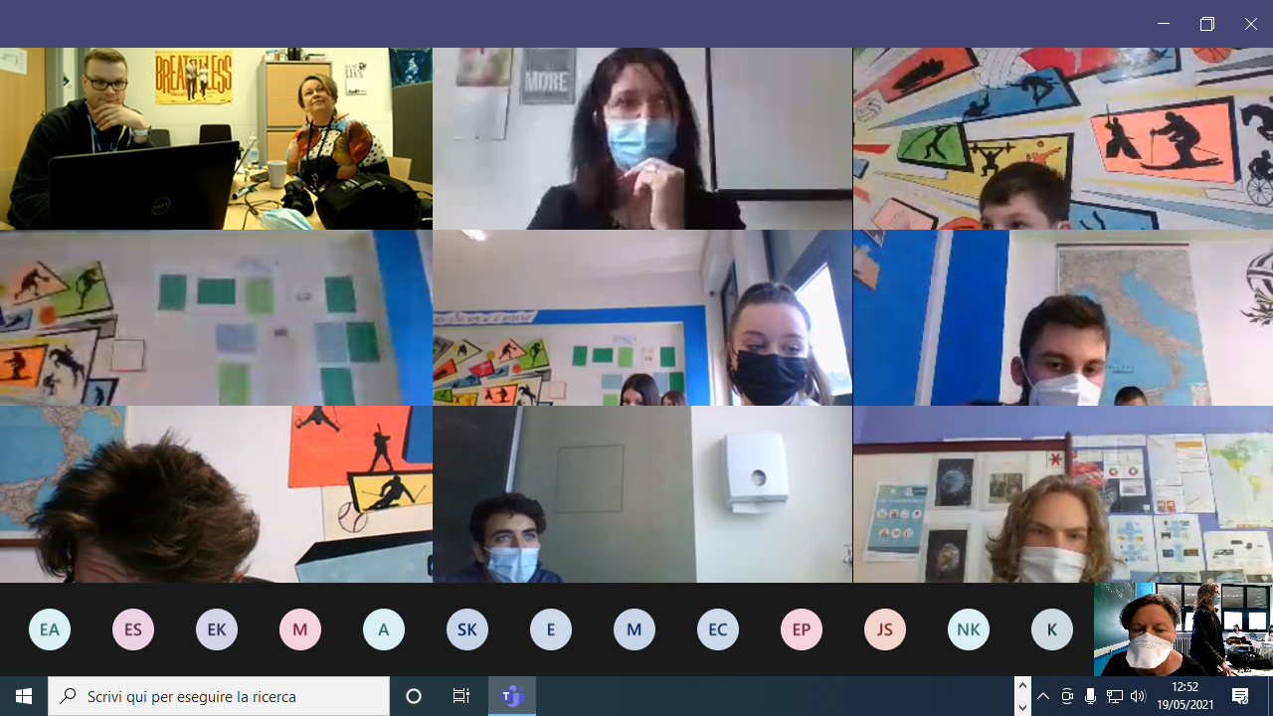
On 5th and 19th May 2021 we organised two meetings with teachers and students from Italy, Finland and Belgium.
The first meeting was only Finland and Italy and in the second meeting we were joined by Belgium too.
Considerations on the positive side:
- Students were curious and enjoyed the meetings
- An opportunity for really speaking English and communicating with peers
- Meetings were short and sweet- about 45 minutes
- It was an intercultural experience- eg- they asked me ‘What language is this link?’- It was the link from Finland
- Using different platforms- Google Meet and Microsoft Teams

Considerations on the negative side:
- It takes quite a lot of organisation ( although well worth it)
- We are so busy in schools it seems like a miracle that we managed just these two meetings (the teachers involved all had other bookings and had to juggle to fit in just these two).
- bad audio- echo- sometimes no sound
- students are shy so good that we had more than one meeting, but it seemed like they were just getting acquainted and would have liked more

Conclusions
- We are teachers not technicians so I feel like more training needed to reach better levels of digital participation ( Perttu an exception so feeling very grateful he was organising this second one)
- Maybe we could plan more than 2 meetings in the future
- Maybe a more select number of students

Quote from the original project aims page 4
‘Another important aim of the project is to develop a teacher training programme that can be used and adapted on a long-term basis.
The future of teaching and learning will be influenced by digitalization and artificial intelligence. To prepare Europe for this challenge, educational institutions will have to cooperate to develop new
ideas and concepts. The project “Digital Europeans“ intends to support the partner schools and other European educational institutions in this process.’

This is pre- Corona but now seeems absolutely essential and we can work on this. We can Exchange skills between each other. Each partner country prepares one lesson. 2021 2022- an idea we could propose to Barbara?????

