APOLLO FOUNTAIN
There are 7 fountains on the Paseo del Prado pedestrian street in Madrid. One of them is the Fountain de Apollo standing a bit off the beaten track, and therefore less known.
Is a statue of Apollo, God of the arts, medicine, and poetry, and enemy of darkness.
The architect of this monument was Ventura Rodriguez.
The construction of the fountain began in 1780 during the reign of Charles III and completed in 1802.
The author of the Apollo sculpture is Alfonso Giraldo Bergaz.
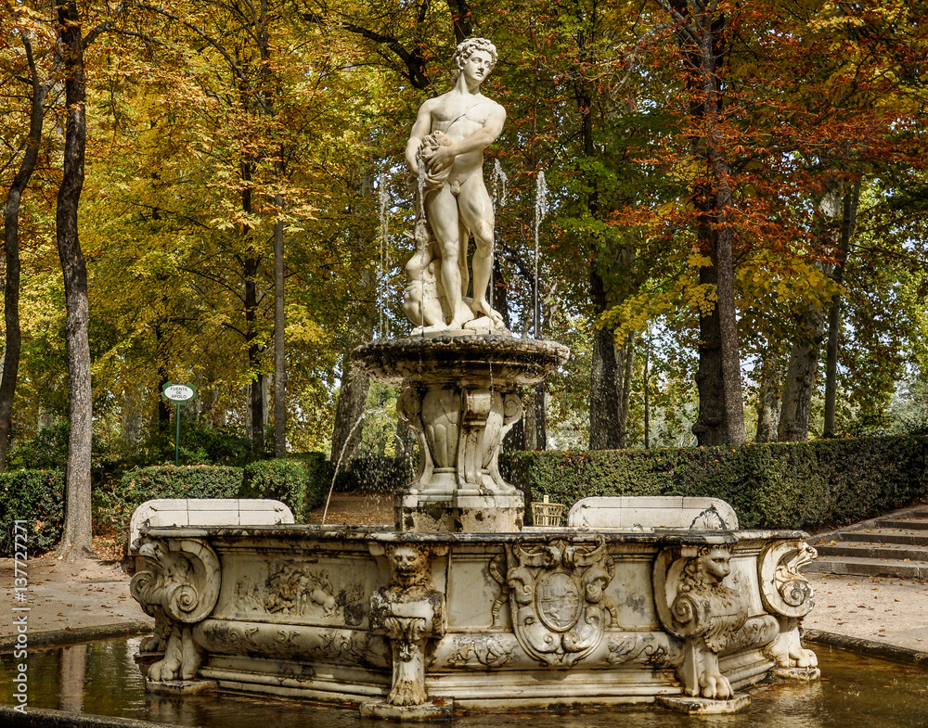

NEPTUNE FOUNTAIN
The Fountain of Neptune is a neoclassical fountain located in Madrid, Spain. It lies in the centre of the Plaza de Cánovas del Castillo, a roundabout in the Paseo del Prado.
It was designed by Ventura Rodríguez, and the sculpture is made of white marble. The sculptural works began in 1781. Following the master's death in April 1784, the fountain was finished in October 1786 by his disciples.
The fountain is formed by a circular pylon with the sculptural group in its center that represents Neptune, a Roman water deity. The crowned Roman god wields a trident with one hand while he grabs a sea snake with the other hand and it has a maximum water capacity of 305 m³.
An interesting fact about this fountain is that it’s the site where Atlético Madrid's fans celebrate the team's trophies.
