Cibeles fountain

Cibeles fountain is one of the main symbols of the change that Madrid experienced in the 18th century under the principles of the Illustration period brought to the Capital by Carlos III.

Nowadays it stands like one of the most important symbols of the City.

The fountain of Cybele is found in the part of Madrid commonly called the Paseo de Recoletos.

This fountain is named after Cybele, a Phrygian goddess of the earth, agriculture and fertility in her chariot pulled by lions. In her left hand she holds the key to the city.

The fountain is traditionally the place where Real Madrid C. F. celebrate their team victories, with the team captain placing a Real Madrid flag and palace scarf on the statue.

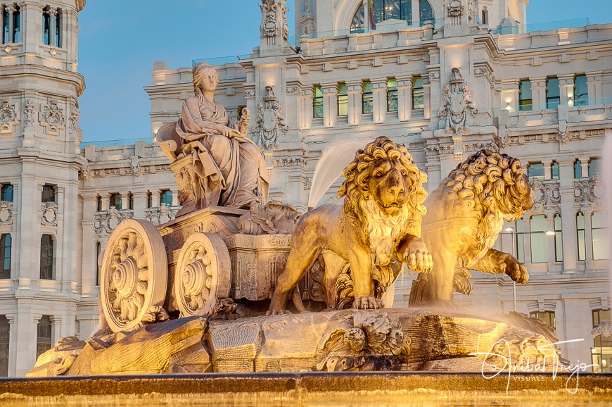

Cibeles Palace

The old Palace of Communications is a monumental building that since 2007 has been the headquarters of the Madrid City Council. Designed and built by Antonio Palacios and Joaquín Otamendi as the headquarters of the Spanish Post and Telegraph Society, it was inaugurated in 1909. In 1993, it was declared a Site of Cultural Interest with a Monument category.

The building represents the union of tradition and modernity. Built in stone, iron and glass, the Palacio de Cibeles sits on land that had housed the old recreational gardens of El Buen Retiro.
The building is divided into different spaces:The old Post and Telegraph Operations Courtyard. The old chapel of the Palace. The Music Box Auditorium. And there is also a restaurant in the palace and a terrace with good views of all of Madrid.

