Lesson plan 2
Traditions and customs in the Czech Republic: Easter
Lesson target: presentation of the typical Czech Easter traditions different from other countries
vocabulary work
development of the group cooperation, creativity development

Warm-up: divide the students into groups – ideally 3-4 students in each group
show the two pictures from the attachment, every group tries to answer the following questions:
What do you think is in the picture? What might the Czech word „pomlázka“ mean? Are the eggs in the picture real / chocolate / plastic? Are coloured eggs an Easter symbol in our country as well?

Step 1: watch the video on YouTube (twice)
https://www.youtube.com/watch?v=pIV24wtLs_U&ab_channel=CzechCenterMuseumHoustonCCMH
answer the questions (the attachment Worksheet) based on the video, other questions about Easter in your country can be added
students work orally, but it is definitely recommended them to take simple notes
students from each group make a short presentation of Easter in the Czech Republic
Step 2: creative work: students are given plastic eggs / eggs cut out of paper and equipment for colouring the eggs (water colours, paints, crayons…), ribbons
each student creates their own Easter egg

Conclusion: Short discussion: Would you like to experience Czech Easter, why / why not? Are there any similar traditions or customs in the countries? What is the most surprising / funniest / craziest about Easter time?
Attachment: worksheet, pictures

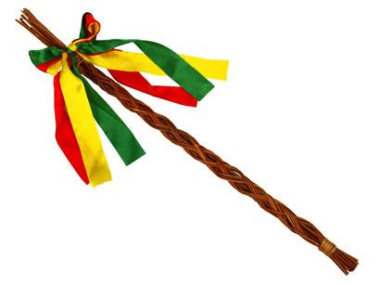

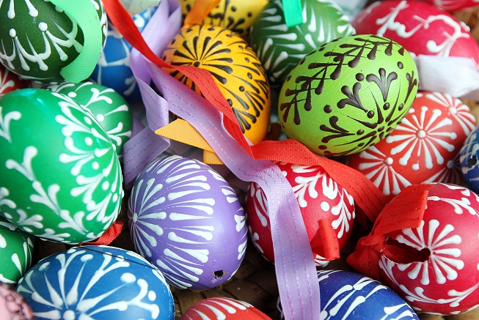

Worksheet: Questions for groups to the video:
What do the Czech women and girls do at Easter? Do you have such a tradition in your country?
What is „pomlázka“? What is it made of?
What do the men and boys do with it and why?
What is the reward for them?

Do you prepare any special Easter meal in your country?
What do you consider best about Easter?
Which traditions are connected to Easter in your country?
Have you got any days off at Easter?

