Lesson Plan: Preparation of a Traditional Maltese Snack

Objectives:
The students will be able to:
- Recognize and name traditional Maltese foods.
- Identify particular ingredients which are staple in a Maltese food diet.
- Prepare and serve a traditional Maltese lunch and/or snack.

Materials needed:
Ingredients needed | Equipment needed
Local crusty bread | White chopping board
5 tbsp tomato paste/ 2 fresh tomatoes | Bread knife
Drizzle of olive oil | Butter knife
1 can tuna | 1 tablespoon
3 tsp butter beans in garlic | 3 teaspoons
2 tsp capers | Can opener
2 tsp olives | Plate
Handful of lettuce leaves | Vegetable knife
5 basil leaves | Apron
1 tsp pickled vegetables | Cap
2 slices onion | Recipe in a plastic folder
Sea salt and pepper | Tea towel

Prior the lesson/ At-home tasks:
- Use one of the video links below as introduction of the lesson.
- Divide the class in groups of four and ask them to carry out some background research on traditional Maltese food. Emphasize that research should be done on ‘Traditional Maltese Ftira’ in particular.
- Distribute the handout attached and ask pupils to fill in all the information except for the evaluation (which is to be carried out after the practical session).
- Discuss findings with the class.
Practical Session:
- Distribute recipe of ‘Traditional Maltese Ftira’ in a plastic folder.
- Ask students to wear apron and cap. Wipe surface top and wash their hands.
- Explain the function of the ingredients and equipment present on each work space.
- Using a chopping board, peel and slice the onion. Chop the remaining ingredients and rinse the capers and olives under fresh water.
- Instruct pupils to slice the bread on a chopping board using a bread knife and spread either tomato paste or fresh tomatoes on the bread.
- Slice the lettuce and place on the bread. Top with the remaining chopped ingredients and season to your likings.
- Wash up all the equipment and cutlery. Place everything back in place.
- Every student is to carry out a self-evaluation. This can be done either verbally or in a written format, as per handout attached.
Evaluation:
Each student needs to carry out a self-evaluation on the practical session in which the following factors should be noted and discussed:
- Judgement on the overall performance;
- Appropriate identification of strengths and weaknesses;
- Considerations given in the use of time;
- Handling of tools,
- Adherence to rules concerning safety, hygiene and sustainability.
- Recommendations for improvement on performance in the practical session.

Resources:
- https://teleskola.mt/l-ikel-tradizzjonali-malti-traditional-maltese-food/
- https://www.youtube.com/watch?v=ccLe5eaO8ls
- https://www.youtube.com/watch?v=2YFlLXOcISY

Name: _ Class:

Practical Assignment:

Dish Chosen:

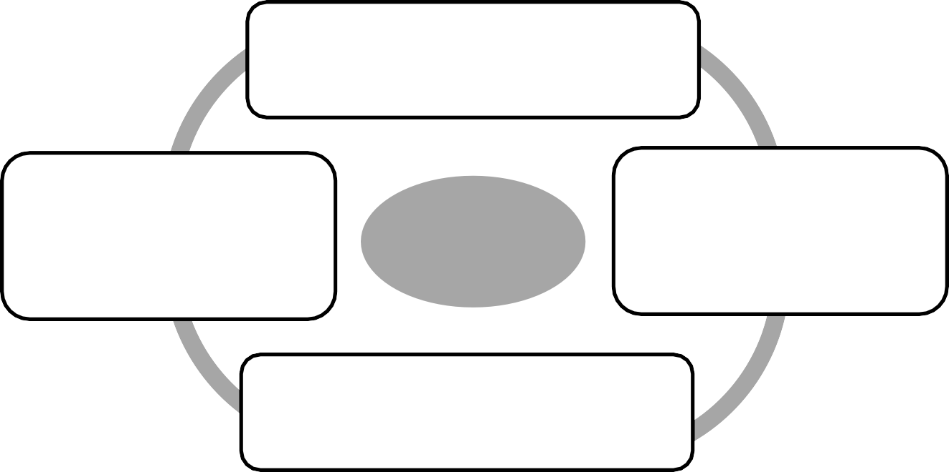
Reasons for
Choice

Ingredients | Utensils/Equipment | Electrical Appliances

START

Wear apron and hat. Wash hands and wipe surface.
Collect my ingredients and equipment.

Do the washing up. Prepare the table. Serve the food.

End

Quantities | Shopping List  (main ingredients) | Approx. Cost
 |  | TOTAL €

N.B. The preparation sheet can be adapted according to the students’ needs and levels.

1. Reasons for choice and Flow-Chart:
My reasons for choice:
Very good: Could be better:
Good: Not done:
2. Preparation: Self
Apron: Cap/Scarf: Jewellery:
Equipment
Collected all equipment: Collected some equipment: Equipment not collected:
Ingredients
Collected all ingredients: Collected some ingredients: Ingredients not collected:
3. Organisation:
My work area:
Well organised: Organised: Disorganised:
4. Hygiene in the Food Lab:
Food covered: Sink kept clean:
Washing-Up: Cooker kept clean:
Spills wiped: Disposal of Waste:
5. Safety in the Food Lab:
Kitchen equipment was used safely:
Kitchen equipment was not always used safely:
6. Cooking Skills:
My cooking skills were very good: My cooking skills were good:
My cooking skills were not good:
7. Time Management:
I used the time available well:
I did not use time available well: I did not finish my work on time:

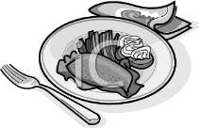

8. Presentation:
Finished item/s was/were presented in an interesting way: Finished item/s was/were presented in a satisfactory way: Finished item/s was/were unsatisfactory:
9. Evaluation:

Strengths – my good points:
•

•

Weaknesses – not so good points:

•

•

_

If I were to do it again I would:

•

•

N.B. The self-evaluation sheet can be adapted according to the students’ needs and level

