Traditional cuisine:

Malta:
- Pasttizi
- 500g of flour, 250ml of water, salt and 100g of butter or puff pastry.
- 200g of ricotta cheese.
- 2 eggs.
- A bunch of spinach.
- An onion.
- Olive oil.
- Salt.
- Pepper.
- Parsley
- .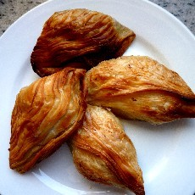
- Torta tal lampuki
- 2 Acqua e Farina- Sfoglia pastry
- 750g filleted lampuki
- 250g tomatoes,peeled and chopped
- 250g cauliflower,boiled
- 250 tomato puree
- 250g onions,chopped
- 200g spinach
- 150g peas
- 100g FOS black kalamata olives
- 4 garlic cloves chopped
- 2 eggs
- 1 egg beaten
- golden drop olive oil
- lemon zest
- mint
- marjoram
- sesame seeds

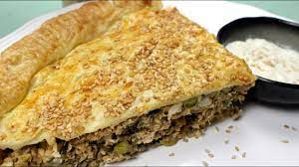

Spain:
- Potato omelette
- Potatoes
- Eggs
- Onion(optionally)
- Salt
- Olive oil
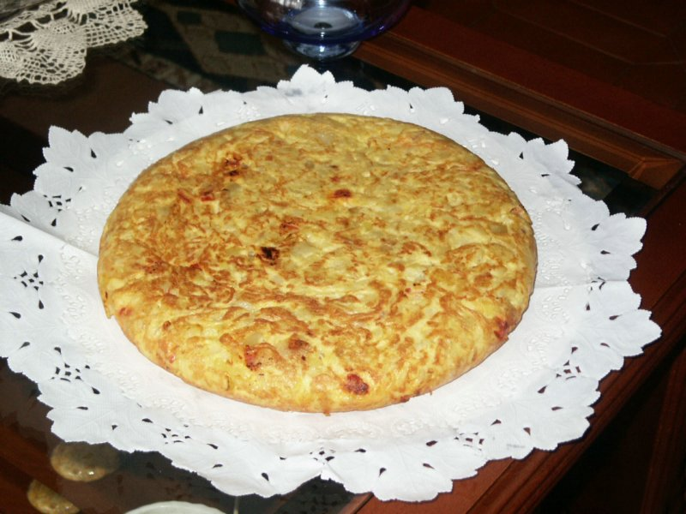

- Croquetas de jamón:
- Serrano ham
- Bread crumbs
- Eggs
- Bechamel
- Flour
- Sunflower Oil
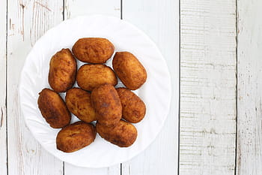

Czech Republic:

- Svíčková
Svíčková, is a Czech meat dish and one of the most popular Czech and Slovak foods. It is a tenderloin prepared with vegetables, seasoned with black pepper, allspice, bay leaf and thyme, and boiled with cream. It is usually served with houskové knedlíky.

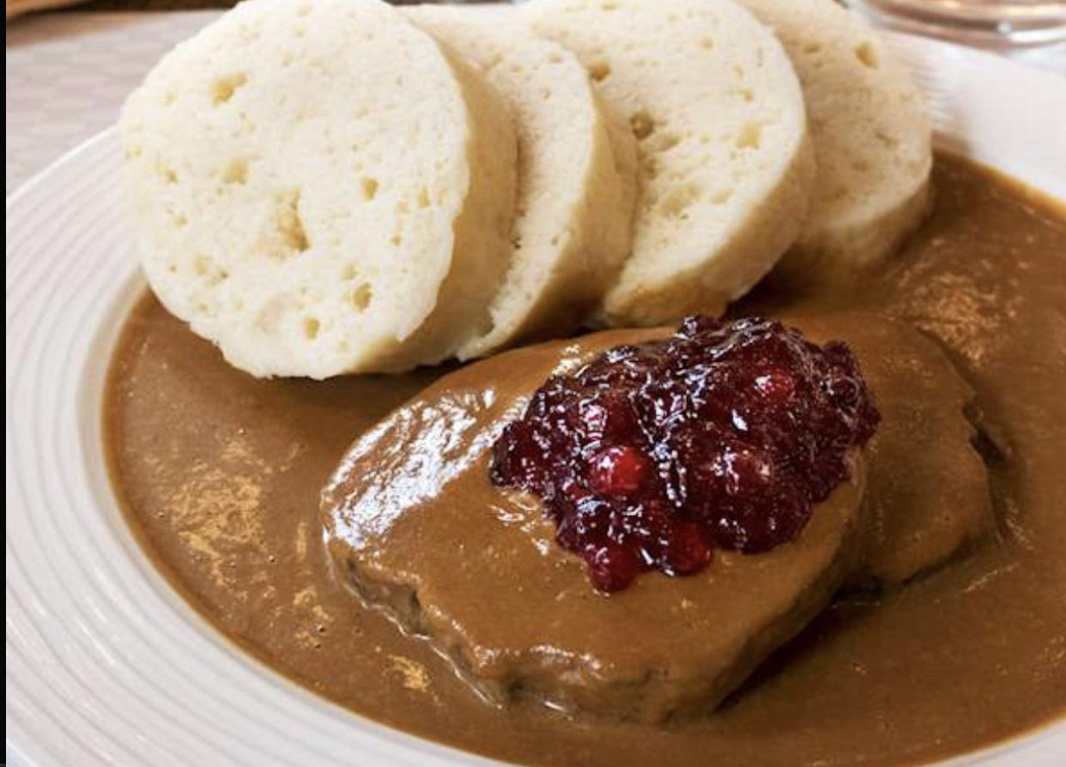

Řízek
- Řízek is the Czech version of the famous Austrian Wiener schnitzel, consisting of thin, tenderized pieces of meat that are coated in a combination of breadcrumbs, flour, and eggs. The meat is then gently fried in oil or butter.

- The Austrian version is exclusively made with veal, and it is one of their unique delicacies. The Czech interpretation is only occasionally made with veal, and more commonly employs pork chops or pork cutlets.

