LESSON PLAN : Famous painters in the Museo del Prado

Objectives:
- Basic information about three famous painters in the Museo del Prado.
- Getting to know how to describe a painting: Analyze three paintings of the Museo del Prado.
- Jheronimus Bosch . The Garden of the Earthly Delights

Goya.The Third of May Shooting

Velazquez. Las Meninas
- Develop the group cooperation
Warm-up:

How would you paint the seine?

https://www.wikiart.org/en/hieronymus-bosch/the-seven-deadly-sins-and-the-four-last-things-1485

How would you draw nonsense?

https://www.wikiart.org/en/francisco-goya/all-works#!#filterName:all-paintings-chronologically,resultType:masonry

How would you depict dignity?
https://www.wikiart.org/en/diego-velazquez/don-sebastian-de-morra

Paintings:
- Jheronimus Bosch . The seven deadly sins and the four last things, 1485

Goya. The sleep of the reason produces monsters, 1799

Velazquez. Don Sebastián de Morra, 1645

Genius!!!! right????

But that is just a little bite of their geniality!!! Let's discover a bit more….

Exercise 1

Diego Velázquez de Silva - Las Meninas
https://www.sothebys.com/en/videos/why-diego-velazquezs-las-meninas-is-one-of-the-most-important-paintings-in-art-history

Answer the following questions:

- Title of the painting:______________________________

-How many focus points does the painting have?______________(number)

-Where are the characters looking? ______________________

-Where does the light come from?______________________

Working with the perspective

Jheronimus Bosch- The Garden of the Earthly Delights
https://www.youtube.com/watch?v=zD_nwg9CMzw

The tryptic has been thrilling audiences ever since… what is your opinion?
________________________________________________________
What does the exterior panel show?___________________________________________
Is there any symbol? What does that represent?__________________________________________
- Left panel depicts:___________________
- Central Panel Shows:________________________________
- Right panel represents:____________________________

It has inspired: ________________

Working the movement and colors. Iconography

Goya-The Third of May Shooting
https://www.youtube.com/watch?v=bIUA74w1tSU

Who is the main character? _____________________________________________

Is he a coward? Is he brave?

How do you feel after looking at the painting?
____________________________________________________________________

Working the light and the meaning

How many feelings can be on a painting?!!

Exercise 2

In groups check the following webs and look for feelings.
Write the name of the painting net to the feeling it is better represented:

https://www.wikiart.org/en/francisco-goya
https://www.wikiart.org/en/hieronymus-bosch
https://www.wikiart.org/en/diego-velazquez

Examples:

Joy: breakfast 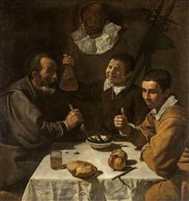 Velázquez
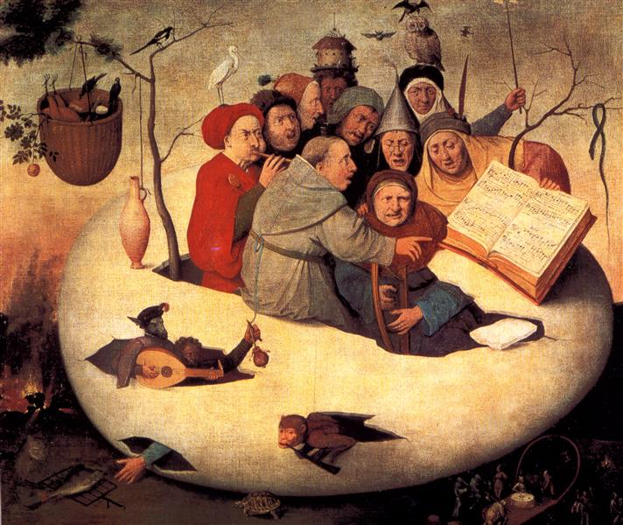
awkward: The Concert in the Egg Bosh

Fear: 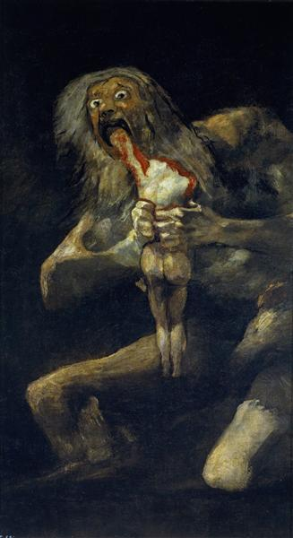 Saturn Devouring One of His Sons - Goya

