-Malta-

-Maltese rabbit stew:
This stew comes from the 14th century, and was published in The Forme of Cury during this time as a recipe for stewed hare.
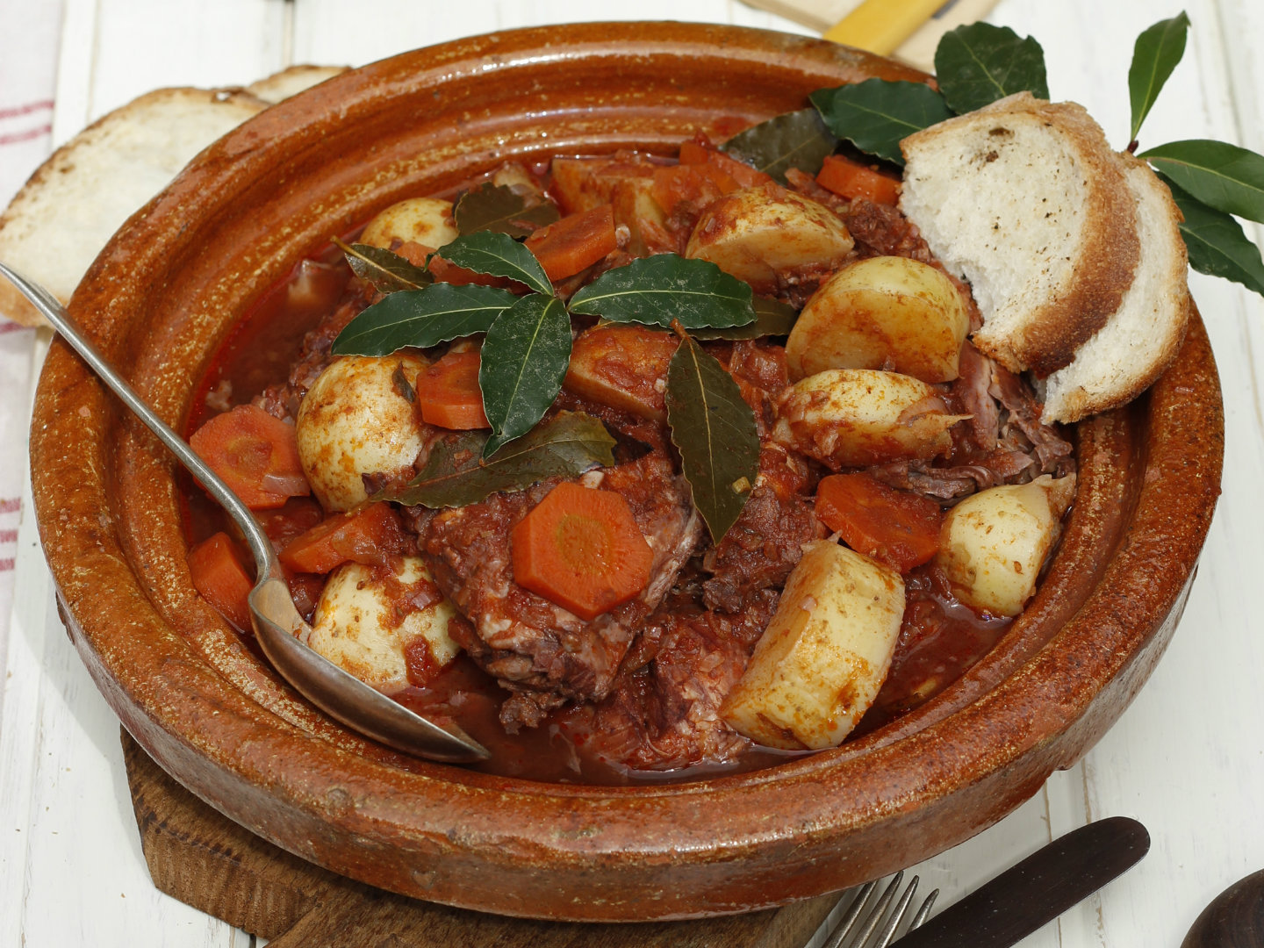

Ingredients: Rabbit, carrots, onion

-Maltese timpana:
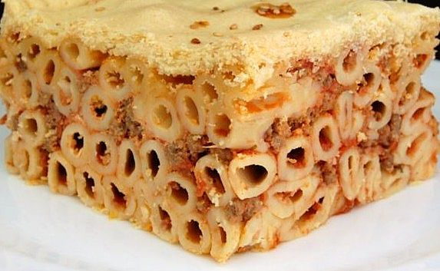
Timpana is a traditional Maltese baked pasta pie made of rigatoni, bacon, hard-boiled egg and minced meat.

-Spain-
-Fabada:
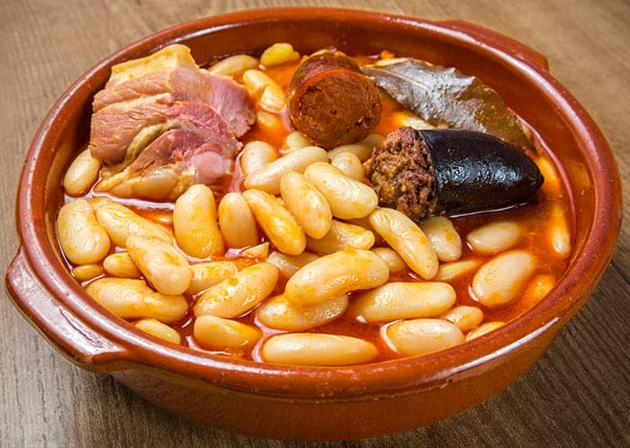
It’s a bean based meal that comes from the region of Asturias.

Ingredients: Faba asturiana, chorizo, black pudding and other pork meat

-Spanish torrija:
It’s a sweet dessert eaten during Easter made of fried bread soaked in milk.
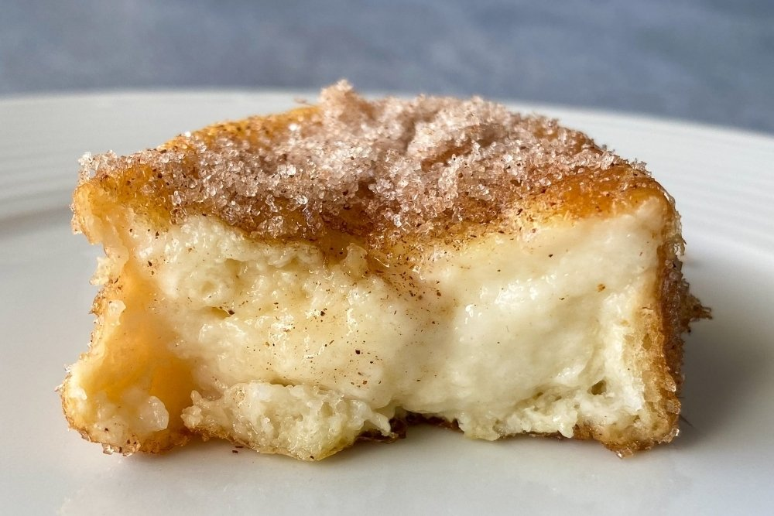

Ingredients: Bread, milk, sugar and cinnamon

