CLASSICAL MYTHS

IN MADRID
  - Lesson plan

introduction
WHAT IS A MYTH?
A myth is a set of stories, tales or popular narratives that build a tradition and a cultural or religious identity. All civilizations have their myths: Greece, Rome, Scandinavia, Japan. The main characters in myths are gods, demigods, and other supernatural figures. However, others also include humans, animals, or combinations in their classification of myth.
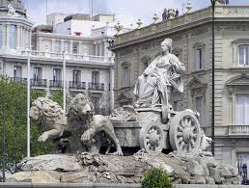
The fountain of Cybele, Madrid
This lesson aims to associate art, culture and society through basic notions of mythology. Students must research, write and present the result of their work in class.

Objectifs and materials
Following these instructions, everything will be fine.

What am I going to discover?
Through a virtual walk through some monuments of Madrid, students will be able to acquire notions of mythology and art, mechanisms of myth in society, and, why not, some interesting places in Madrid.

What will I need to do it right?
We will only need usual tools: paper, pens and a computer connected to the Internet. And above all, curiosity, attention and desire to work.
Remember that learning and teaching are the same activity.

PROCEDURES
All students will see some slides or a video about classical sculptures in Madrid.
Next, in groups, they will look for information about the main mythological figures according to their qualities: power, intelligence, evil, goodness. With the essential data, you have to compare an ancient myth with a current figure of sport, culture, science,...
The result will be an article, a video or slides that the students will present to their classmates.

The role of the teacher
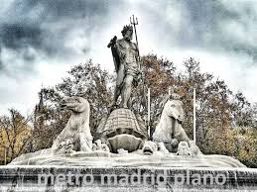
Fountain of Neptune, Madrid.
Some interesting links
https://www.youtube.com/watch?v=JJ7BBjoXa14

https://www.esmadrid.com/en/mythological-madrid

https://www.youtube.com/watch?v=NgeWSEqjPuY

Before the activity, the teacher will present a generic document about “Classical myths in Madrid” that will give clues on how to work.
During the investigation, the teacher will advise the students about the method, the documents, the expression and the public presentation.
The teacher will evaluate during the process so that the result is adequate.

the role of students
Students must show autonomy in the search for data, links and useful documents.
It is important that they distinguish between the quality of the materials found: what is essential and what is accessory?
Students will know how to evaluate their own work, evaluate that of their classmates and accept the comments received.
The evaluation criteria are: interest in the content, clarity of the presentation, response to questions.

