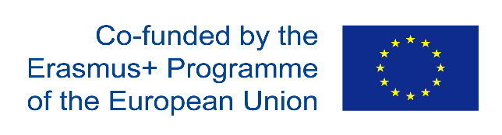

Evaluation Form – Meeting in Nachod 15th-17th November 2022

C1- Erasmus+ Short-term joint staff training event – Preventing dropping out: methodological approaches to motivate students to continue studying
Erasmus+ Project No: 2019-1-CZ01-KA229-061113 / Project title: European Citizenship – Cultural heritage unites us

QUESTIONS:

Preparatory work | yes | no | Comments
Was sufficient information supplied before the meeting? | 10
Was the work load prior to the meeting acceptable? | 10
Did you achieve the tasks you were supposed to deliver before the meeting? | 10
The meeting itself |  |  | Comments
Did the meeting give adequate time to introductions and finding out the background of the partners? | 9 | 1 | - Aside from the proffesional atmosphere. We have great opportunity tu stablish relations  - Yes, Iavana sent a detailed mail with the topics to be covered
Are you satisfied that you were able to contribute to the discussion and decision making? | 10
Did the meeting adhere to the agenda and were any changes discussed? | 10 |  | - Yes
Were the goals of the meeting achieved? | 10 |  | - Above Expectations
Are some goals not met? | 1 | 9
Other factors |  |  | Comments
Was the working environment satisfactory? | 10 |  | - The enviroment was perfect to comunicate with other and disccus the goals  - Very friendly and well coming  - Very hospitable and kind
Were the accommodation, food and the social element satisfactory? | 10 |  | - Absolutley
We now know each other well (professionally) | 10 |  | - Absolutely yes  - We have the opportunity to discuss important issues
Follow-up |  |  | Comments
There is a clear and reasonable timetable in place | 10
I understand my role in the project | 10

Evaluation Form – Meeting in Nachod 15th-17th November 2022

C1- Erasmus+ Short-term joint staff training event – Preventing dropping out: methodological approaches to motivate students to continue studying
Erasmus+ Project No: 2019-1-CZ01-KA229-061113 / Project title: European Citizenship – Cultural heritage unites us

- What do you consider to be the main strength of this project meeting?

- The importance os the topic
- How differetn countries and systems tachle the same situation differently
- Personal relations have been strengthened
- International collaboration works better when professionals have a good personal relationship
- Methodologies in the project countries
- Different aproaches
- Getting new ideas for our school
- Sharing good practices
- Possibility of gettting information how dropping out prevention is done in other schools, waht methodologies work for them
- We have achieved a timetable for the exchange between the schools
- Discuss the goal and the end write a summary in order to evaluate and give resources and ideas to other countries to motivate students to continue stydying
- We had the chance to meet face to face and discuss importat issues about the project: next mobilities, activitie

- Were there any weak points?

- Not really but somaetimes matters are discussed better in an informal way, sucha us during a meal than around a table with computer
- Not really.
- I don´t think so. Ther were specific points to discuss

- Can you see any problem areas for the project that should be tackled as soon as possible?

- The biggest problem, Denmark was tached smoothy on the first day
- To coordinate all the future meetings without participation of Danish students
- Danish school can not travel with studentes to our mobilities
- It is a proble, that Denmark can´t participate with students in the first term

- If so please suggest some measures or ways for solving the problem(s)

- We will change some activities from activities with students to training activities for teachers

