Maltese
- Typical food: Pastizzi 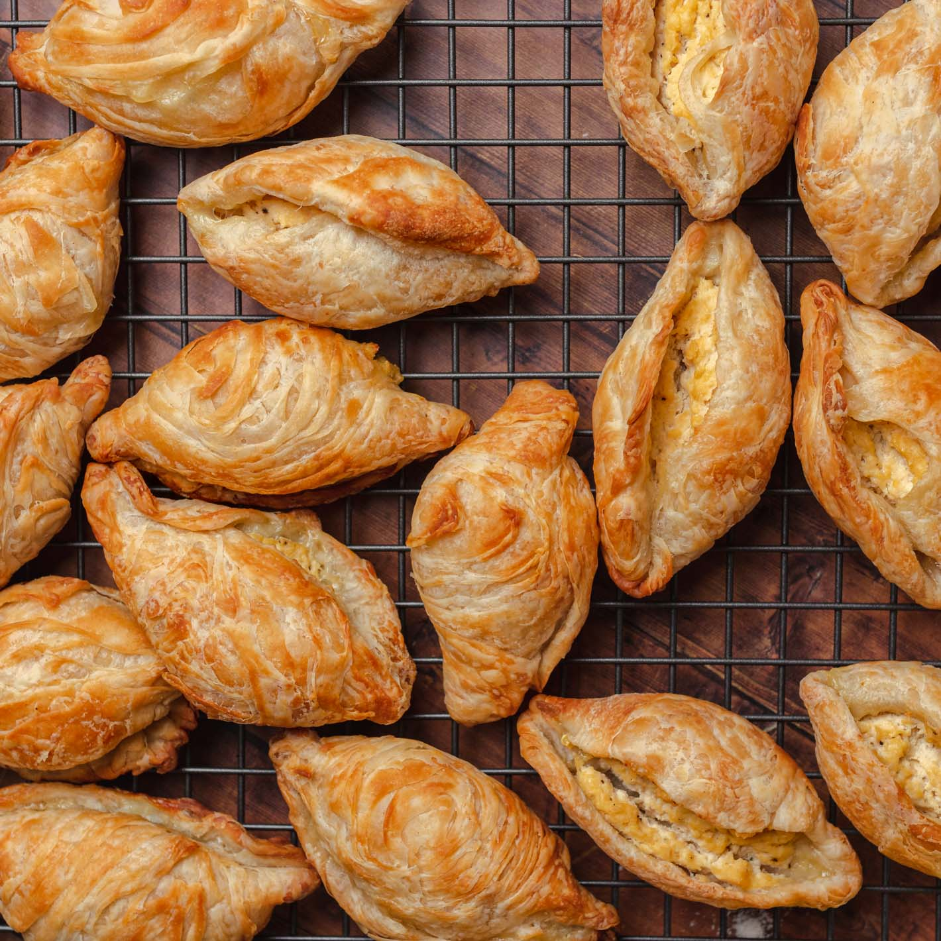
- Cheese
- Peas
- Meat
- Ingredients :
- 200g (7oz) whole milk ricotta
- 1 large egg
- Salt & pepper
- 50g (4 tbsp) unsalted butter, melted
- 6 sheets phyllo pastry
- Typical food: Spaghetti tal-Fenek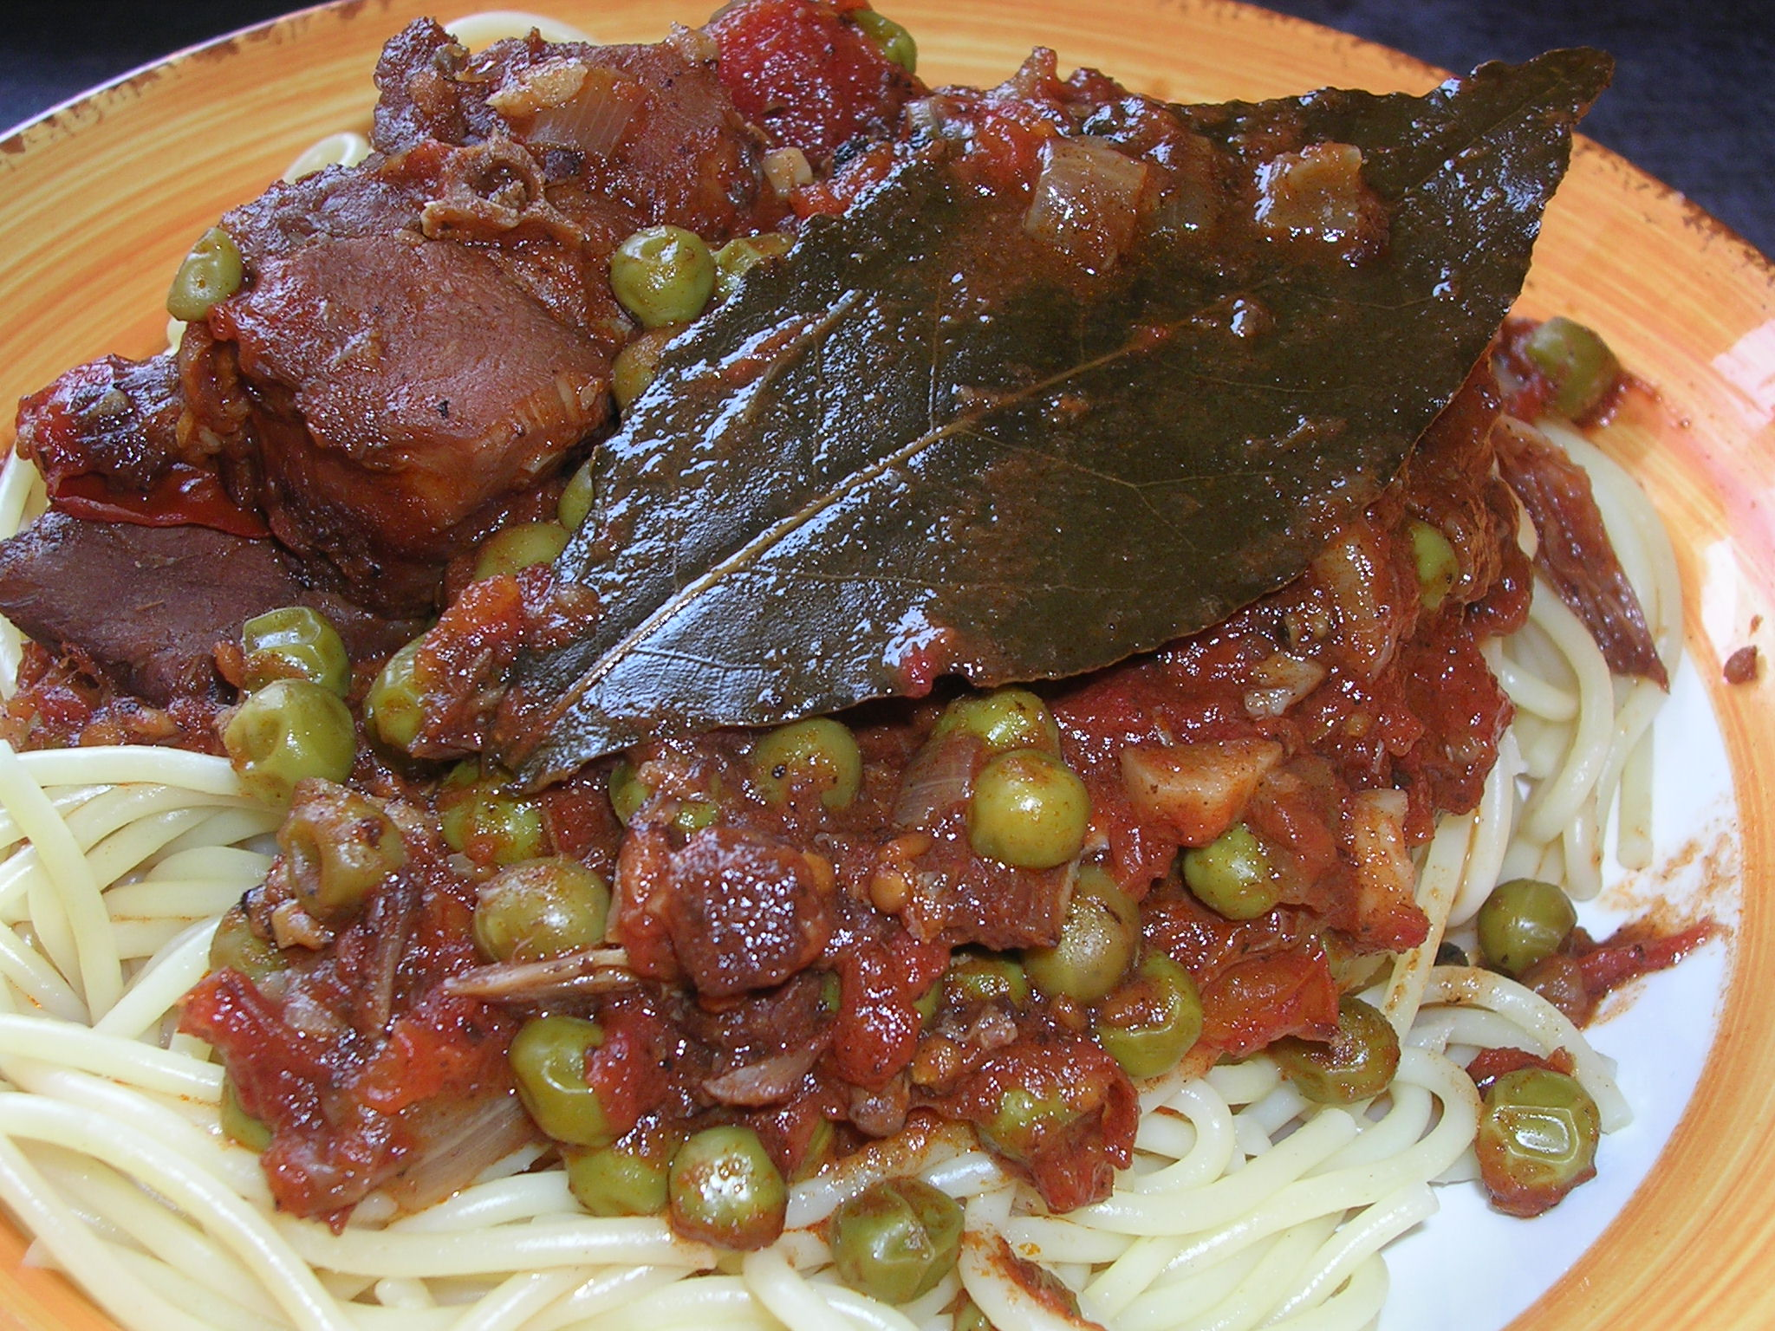
- Ingredients:
- 500g spaghetti
- 500g rabbit meat
- 300g tomato juice
- 200g onions
- 150g garden peas. (If you use frozen ones, follow the directions on the packet.)
- 50g tomato paste
- 1 glass red wine
- 5 or 6 garlic cloves (You can add as much garlic as you want.)
- bay leaves
- margarine
- salt and freshly ground pepper
- grated cheese
- rabbit seasoning
Spanish
- Typical food: cachopo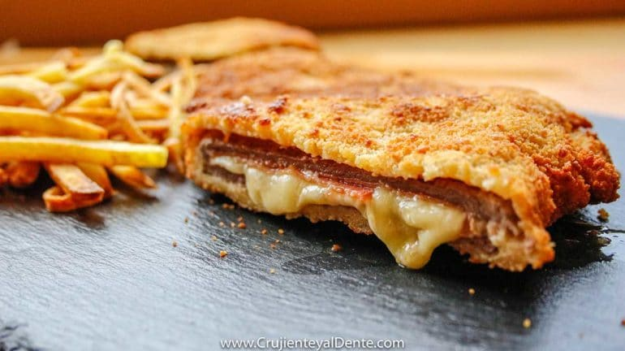
- Ingredients: -8 beef filets (between 100 – 120 g very thin slices)
- 4 slices of serrano ham
- 8 slices of cheese
- Pepper and salt
- 100 g of flour
- 2 large eggs
- 200 g of bread crumbs

- Typical food: Cocido 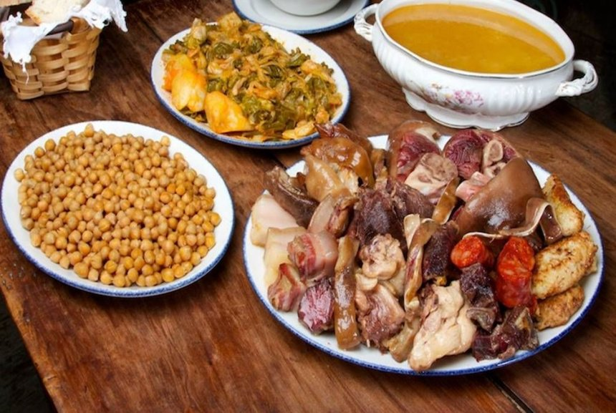
- Ingredients:
- 8 beef filets (between 100 – 120 g very thin slices)
- 4 slices of serrano ham
- 8 slices of cheese
- Pepper and salt
- 100 g of flour
- 2 large eggs
- 200 g of bread crumbs
Czech
Typical food: Svíčková na smetaně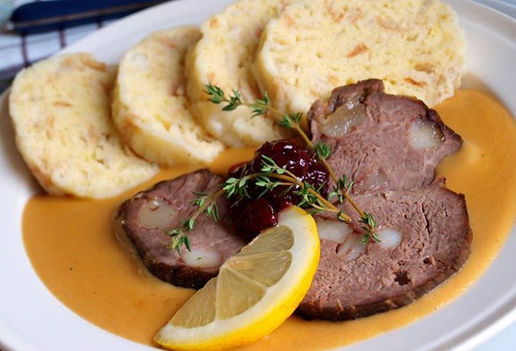
Ingredients:
- 800 g of rear beef
- 300 g root vegetables
- (carrots, celery, parsley in the same proportion)
- 1 onion
- 50 g full mustard
- 2 tablespoons sugar
- 2 tablespoons vinegar
- 100 g of oil
- piece of butter
- 100 g smoked bacon
- 1 tablespoon flour (or as needed)
- 250 ml whipping cream 33%
- 3 bay leaves
- 5 pieces of new spices
- 5 balls of pepper
- lemon juice for flavoring
- salt
- broth

