Birthday Name- Vladimir Dimitrov Poppetrov 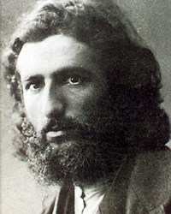
Born February 1, 1882, Frolos, Bulgaria
Died September 29, 1960 (78 years) Sofia, Bulgaria
Vladimir Dimitrov - The Master is a prominent Bulgarian artist. One of the great names in Bulgarian painting. He created in the first half of the 20th century. Appears in the portrait and landscape genre and in the household composition. His portraits and compositions have expressive colors, an idealistic drawing and a strong symbolic radiance. Besides the typical painting created by the master, we must not forget his unique contribution as a military artist. He creates hundreds of sketches of Bulgarian troops. It delivers with simplicity and finesse the emotions in the trenches and the bits of war. He is the first official Bulgarian military correspondent.

