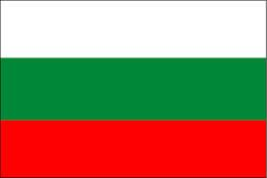  Flag | 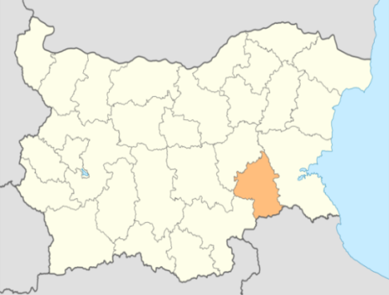  Borders | 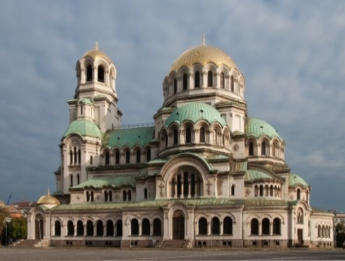  Sofia - capital | Folklore
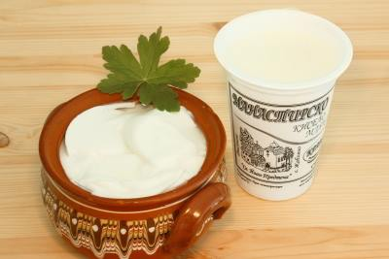  Bulgarian yogurt | 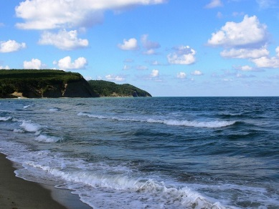  Black sea coast | 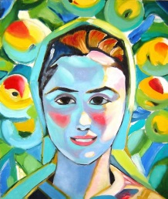  Bulgarian art | 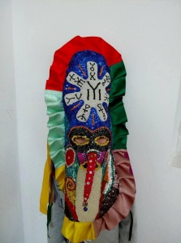  Mummer’s mask

Bulgarian national symbols

- Bulgarian’s national flag – rectangular shape with three colors – white, green and red, arranged horizontally from top to bottom. The national flag, coat of arms and anthem of the Republic of Bulgaria are set out in the programme of pre-school education.

- Borders and administrative division of Bulgaria

- Sofia city – capital of Bulgaria. In the photo – the St.Alexander Nevsky Cathedral

- Bulgarian folklore costumes – folklore songs and dances are preserved over the centuries and are set out in the programme of Kindergarten “Izvorche”

- Bulgarian yogurt – the real Bulgarian yogurt is produced with the participation of two bacteria ( lactobacillus bulgaricus – sour and streptococcus thermophiles – sweet ). The first one circulates in the Bulgarian lands.

- Black sea – this is Bulgarian east border. Three big rivers flow into Black sea – Danube, Dnieper, Dniester. On the Bulgaria’s territory there are five Black sea islands and a lot of sea resorts – Albena, Golden sands, Sozopol, Nesebar, Sunny beach , etc )

- Bulgarian painting from Vladimir Dimitrov (the Master) – one of the greatest Bulgarian artists. He created his work in the first half of 20th century. He is expressed in portrait and landscape genre and household composition.
- Traditional colorful mummer’s mask from village of Kabile ,which one has a rosette with the Glagolitic alphabet

