Biography
Leonardo da Vinci
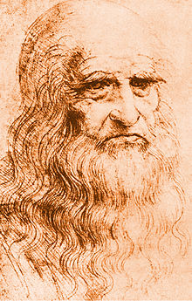
Self Portrait by Leonardo da Vinci
Back to Biographies
Occupation: Artist, Inventor, Scientist
Born: April 15, 1452 in Vinci, Italy Died: May 2, 1519 in Amboise, Kingdom of France
Famous works: Mona Lisa, The Last Supper, The Vitruvian Man
Style/Period: High Renaissance
Biography: Leonardo da Vinci was an artist, scientist, and inventor during the Italian Renaissance. He is considered by many to be one of the most talented and intelligent people of all time. The term Renaissance Man (someone who does many things very well) was coined from Leonardo's many talents and is today used to describe people who resemble da Vinci.
Where was Leonardo da Vinci born? Leonardo was born in the town of Vinci, Italy on April 15, 1452. Not much is known about his childhood other than his father was wealthy and had a number of wives. About the age of 14 he became an apprentice to a famous artist named Verrocchio. This is where he learned about art, drawing, painting and more.
Leonardo the Artist :Leonardo da Vinci is regarded as one of the greatest artists in history. Leonardo excelled in many areas including drawing, painting, and sculpture. Although we don't have a lot of his paintings today, he is probably most famous for his paintings and also gained great fame during his own time due to his paintings. Two of his most famous paintings, and perhaps two of the most famous in the world, include the Mona Lisa and The Last Supper.
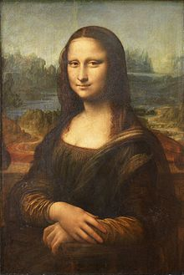

Mona Lisa by Leonardo da Vinci
Leonardo's drawings are also quite extraordinary. He would keep journals full of drawings and sketches, often of different subjects that he was studying. Some of his drawings were previews to later paintings, some were studies of anatomy, some were closer to scientific sketches. One famous drawing is the Vitruvian Man drawing. It is a picture of man who has perfect proportions based off the notes from the Roman architect Vitruvius. Other famous drawings include a design for a flying machine and a self portrait.

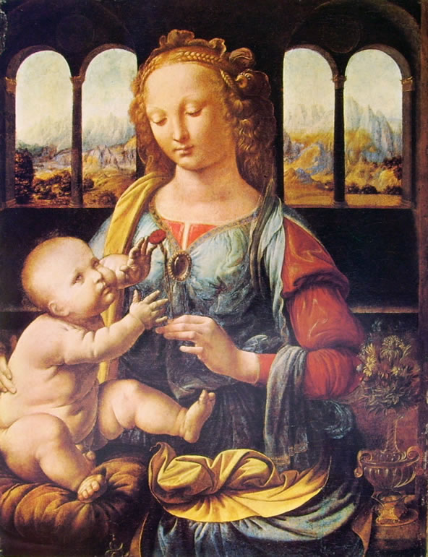

Leonardo the Inventor and Scientist :Many of da Vinci's drawings and journals were made in his pursuit of scientific knowledge and inventions. His journals were filled with over 13,000 pages of his observations of the world. He drew pictures and designs of hang gliders, helicopters, war machines, musical instruments, various pumps, and more. He was interested in civil engineering projects and designed a single span bridge, a way to divert the Arno River, and moveable barricades which would help protect a city in the case of attack.
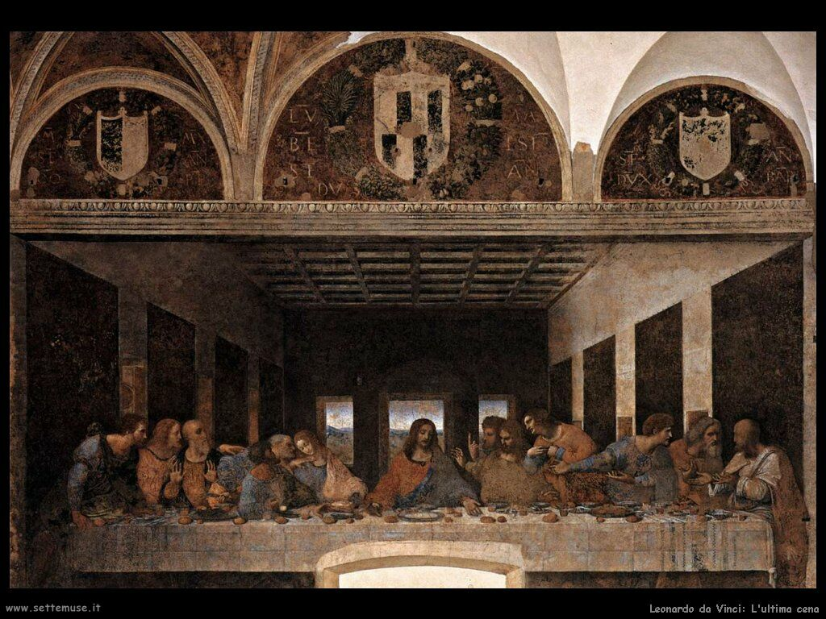
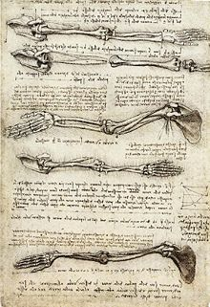
Studies of the arm by Leonardo da Vinci Many of his drawings were on the subject of anatomy. He studied the human body including many drawings on muscles, tendons, and the human skeleton. He had detailed figures of various parts of the body including the heart, arms, and other internal organs. Leonardo didn't just study the human anatomy either. He also had a strong interest in horses as well as cows, frogs, monkeys, and other animals.
Fun Facts about Leonardo da Vinci :The term Renaissance Man means someone who is good at everything. Leonardo is considered to be the ultimate Renaissance man. Some people claim he invented the bicycle. He was very logical and used a process like the scientific method when investigating a subject. His Vitruvian man is on the Italian Euro coin. Only around 15 of his paintings are still around. The Mona Lisa is also called "La Giaconda" meaning the laughing one. Unlike some artists, Leonardo was very famous for his paintings while he was still alive. It's only recently that we've realized what a great scientist and inventor he was.

