Flag | 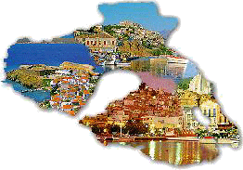  Lesvos | 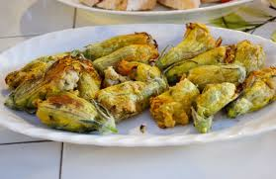  Traditional dish,  Zucchini flowers | 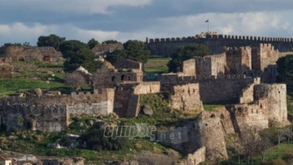  Mitilini’ s castle
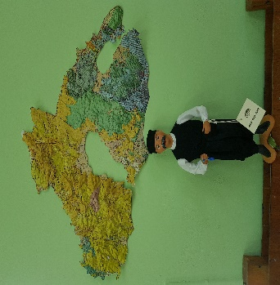  Mascot, name’s Stratis | 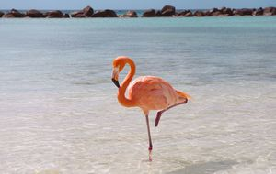  Flamingo | 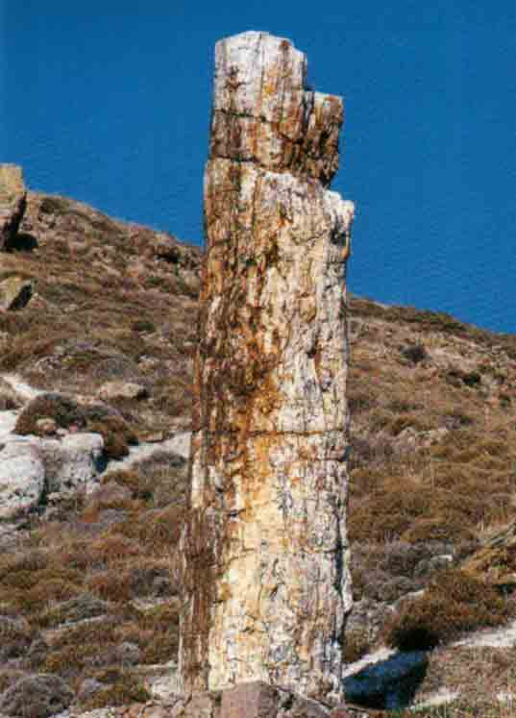  Sigri’s petrified forest | 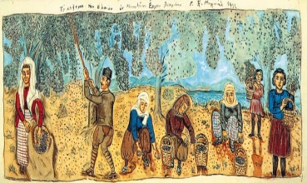  Theofilos, local artist

Flag | Lesvos | Traditional dish,  Zucchini flowers | Mitilini’ s castle
Mascot, name’s Stratis | Flamingo | Sigri’s petrified forest | Theofilos, local artist

