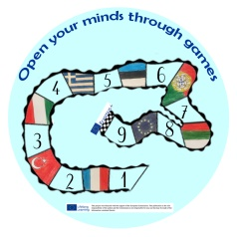 Teacher's questionnaire about DOMINO games
- Please write down your name, educational institution
TOTAL: 6 teachers
- Please rate some of the DOMINO game items using the following response scale.
0 - low rating
1- high evaluation
2- оценка highly praised
Check mark below the number you choose to reply
0 1 2
Evaluation
Understanding of children |  |  | 6 – 100%
Game quality |  | 2 – 33% | 4 – 66%
Benefits for children from games |  |  | 6 – 100%
Compliance with Domino rules |  |  | 6 – 100%
Total utility for you |  |  | 6 – 100%
Total utility from contact with partners |  |  | 6 – 100%
OVERALL ASSESSMENT |  |  | 6 – 100%
Have you encountered any difficulties playing games with children?
No problem. Children like this Domino game.
Problems were before the game, it was necessary to carefully consider the pictures and explain their meaning. And then there was no difficulty.
There were no difficulties, the children quickly understood the rules of the game. But one difficulty was that children are hard to get interested in playing Domino, as there are a lot of interactive games in the kindergarten, Education Lego, Education Robots, Numicon.
What do you think should be changed to improve work on the activities / games in the project?
Dominoes Picture quality can be better!
Maybe it was necessary to make a presentation about the pictures that will meet in dominoes.
I wish that the games were more colorful and modern, so that it would be easy to attract children. Children in our kindergarten are accustomed to interactive games (educational robots, SMART board, computers and a projector).
THANK YOU!

