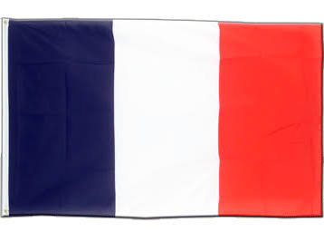  Flag | 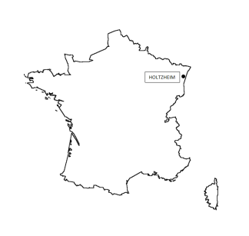 | 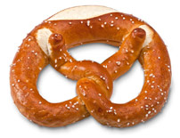  Traditional dish,  Bretzel | 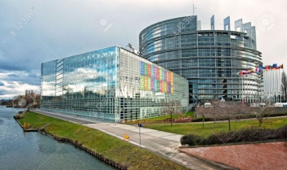  European Parliament
Mascot, name’s Maidela | 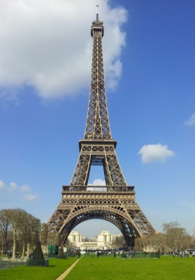  Paris, Capital of France | 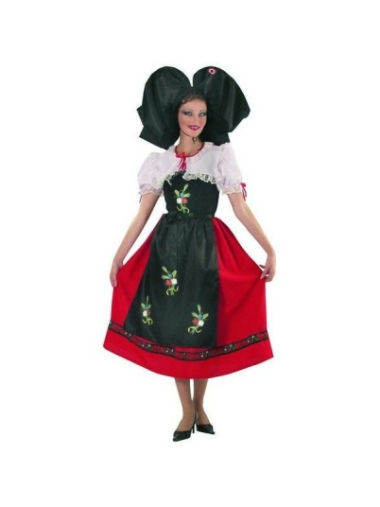  Traditional costume | 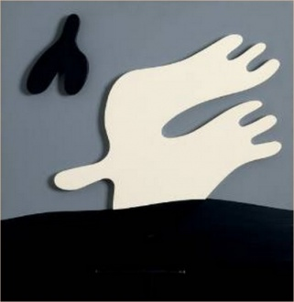  Hans Arp, local artist

Flag |  | 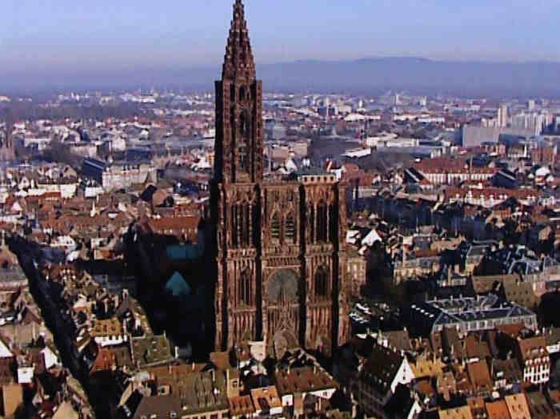  Cathedral of Strasbourg | European Parliament
Mascot, name’s Maidela | Paris, Capital of France | Traditional costume | Hans Arp, local artist
Give some explanations about the cards………..

Flag : blue, white, red

Country : our country is a hexagon, our capital is Paris

European Parliament : Strasbourg is one of the capital of Europe with Bruxelles

Stork is a traditional bird of Alsace, we choose her like mascot, her name’s Maidela

Bretzel, traditional dish, receipt ?

Jean Arp or Hans Arp (16 September 1886 – 7 June 1966) was a German-French sculptor, painter, poet, and abstract artist in other media such as torn and pasted paper. Arp was born in Strasbourg

give to the partners big pictures of the work of the artist, and also a teaching exploitation which have been done or you will do with your classes….

