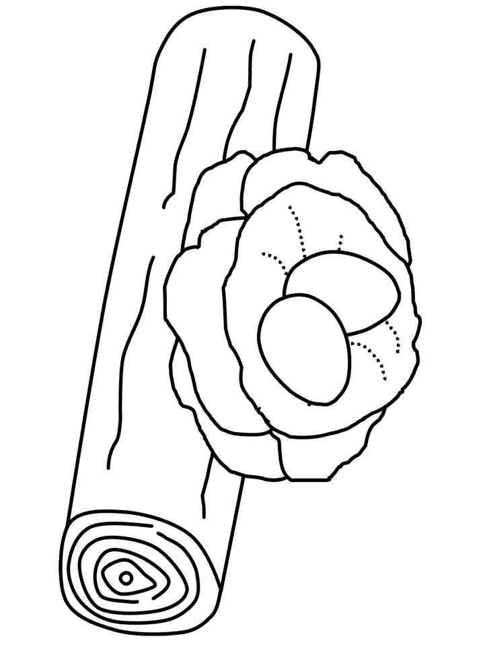
1+2=
1+1=
Color the picture. Join points with a pencil
The sum of the numbers where is 2 with a beige and the sum of the numbers where is 3 with a brown

