YOGIES – TURKISH MOBILITY
INFORMATION PACK

2ND – 9th MAY 2017
has anatolıan hıgh school/antalya
YOGIES
Project YOGIES: Information package regarding Turkish Mobility on 2 – 9 May 2017 in Antalya

In this package you will find the following:

- The purpose of this information package is to provide all partners with necessary information to enable a successful Mobility.
- Based on the decisions taken at the previous Transnational Meeting, we have prepared a programme which will enable us to achieve the first Mobility objectives of the project while also allowing time for social events and some sightseeing in Antalya.
- A list of all partners including students and teachers. The list also includes Has Schools YOGIES Project team and their contact information.
- The Programme for the Mobility.
- A map showing the location of the School and the Hotel
- Key contacts

Key contacts
Name | YOGIES role | Mobile | email
Özge Özçopur | Has Schools English Teacher – Project Manager | +905345699955 | ozgeozcopur@gmail.com
Seda Zeybekoğlu | Has Schools English Teacher – Project Manager | +905416100738
Gökhan Kamış | Has Schools Teacher – Project Team Member | +905333382272 | gokhankamis@hasokullari.com
Seçil Çimen | School Manager | +905307702588 | secilcimen@hasokullari.com

Turkey Project team contacts
Name | role | Mobile | email
Rabia Dilara Yasak  Host of Miss Natalie | Has Schools Student – Project Team | +905340322804
Lara Coşkuntuna  Host of Miss Barbora | Has Schools Student – Project Team
Mert Akkurt  Host of Mr Jakub | Has Schools Student – Project Team
Aziz Okhan  Host of Mr Danilo | Has Schools Student – Project Team
İbrahim Buğra  Host of Mr Jacopo | Has Schools Student – Project Team
Sinem Aytan  Host of Miss Lina | Has Schools Student – Project Team
Efe Uyanık  Host of Mr Martynas | Has Schools Student – Project Team

Team Members
TURKISH TEAM
Miss Özge Özçopur - Teacher | +90 534 5699955
Miss Seda Zeybekoğlu - Teacher | +90 541 6100738
Mr. Gökhan KAMIŞ - Teacher | +90 533 3382272
Ms. Ayşe Seçil ÇİMEN - Manager | +90 530 7702588
Miss Rabia Dilara Yasak - Student | +90 534 0322804
Miss Lara Coşkuntuna - Student
Mr. Mert Akkurt - Student
Mr. Aziz Okhan - Student
Mr. İbrahim Buğra - Student
Miss Sinem Aytan - Student
Mr. Efe Uyanık - Student
ITALIAN TEAM
Mr. Giuseppe Puntarello - Teacher
Mr.Nino Finauri - Teacher
Mr. Danilo Di Berardino - Student
Mr. Jacopo Bruno Spaccazocchi - Student
CZECH TEAM
Mrs. Gabriela Marchewková - Teacher
Mr. Michal Ledwoń - Teacher
Miss Natálie Tkáčová - Student
Miss Barbora Viačková - Student
Mr. Jakub Dobeš - Student
LITHUANIAN TEAM
Mrs. Jolanta Ručiene – Teacher
Mr. Vidas Davičikas - Teacher
Miss Lina Jurkonytė - Student
Mr. Martynas Dubovikas - Student
UK TEAM
Will Salisbury - Teacher
Fariha Quddus - Teacher
Santhuvi Srikandakannanathan - Student
Aisha Ali - Student

Project Programme
2 May (Tuesday)
Arrival of the Teams
3 May (Wednesday)
10:00 Meeting at School: Greeting of the Team Members and Orientation
13:10 Lunch at School
14:00 Meeting at the Conference Hall – Introduction of Erasmus+ and the YOGIES project and the content of the Turkish Mobility
19:00 Dinner at a Turkish Restaurant
4 May (Thursday)
10:00 Meeting at School: Students attend English lessons with Turkish students
13:10 Lunch at School
14:00 Meeting at the Conference Hall: Seminer on Doping awareness, violence and racism in sport, slogan, sports friendship, alcohol and drugs
Activity/Trip: Details will be included

5 May (Friday)
10:00 Meeting at School: Students attend English lessons with Turkish students
13:10 Lunch at School
14:00 Meeting at Conference Hall: Presentation of the Survey Results on Multilinguilism and Human Rights
Activity/Trip: Details will be included

6 May (Saturday)
10:00 Meeting at Has School: Trip to Has Farm for traditional Turkish breakfast
Beach Volley Tournament and Award Ceremony
7 May (Sunday)
Free-Time
Suggestions for Sight-seeing and Shopping
8 May (Monday)
10:00 Meeting at School: Students attend English Lessons with Turkish Students
13:10 Lunch at School
14:00 Meeting at Conference Hall: Explaining and starting “Europass”
Activity/Trip: Details will be included

9 May (Tuesday)
Departure

Transportation and Location
From Airport to Blue Garden:
Public Transport
There are two bus numbers from airport going to the city center: 600 and 800. They do not go directly to Blue Garden Hotel but below you can find the nearest bus stops you can get off for the hotel, and from there you can take a taxi and it should be around 20 Turkish Liras at most to get to the hotel.
If you take the bus 800, please get off in front of Migros Shopping Center. You will find a taxi stop right where you get off.
If you take the bus 600, please get off at Meltem Bulvarı and take a taxi. The nearest taxi stop is Adliye Taksi (+90242 237 38 00).
Taxi
I will add a price info by taxi from airport to the hotel.

From Blue Garden Hotel to Has Schools:
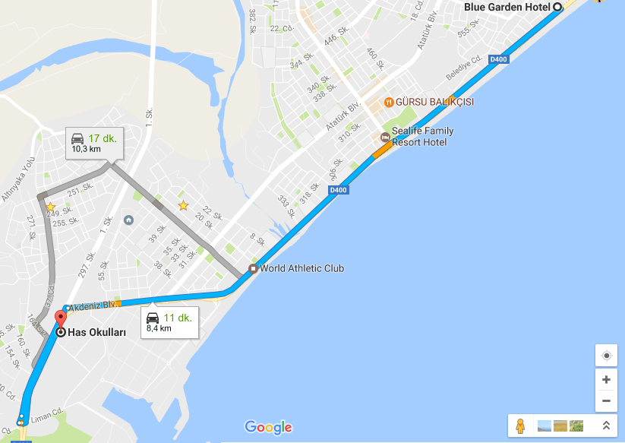
https://www.google.com/maps/dir/Arapsuyu+Mahallesi,+Blue+Garden+Hotel,+Konyaalt%C4%B1%2FAntalya,+T%C3%BCrkiye/Liman+Mahallesi,+Has+Okullar%C4%B1,+No:,+No:60,+19.+Sk.,+07130+Konyaalt%C4%B1%2FAntalya,+T%C3%BCrkiye/@36.8536529,30.6113214,14z/data=!4m13!4m12!1m5!1m1!1s0x14c391af5db958ab:0x2c3c2fa967451bbc!2m2!1d30.65587!2d36.873617!1m5!1m1!1s0x14c393f5b0f332e1:0x1ee8fe6836c5f2d7!2m2!1d30.5997314!2d36.8442307?hl=tr-TR
From Blue Garden Hotel, it takes approximately 25 minutes by public transport.
*Bus Number will be included tomorrow.

Emergency Taxi Numbers:
Hurma Taxi: +90242 259 14 35 (Close to the school)
Konyaaltı Birlik Taksi: +90242 229 03 31 (Close to the hotel)

Hospital Info In Case of Emergency:
Özel Olimpos Hastanesi
Phone: 00 90 242 228 09 09
E-mail: info@olimposhastanesi.com.tr
Address: Öğretmenevleri Mah. Çamlık Cad. 460 Sk. No : 48 Konyaaltı / Antalya

