YOGIES partnership - March 2017
Newsletter n. 1 from IIS Raffaello, Urbino (PU), Italy

Here is our school webpage that has been recently created to disseminate our project:

http://www.iisraffaello.gov.it/progetto-yogies/

At IIS Raffaello, Urbino, Italy, we have also started creating the YOGIES Twinspace on the European eTwinning platform.

https://twinspace.etwinning.net/6482/home/

The YOGIES project actually started at the beginning of the school year 2016/17 when we all discovered that our partnership had been approved and co-funded by the European Union.

After a detailed exchange of information with all the partners involved in the YOGIES partnership the first transnational meeting was finally announced and the Logo competition was launched.

An informal Whatsapp Steering Commettee Group was created to encourage communication both before and after the transnational meeting held in London 16-19 February 2017

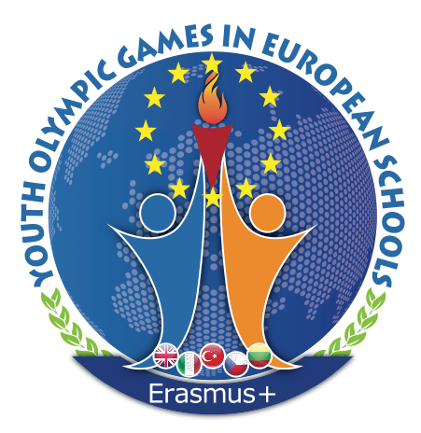
In our school our students were really good at finding the right software to design the logos and worked together in a cooperative mode. The logos were created through a learning by doing approach. Small groups gathered together taking into account their specific skills and managed to create a set of logos that were highly appreciated by the first transnational meeting members who selected the best three logos that received the prizes provided by the Regent Independent College, Harrow, London. We were very lucky because two of our logos were selected for the second and the third prize.

Soon after the transnational meeting in London we shared detailed information about the Yogies project amongst students, their families and all the members of our school staff.
Both formal and informal meetings were held at school to socialize the main objectives of the project and the activities that will be performed during the three years of the partnership.

News about the logo competition and the connected prizes was spread and prizes were eventually given to the students had contributed most to the winning logos design activities.

An Erasmus+ corner especially dedicated to our partnership has been recently created. All the logos and presentations created so far have been exhibited in order to improve communication on the project activities and events.

We all shared ideas on the YOGIES website that our British partner has been brilliantly designing and publishing www.yogieserasmusplus.com.

We have also been participating to the Yogies FB closed group that we used to share info, documents and pictures concerning our partnership facts, meetings, talks, workshops, issues and objectives.

A team of Italian teachers and students who will partecipate to the mobility in Turkey has been selected according to the partnership criteria shared with both teachers, students and their families. The families have signed their parental consent for the upcoming mobility.

In addition, at our school a new “climbing practice” workshop has been held regularly since January and it is possible that this kind of activity might be implemented again during the week mobility in Italy in March 2018 when a climbing competition might be organized in case all the partners agree on that.

