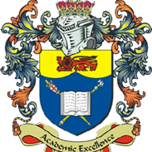
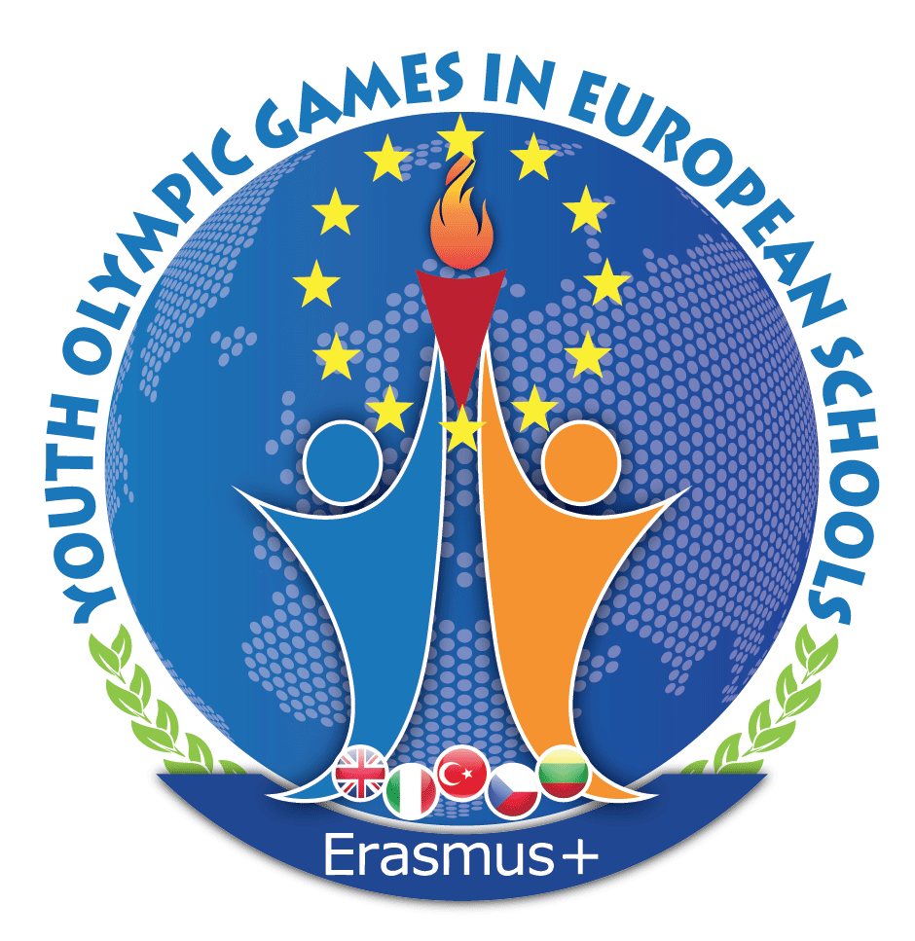

YOUTH OLYMPIC GAMES IN EUROPEAN SCHOOLS
REPORT OF THE 3rd Mobility
URBINO, ITALY 5th - 12th MARCH 2018
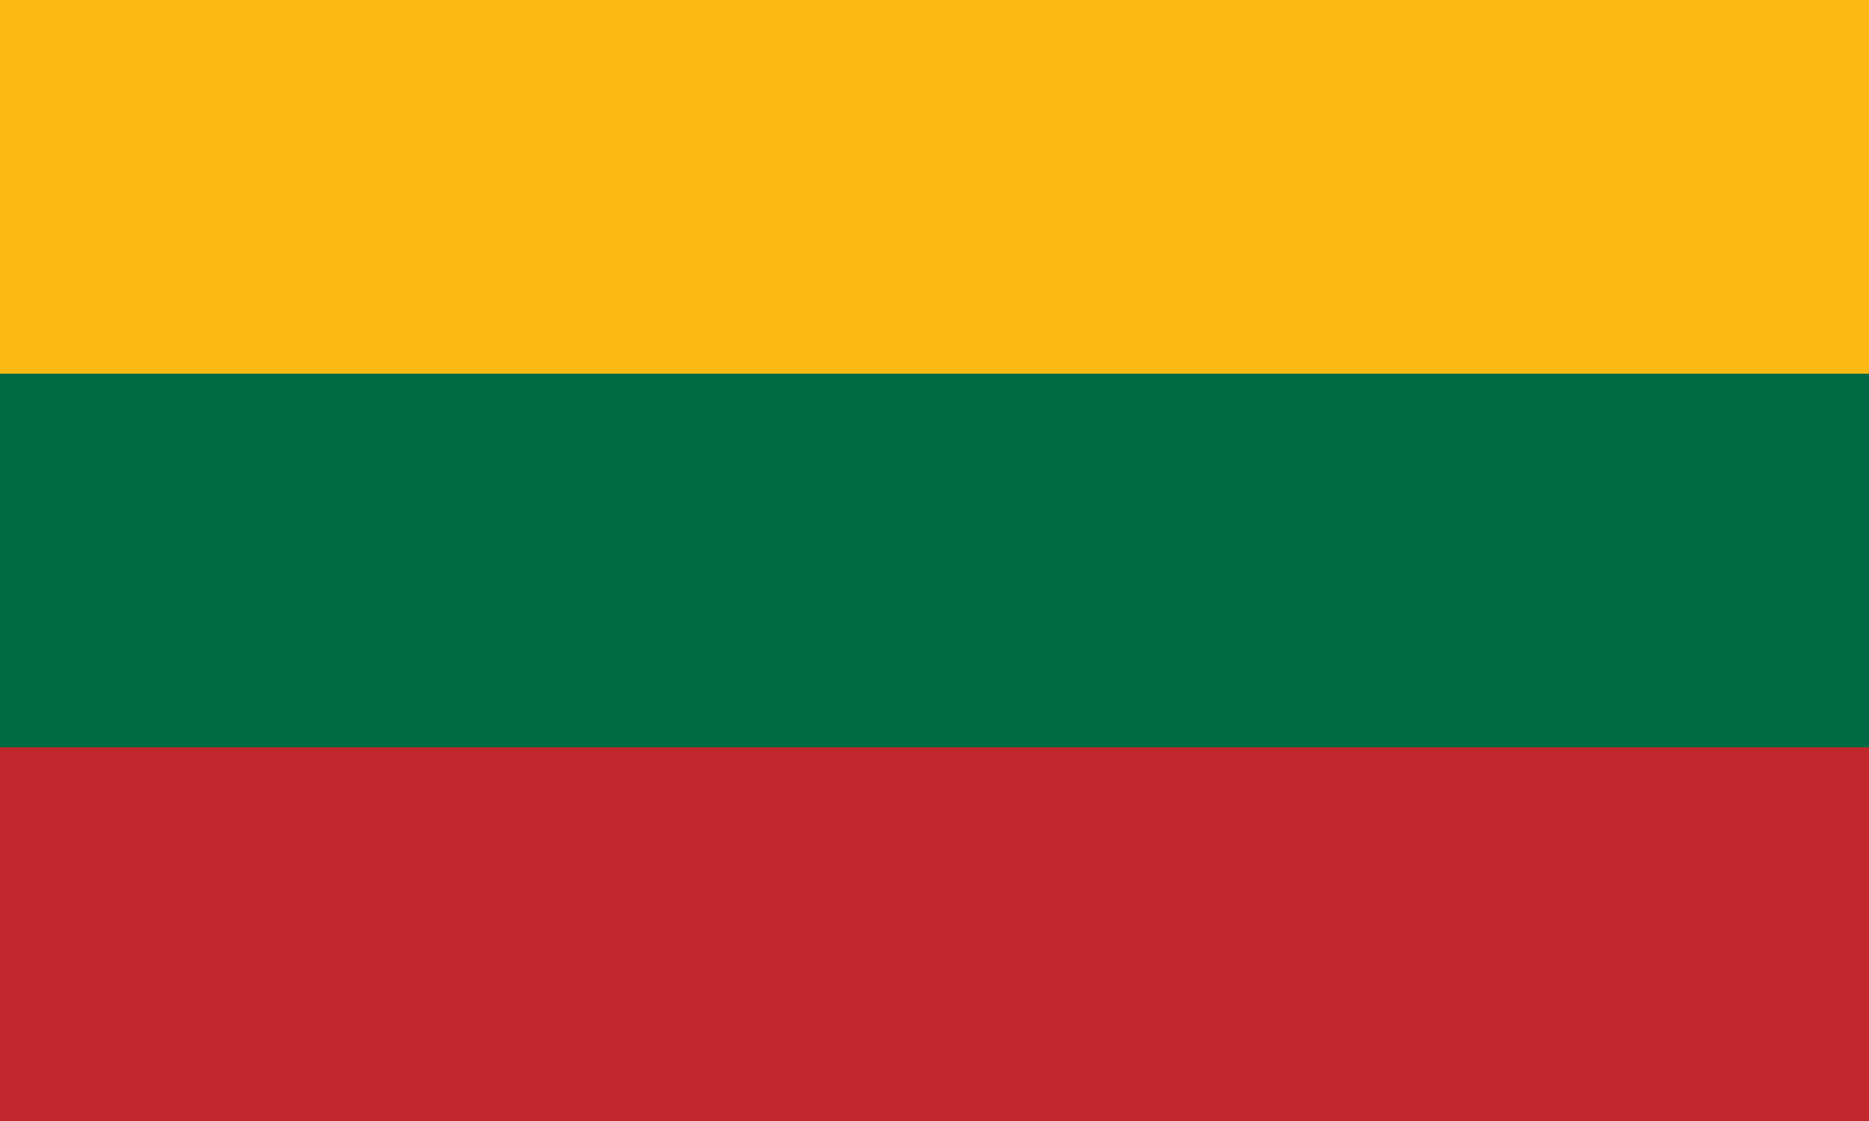
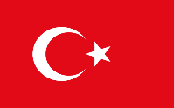
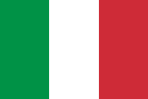
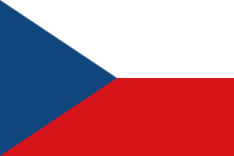

CZECHIA ITALY LITHUANIA TURKEY UK

The third mobility meeting of the Erasmus+ (KA2) project "Youth Olympic Games in European Schools" was held from 5th March to 12th March 2018 in Urbino, Italy.
The Italian delegation from Urbino, Italy were hosting this Mobility and therefore met the other delegations at the IIS “Raffaello” school premises. Their delegation was composed of the School Team including Ms. Carla Campogiani, Ms. Daria Parisi, Mr. Giuseppe Puntarello and Ms. Ombretta Michelini.
The Turkish delegation from Ozel Antalya HAS Anadolu Lisesi Antalya, Turkey arrived on Monday, 5th March and departed on Monday, 12th March 2018. Their delegation was composed of the teachers Mr. Mesut Yayla and Mr. Gokhan Kamis and the students Ms. Lara Arslan and Ms. Ezgi Yaman.
The Lithuanian delegation from Prienu r. Staklišklu Gimnazua in Stakliškés arrived on Monday, 5th March and departed on Monday, 12th March 2018. Their delegation was composed of the teachers Ms. Jolanta Ruciene and Ms. Sidona Mankeviciene and students Mr. Vakaris Vindziulis, Ms. Agne Sermuksnyte and Ms. Viktorija Svelpaite.
The Czech delegation from Gymnázium, Karviná, prispevková organizace in Karviná arrived on Monday, 5th March and departed Monday, 12th March 2018. Their delegation was composed of the teachers Ms. Iva Vrbova and Ms. Veronika Cadova and students Ms. Marie Strzelcova, Mr. Jan Swiatkowski and Ms. Vendula Krocilova.
The British delegation from Regent Independent College in London arrived on Monday, 5th March and departed on Monday, 12th March 2018. Their delegation was composed of the teachers Ms. Vritti Shah and Ms. Leonora Tomas and the students Ms. Sangavi Suresh and Mr. Faizan Rahman.
The organizer of the Italian mobility was IIS “Raffaello” in Urbino, Italy. The project co-ordinator is Ms Carla Campogiani.
On Tuesday 6th March, there was a welcome meeting with all delegations at IIS “Raffaello” in Urbino. Breakfast was offered to the meeting participants. The programme started with some warm up activities and an introduction to the ERASMUS + programme, the YOGIES project all with specific links to the Italian mobility. Headmaster, Mr. Samuele Giombi, of the school welcomed the mobility to Urbino. Students from the school organized a walking tour of the city with facts of different historical buildings such as Ducal Palace, Raffaello Birth place, St. John’s Oratory and the Fortress. Each country introduced some national dishes during lunch time after the tour. In the Plenary Room, students form the mobility gave presentations on their country, education system and school. The students then presented survey results based on “Cultural Knowledge/EU Citizenship in partner countries”.
On Wednesday 7th March, the delegation gathered in the gym for some ice breaking activities with a large number of IIS “Raffaello” students participating in the planned activities. There was a laughter yoga session carried out by the Accademia Della Risata before sport activities. The students then took part in various games e.g. archery, volleyball and basketball. During lunch, we were joined by Professor Carmen Belacchi from the Urbino University. She gave a lecture on “Bullying and Violence in Schools and Early School Leaving”. Some teachers and students then took part in an urban trekking tour of the city which walked along the city walls, small alleys and streets.
On Thursday 8th March, the organizers took the guests to meet the Mayor, Mr. Maurizio Gambini, of the Urbino Municipality. The Mayor introduced the town and answered some general questions based on residency, education and heritage. Students went onto taking part in the Table Tennis Tournament and the winners were Mr. Giacomo Falasconi, Mr. Davide Mazzini and Mr. Jacopo Bruno Spaccazocchi. Other games the students took part in, were indoor rock climbing, Zumba, volleyball and basketball. After the tournament, the teachers gathered in the Plenary Room to plan and discuss various tasks that need to be completed by the mobility. IIS “Raffaello” organized lunch for all teachers and students who are part of the project. A visit took place to Raphael’s birthplace with another large number of students from the host school, who acted as tour guides for the delegations.
On Friday 9th March, the planned Day Trip to Ravenna took place where all the delegates and twins had the opportunity to visit and discuss about the World Heritage Sites situated there e.g. S.Apollinare in Classe, Domus of Tappeti di Pietra, Dante burial place, Basilica di S. Vitale, Mausoleo di Galla Placidia and etc. There was an additional group of students from IIS “Raffaello” who acted as tour guides and provided some historical information about the places everyone visited. For Lunch, all the delegates met together and shared food at “Enoteca Ca’ De Ven” in Ravenna City Centre.
On Saturday 10th March, the students attended lessons together with their twins while all the teachers met in the school Library to discuss the project progress and make a start on the mobility report. After a short break, the delegation and twins visited the Ducal Palace together with another group of students belonging to IIS “Raffaello” who explained the history behind the Palace. Lunch was followed by the planned workshop on “Bullying and Cyberbullying” in order to create posters on the topic. After that, the posters were shared among all the groups and the top three were selected for display. The working session was then followed by a party at school where there was a group of musicians who taught the students and teachers traditional Italian dance.
On Sunday 11th March, the students spent the day with their host families while the teachers met and finalized the report and listed the further tasks that need to be completed to implement the project. At the end of the mobility in Italy, the teachers agreed on the tasks to be done for the next mobility which will be Czech Republic from Sunday 30th September to Sunday 7th October 2018 instead of UK due to examinations finishing late in the UK therefore the students and teachers cannot be released in June to take part in the ERASMUS+ project.
These tasks include:
- Each country to give information on extra mobility activities to Czech for the 4th newsletter by Friday 6th April 2018.
- Photos and videos should be provided to Lithuania of the Italian mobility by Friday 16th March 2018 to be uploaded on YOGIES Facebook page.
- Student presentations/other documents to be sent to UK of the Italian mobility by Friday 16th March 2018 to upload on the YOGIES website.
- The British team needs to update and make changes on the website to make sure all information regarding each mobility is present plus making sure the links are working for exporting the files before the next mobility takes place.
- Information/photos/videos of the Italian mobility to be uploaded on TwinSpace by Friday 23rd March 2018. Each country will designate a coordinator to upload information on TwinSpace and to keep updating while the project is on.
- We have prepared the content for the Europass Mobility Document for it to be completed by the last transnational meeting in Turkey.
- The British coordinator will send the template for the Europass Mobility Document by end of June 2018.
- The British team takes responsibility in providing the evaluation questionnaire by Friday 16th March and ensuring that all the participants have completed evaluation questionnaires for the mobility by Thursday 30th March 2018.
- The host, Czech Republic, will prepare a survey on the topic of Sports and Healthy Lifestyle in Partner Countries and send to the participating schools by 31st August 2018.
- Each country will make a presentation of survey results on Sports and Healthy Lifestyle in Partner Countries. At least 10% of the school students, aged between 17 to 19 years, should be completing the survey.
- The host, Czech Republic, is responsible for preparation and delivery of the workshop and lecture/seminar on Gender issues, racism, discrimination of all sorts and political and religious extremism.
- Each country will prepare a presentation on their country, town and school to be presented during the mobility in Czech Republic.
- The host, Czech Republic, is responsible for a presentation on Erasmus+ to be presented during their mobility to the students.
- Each country may introduce some national dishes that will be presented at the Czech mobility on the first day of the project with some gifts for the host country.
- The Czech school will send the other partners the host families’ contacts by Friday 14th September 2018.
- The Czech school will send the other partners the program of the 4th mobility by Friday 14th September 2018.
- The Turkish school will organize a meeting over current technology to discuss about the next mobility on Friday 21st September 2018 10am UK time.
- The participating schools will update their data in the Mobility Tool (i.e. principals and coordinators) and in case of any problems they will contact their National Agencies and will also inform the coordinator of the project.
- It has been agreed that the final transnational/monitoring meeting will be carried out by coordinators and principals in Turkey in May 2019 (dates to be confirmed) which is the 3rd year of the project.
- The host, Czech Republic, will send official invitation letter/s to Turkey in May 2018 to process their travel paperwork for the mobility.
- All the participating schools will confirm their teams (teachers, student names, DOB, gender) officially no later than Friday 7th September 2018.
- The Czech school may be able to host more than two students per guest school.
- The Czech school will check the transport and accommodation possibilities for the mobility in Czech and will inform the participants four weeks before the mobility (by Friday 7th September 2018).
- By June 2018, The British team will confirm the number of students who will be attending the Czech mobility in order for Czech to cross check the host families.

All the participants of the “Youth Olympic Games in European Schools / YOGIES” project appreciate the effort, the work and the warm hospitality of the Italian organizers for the 3rd mobility. All the participants had a wonderful, engaging time and found all topics covered to be very interesting and agree they that have earned a lot during the mobility. The entire ‘planned programme’ was fully accomplished.
Urbino, Italy, 11th March 2018

………………………………………
Ms. Carla Campogiani, Italy

……………………………….. …………………………………
Mr. Mesut Yayla, Turkey Mr. Gokhan Kamis, Turkey

………………………………… ………………………………….
Ms. Jolanta Ruciene, Lithuania Ms. Sidona Mankeviciene

………………………………… ………………………………….
Ms. Iva Vrbova, Czech Republic Ms. Veronika Cadova, Czech Republic

………………………………… ………………………………….
Ms. Leonora Tomas, UK Ms. Vritti Shah, UK

…………………………………..
Mr. Giuseppe Puntarello, Italy

The project has been funded with support from the European Commission.

