The salary
I just got my salary, so I bought a bag for 1/3 of my salary and then I bought a shirt for 40% of what I had left of my salary.
Finally I bought an ice-cream for 1/10 of the money that was left after my two great purchases.
Now I have 216 kr in my wallet.
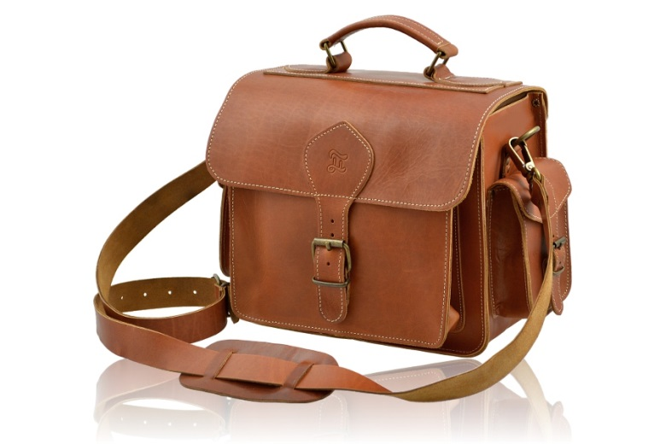
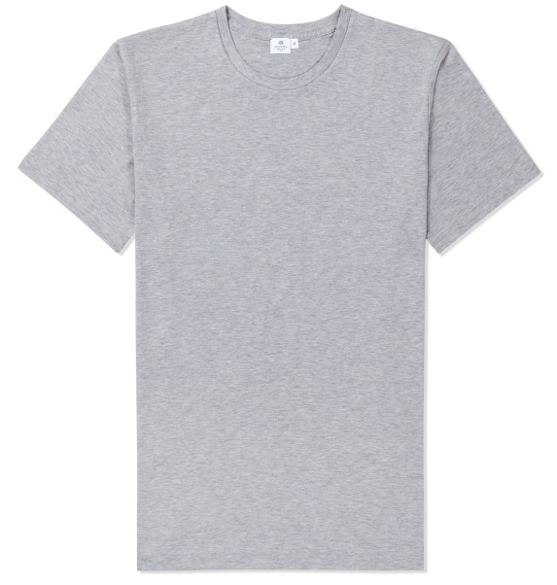
How much money did I get this month in salary?
By Ida Karlsson and Isabel Sigfridsson Perea from Sweden

