Bushes On A Row
Camilla is going to plant bushes alongside a street in the city. Around every bush she puts down flagstones as the picture shows. Every white square is a flagstone and every black square is a bush.
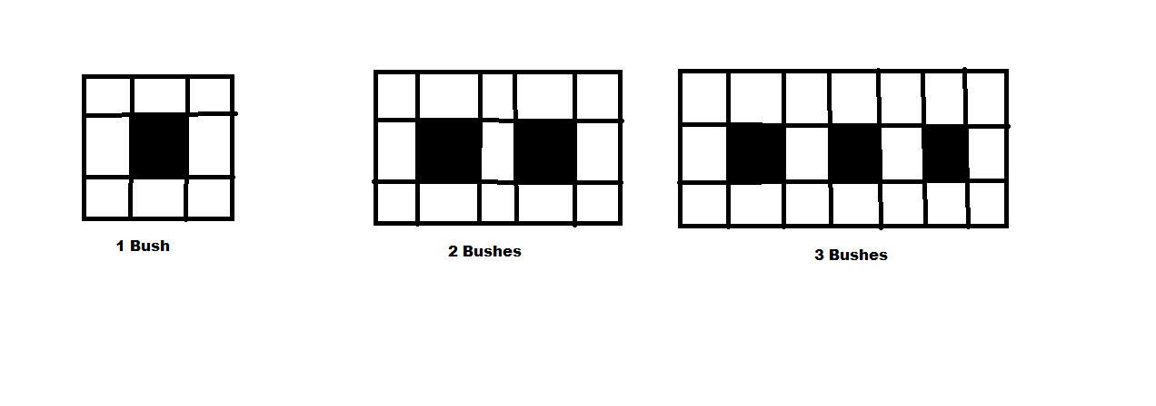
- How many flagstones goes around
- 4 bushes
- 5 bushes
- 10 bushes
- 100 bushes
- n bushes

- How many bushes does she have to plant if she puts down 208 pads?

Greetings from Vasaskolan, Kalmar!

