The Cube
We have a cube and three cuboids with extreme dimensions:
1cm x 1dm x 1m 1mm x 1m x 1m 1mm x 1mm x 1km
The volume of the cube is not bigger than any of the cuboids’
volumes, not smaller either. What edge length does the cube have?
(The picture has nothing to do with the problem)

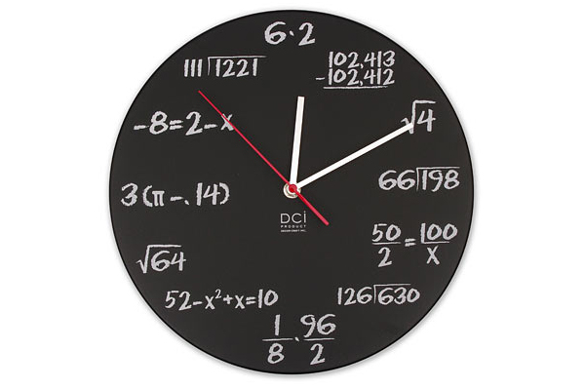
/ Clara, Beata and Rina, 9A, Vasasskolan

