Cupcake problem
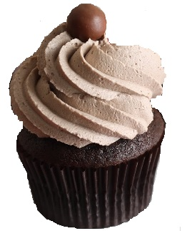

There are seven cupcakes on a plate. Three of them are blueberry cupcakes, two of them are raspberry cupcakes and the two that are left are chocolate cupcakes.

Stina likes all but raspberry cupcakes.
Kalle likes all but chocolate cupcakes.
Kim likes all but blueberry cupcakes.

Each of them take two cupcakes that they like the most. Someone takes two of the same taste, and another one takes two with different tastes.

Who gets the cupcake that is left on the plate? Propose one of the children who you know like the taste of this cupcake.

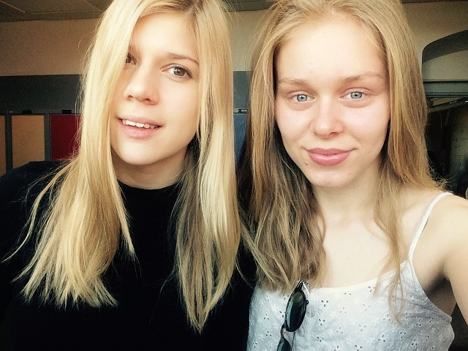
Tea and Lovisa in 9th grade at Vasaskolan, Kalmar
21/5-15 Sweden

