Follow this dialog:
- The noise outside is done by The Ionesco’s three children.
- What age are they?
- The product of their age is 36.
- I asked you the age of each of them.
- You can calculate yourself, knowing that three children ages amount equals the number of the house where I live and whom you know.
- (After a few minutes of thinking…) it is impossible, give me another clue.
- The eldest has green eyes.
- Now I really can calculate the age of each child.
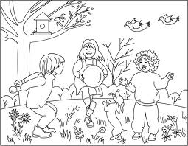
Using the information from this dialog, can you specify the age of The Ionesco’s children?

