

***Information about the Project***

***WEB PAGE:***

[***http://www.nostereotypesbutd.com/***](http://www.nostereotypesbutd.com/)

***eTwinning:***

[***https://twinspace.etwinning.net/46023***](https://twinspace.etwinning.net/46023)

***FACEBOOK:***

[***https://www.facebook.com/groups/287456478422849***](https://www.facebook.com/groups/287456478422849)



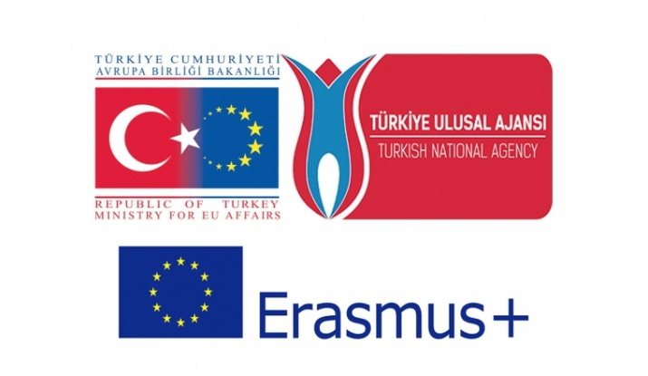





spain_flag

***“No Stereotypes But Diversity”*** *is an international Project co-funded and supported by the Erasmus+ Programme of the European Union.*

***Why streotypes?***

*A* ***stereotype*** *is how we judge others based on their appearances, gender, race or beliefs; how we label them and put them into particular categories.*

*Stereotypes make us ignore differences between individuals and may lead to discrimination.*

*Discrimination ultimately results in treating individuals or groups unfairly based on perceived differences and inferiority, which in turn bursts into conflicts.*

*We want to free our students from stereotypical mindsets and promote the concepts of tolerance, acceptance, European democratic values, European citizenship and a culture for care and peace.*







*In this Project, with the international partnerships and co-operation of the NGOs, we discuss the the stereotypes and try to find a solution to the problem in group activities in which students actively participate.*

*We also aim at increasing social awareness, tolerance, empathy for the immigrants and refugees.*

*Throughout the Project the topics we discuss are;*

* ***Stereotypical thinking and discrimination, related with the nationalities***
* ***Gender and Racial equality and ways of combating them***
* ***Religious equality, common stereotypes related to religions and religious beliefs***
* ***Stereotypical thinking and discrimination in schools, how can we address and solve these issues?***

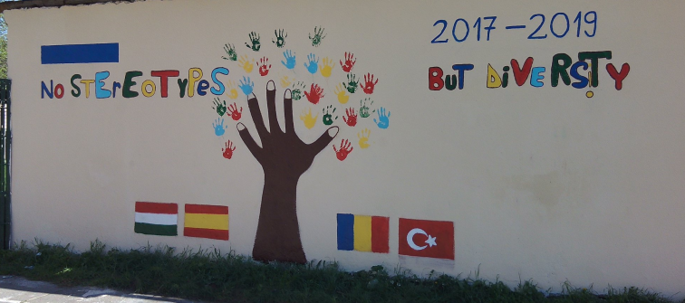

***Our partners are;***

***-Mustafa Mihriban Boysan Middle School***

***Istanbul, Turkey***

***-Budapest XIII. Kerületi Ady Endre Gimnázium Budapest, Hungary***

***-Scoala Gimnaziala "Alexandru Deparatenu"***

***Rosiorii de Vede, Romania***

***-Collegio San Isidoro***

***Granada, Spain***

