Module #2 is focused on both the manipulation of statistics to produce bad science and the ultimate bad science of the 20th century, eugenics. In order to start right away with exploring the use of statistics, you will be introducing your country’s group to our partner countries through statistics.
Your assignment, then, is to create statistical images about the various things that characterize your group. The challenge is to choose what kinds of graphs or charts you’ll use to convey the data, and to explore how you might exaggerate or imply some conclusions that might be somewhat misleading…
***One of the best ways to mislead is through the use of the mean or the mode. Try this here!
Here are some ideas for your data collection:
- How many siblings do you have?
- How far away were you born from where you live now?
- How many times a year do you…(play a sport, ride a bike, travel to a different country, go dancing, etc.)
- What are your leisure activities?
- What’s your favorite school subject?
- How often do you eat fast food?
There are many possibilities. Even though your sample group is small, using certain graphs or charts can make your conclusions seem to say a lot more than they do! Please try to make 2 charts each. So if you are 5 students, 10 charts.
This is how your page should look. Make graphs to present your data and write conclusions:
Conclusion: (write it here))

Netherlands – Rotterdam International Secondary School: Names of Students and a Greeting from each
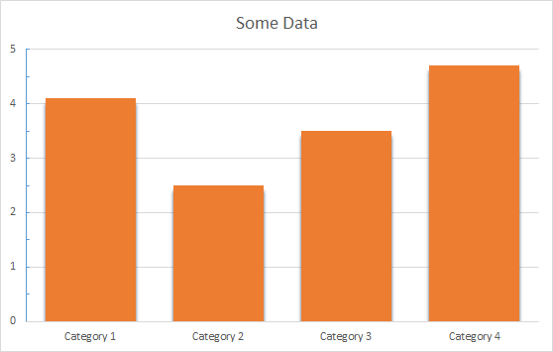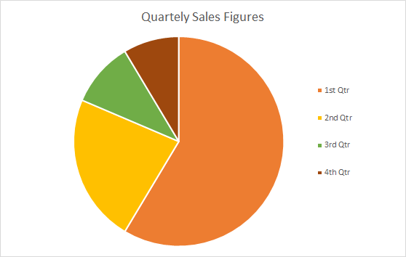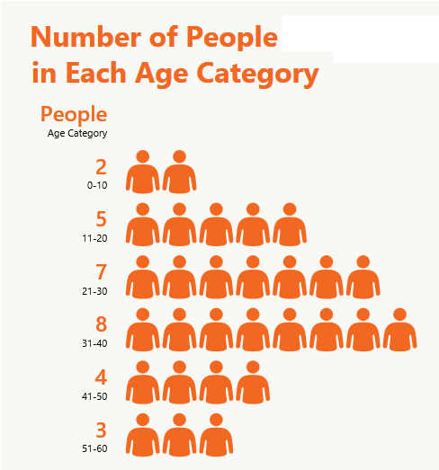
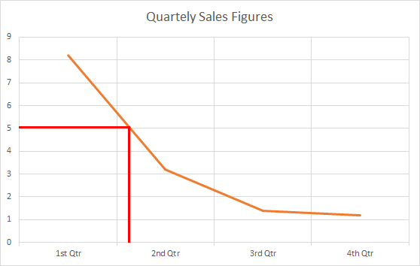
Conclusion: (write it here))

Conclusion: (write it here))

