Scenario Title:

Learning Activities | Free thinking, sharing ideas |  | Looking for and finding content |  | 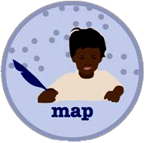  Structuring thoughts |  | 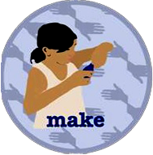  Developing or practising |  | Interviewing/  Feedback |  | 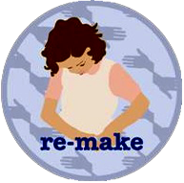  Revising |  | Performing and presenting
Time (weeks)
Goal
(learning outcomes, match to specification)
Description
(of each learning activity)
Learning Environment/s
(the physical or virtual setting(s) in which learning takes place)
Digital Technologies and Tools
Roles
(teacher, students, parents, experts, etc.)
Collaboration
(team work)

Individual Work
(personalisation)
Reflection
(reflecting upon one’s learning and reporting activity status and progress)
Assessment
(type, instruments)

This template was originally developed within the Creative Classrooms Lab project, and is being used for the purposes of the CO-LAB project.

