TÁBOR RALLY 2019; ERASMUS+/eTwinning Project; „School 21, Digitally and Socially Yours“

- take the walking tour of the town, visit the main sights (1 – 11 in the photo guide) and complete the tasks
- complete all the tasks on the list
- come back to school at about 15:30
---------------------------------------------------------------------------------------------------------------------------------------------------

1 Visit the main sights: start at Jordan Lake, finish at Parkany Street
- take a eye-catching photo of each sight (with or without team members)
- take a funny photo of your team
- take a photo of a letter E made by your team members

2 Complete these photo tasks on the way from one sight to another:
- your team making a star with their fingers
- whole team´s left shoes
- team selfie with something blue
- team member/s picking up litter
- super silly selfie
- team members doing a dance
- team members walking like ducks
- smelling a flower (team member/s)
- showing a catalogue pose (team member/s)
- showing a Czech Easter tradition (whipping, team members)

3 Come back to school at about 15:30 (computer labs 474, 475)
4 Create your Tabor Rally online diary with photo captions (online presentation for each team; online tool: addtext.com)

TÁBOR PHOTO GUIDE
1 Jordan Lake (1492)  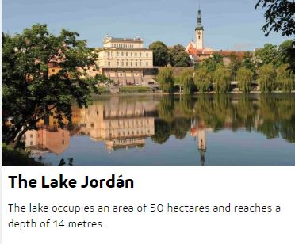 | 2 Shooting Range (1894)  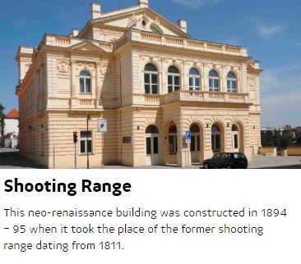
3 Water Tower (1559)  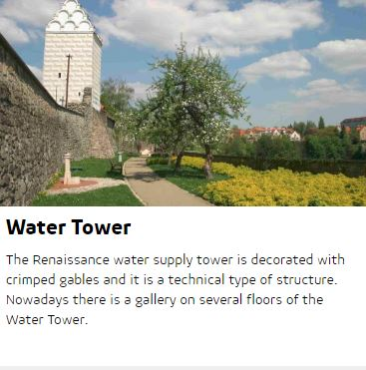 | 4 Town Walls (15 – 16th centuries)  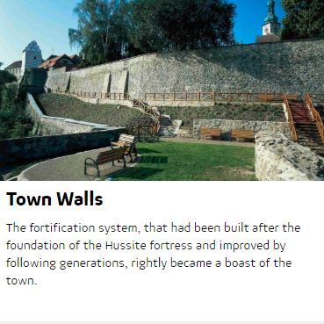
5 Zizka Square (main town square) | 6 Dean Church (1480)  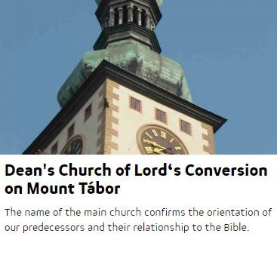

7 Town Hall  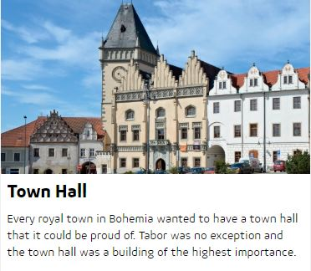 | 8 Jan Zizka Monument (1884)  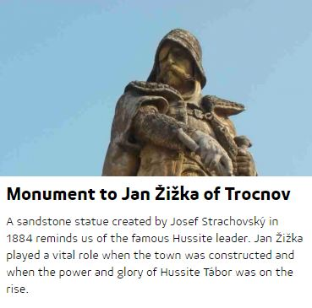
9 Renaissance Fountain (1567)  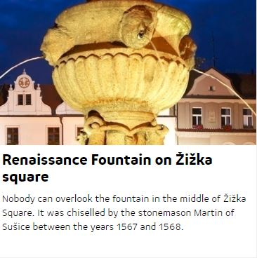 | 10 Oskar Nedbal Theatre (1887)  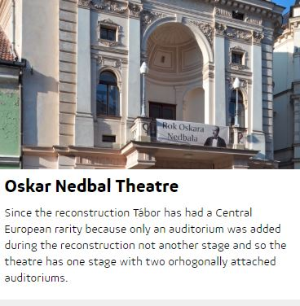
11 Luznice River
