Marsican Bear
(Center of Italy)

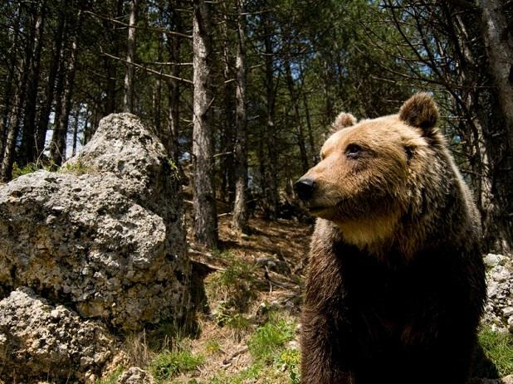
Etymology
lat. ursus; lat. scient. Ursus Linneo, 1758; fr. ours; sp. oso; ted. Bär; ingl. Bear- Ursus derived from an archaic form “orcsos”, dating back to the indo-european ṛkyo - “orso”.
It is present only in central Italy and in no other part of the world, it belongs to a subspecies from the bears of the Alps. The males of marsican brown bear reach a weight between 130 and 150 kg, while the females barely exceed 120 kg. It is the most important Italian carnivorous, even if its diet consists of about 80% of vegetable substances. It lives mainly in mountain woods.
Question
How much do the females of the bear weigh?
Answers
A) 200 Kg
B) 80 Kg
C) 120 Kg
D)150 Kg

GOAT- Rupicapra pyrenaica ornata
(Central Italy Apennine chain)
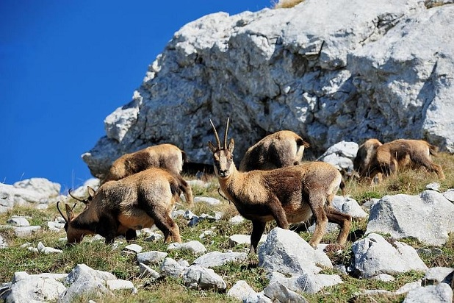
Etymology

From late Latin camox-ōcis.
It is considered “the most beautiful Chamois in the world”. It is one of the rarest faunal entities in Italy. It is a herbivore of the grasslands in hight quotes, over 2000 metres, used to living in inacessible places, above all in rocky walls where it is sheltered to escape predator attacks. If it is alarmed, the chamois emits a typical warning whistle.
Question
What does the Chamois do in case of danger?
Answers
A) Shouts
B) Whistles
C) Howls
D) Ceases

FOX
(Boreal Hemisphere)

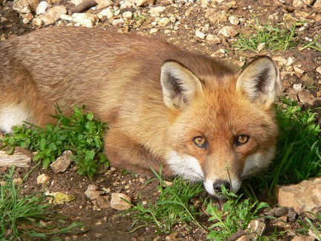
Etymology
lat. vulpes; lat. scient. Vulpes Frisch, 1775; fr. renard; sp. zorro; ted. Fuchs; ingl. fox).
Originated in Eurasia, it is the biggest among the foxes. It is a carnivorous mammal of average dimensions, with thin and lean forms. The predominant color is tawny tending to a reddish brown. Its individual feature for excellence is the long thick fur tail. The birth takes place between March and April and every female can give birth from three to eight cubs. The male actively takes care of the cubs’ health and defense.
QUESTION
When does the fox’s birth happen?
Answers
A) January/February
B) July/August
C) March/April
D) March/June

BLACK SQUIRREL
(Calabria and Basilicata) Southern Italy

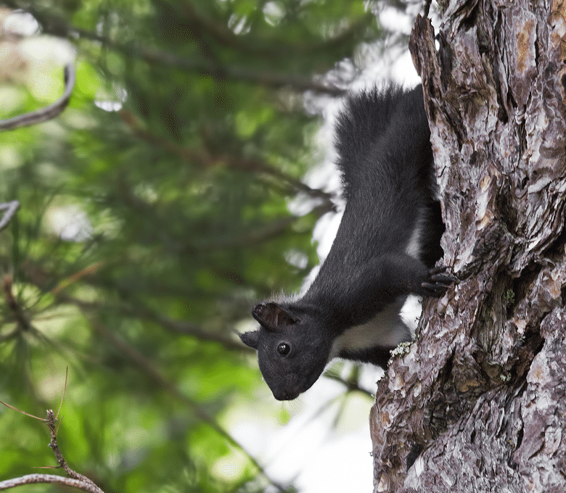
Etymology
The Latin term sciurus, derived from ancient Greek, σκιά and οὐρά, is a word composed of two terms that means shadow and tail.
It presents a unique color of the coat in every season, it is all black in the upper parts, tail included, while the belly is white. The long tail, of thick appearance and rich of long fur, is often kept folded on the body. It is a diurnal species, essentially forest and arboreal. It feeds on a wide variety of types of food, but he prefers the seeds of trees, which he hides and stores.
Question
What is the black squirrel’s favorite food?
Answers
A) Fruits
B) Seeds
C) Grass
D) Meat

Italian Salamander
(Western slope of the Italian Apennine chain)
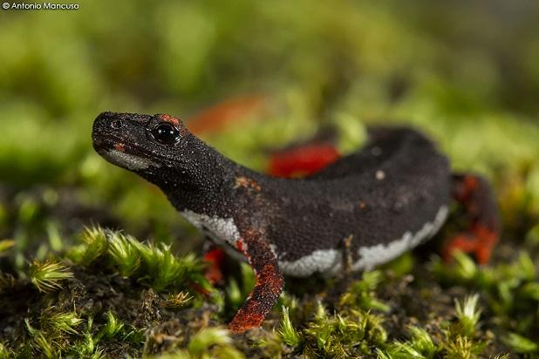

Salamandrina from the Latin and Greek salamándra. gr. σαλαμάνδρα; ; fr. salamandre; sp. salamandra; ingl. salamander; ted. Erdmolch
It is the smallest European example. It lives only in Italy and is active exclusively at night or in cool and covered weather. The adult feeds on invertebrates, mainly annelids, molluscs and insects that it captures with its long and sticky tongue. Pliny the Elder in his Naturalis historia reports the belief that the salamander had the power to extinguish the fire.
Question
What power did the Salamander have according to Pliny the Elder?

Answers
A) to trasform people
B) to kill giraffes
C) to estinguish the fire
D) to produce water

Cyclamen persicum
(Mediterranean Region- Appenines)

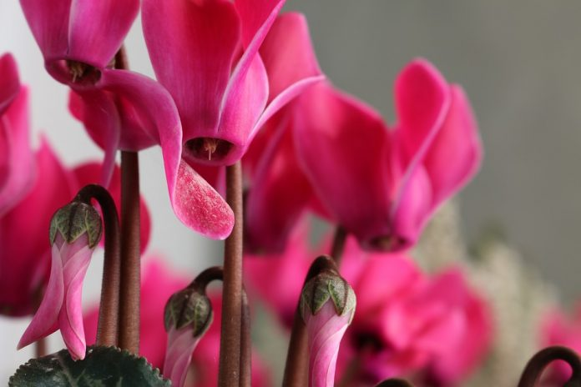
Etymology
Greek: κυκλάμινος, κύκλος "circle"; lat. scient. Cyclamen persicum; it. panporcino; fr. cyclamen; sp. artánita, pan de puerco; ted. Erdscheibe; ingl. sowbread
Perennial herbaceous plant develops large roundish tubers; the leaves have the shape of a heart and an intense green color, the flower appears in groups, with its petals turned upwards in shades of pink and red, or two colors. Flowering lasts from September until Spring.
The root of the plant has anti-inflammatory and antimicrobial properties.
The ancients believed the plant was able to facilitate conception for its shape.
Question
What properties does the root of the plant have?

Answers
A) Antihistaminic
B) Diuretic
C) Antiflammatory
D) Laxative

BORAGE-BORRAGO OFFICINALIS
(Everywhere in Italy
from Mediterranean to Sub Mountain)

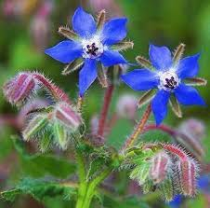
Etymology
lat. sc. Borrago officinalis L., fr. bourrache; sp. Borraja; ted. Gurkenkraut, Boretsch; ingl. borage
Very common annual plant of the Borraginacee family, it can be found everywhere with its blue-violet star-shaped flowers with almost 5 black stamens, the stem is covered with stiff hairs and the leaves are covered by a dense fuzz which gives it a velvety appearance.
The ancient Romans considered borage an excellent remedy against melancholy.
French and English people obtained from it a cool summer drink.
What is the colour of the stamens of the Borage:
a) Green
b) Black
c ) White
d) Blue- violet

CAPER BUSH-CAPPARIS SPINOSA
(South Italy- Mediterranean coasts))
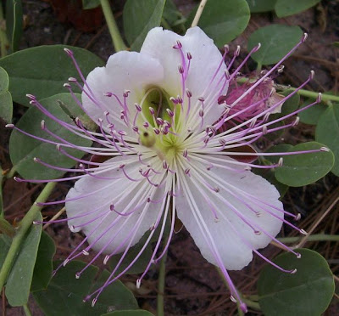
Etymology
lat. scient. Capparis spinosa L.; fr. câprier; sp. alcaparra; ted. Kapper; ingl. caperbush)

Bushy woody plant with numerous ascending branches, oval leaves, with two curved spines at the base of the petiole. The flowers are solitary, axillary and showy, with large white or rosy petals and numerous stamens with long purple strands of beautiful effect. The fruit is an oblong oval berry. It lives spontaneously in the Mediterranean region in the cracks of the rocks and of old walls. The buds called capers are harvested, put in vinegar and used for sauce and seasoning with aromatic properties.
Question
Which part of the plant is frequently used?

Answers
- The root
- The bud
- The stem
- The flower

Narcissus
(Mediterreanean Region)
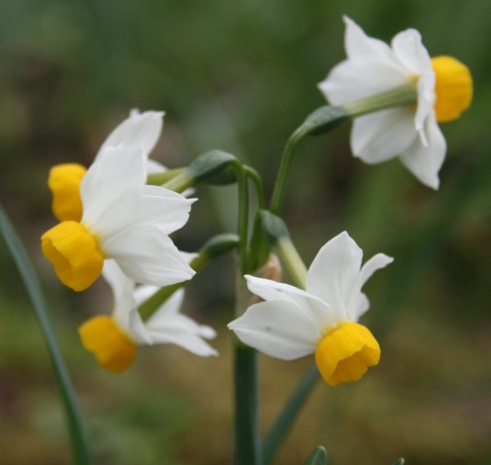
Etymology
Greek narkào - stun in relation to the intense perfume of its flowers. From latin Narcissus.
Perennial bulbous herbaceous plant with fragrant, sessile flowers forming an umbrella placed on peduncles of different length that depart from a whitish membranous. Due to its anti-inflammatory and analgesic properties, the bulb was used to treat abscesses and mastitis. It was boiled, cut into pieces and applied to the skin. It has emetic properties and its scent is useful against migraines.
Its essential oil is used in perfumery.
Question
Its scent can help in case of _______________
- Headache
- High temperature
- Backache
- Vomit

Calendula officinalis L.
(Mediterranean Region)
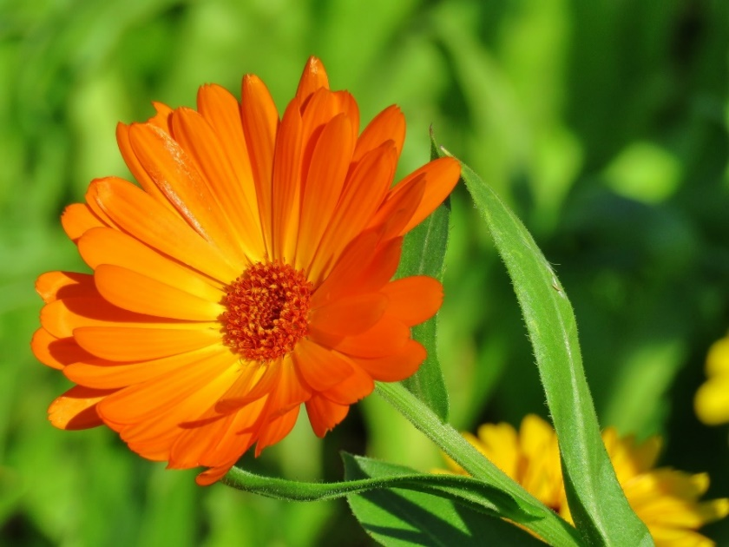
Etymology
The name derives from the Latin calendae which was indicated by Romans as the first day of the month, (figuratively, meaning that it blossoms every month). Calendula has its origins in Egypt.
Herbaceous plant with erect stem rich in hair, with yellow-orange-flowered heads. It flourishes in Spring and Summer. The Calendula extract is very useful for its soothing and calming properties.
The petals and the whole Calendula flower can be used to prepare soups, risotto and salads.
The flowers in bud can be collected and prepared as pickle.
The farmers used the flowers to predict the weather : if they remained closed in the morning, it would have probably rained.
Question
What colour is the flower of Calendula?
Answers
- Pink
- White
- Orange
- Green

