GOLDEN EAGLE.
(Sierra de las Nieves) South Spain.

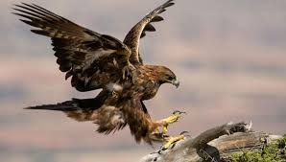

Etymology
The golden eagle (Aquila chrysaetos)
Aquila is Latin for "eagle", possibly derived from aquilus, "dark in colour".

The golden eagle is the most common of the Iberian Peninsula. It inhabits mountainous areas. These diurnal birds of prey are dark brown. They are noted for their strength, size, excellent long-distance vision, and powers of flight.

They use their agility and speed combined with powerful feet to hunt preys like: hares, rabbits, marmots and squirrels.

Question:
What features do eagles usually use to hunt?

Answers:
- powers of flight.
- excellent long-distance vision.
- their agility and speed.
- brown plumage.

FLAMINGO.
(Fuente de Piedra)
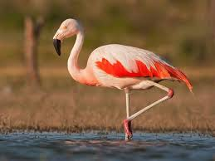

Etymology
The name "flamingo" comes from Portuguese or Spanish flamengo, "flame-colored".

Flamingos are a type of wading bird. The greater flamingo is the most widespread and largest species.
This species lays a single chalky-white egg on a mud mound. Most of the plumage is pinkish. The beak is pink with a restricted black tip, and the legs are entirely pink. It lives in mudflats and shallow lagoons with salt water. It feeds on small shrimp, seeds and algae.

Question: What do flamingos eat?

Answers:
- shrimps.
- fish.
- grass and mud.
- shrimps, seeds and algae.

IBERIAN LYNX.

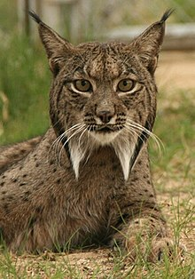

Etymology
Lince (“lynx”) + ibérico (“Iberian”), its habitat is in the Iberian Peninsula.

The Iberian lynx is a wild cat species native to the Iberian Peninsula in southwestern Europe that is listed as endangered.
The Iberian lynx is heavily spotted, with long legs and a very short tail with a black tip. Its hair is red with dark spots and it has a characteristic "beard" around its face and big black tufts on its ears.
It feeds mostly on the European rabbit.

Question:
What is the main food of the Iberian lynx?

Answers:
- grass.
- apples.
- rabbits.
- horses.

WHITE STORK.

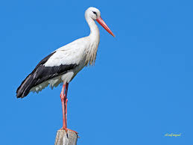

Etymology
Old English storc, of Germanic origin; probably related to stark (because of its rigid stance).

Storks are large, long-legged, long-necked wading birds with long, stout beaks. Many species are migratory birds. Storks plumage is mostly white with black on its wings. Adults have long red legs and long pointed red beaks. The white stork is carnivore. It eats many types of animals like insects, fish, amphibians, reptiles, small mammals and small birds.
The white stork has a wide although disjunct habitat ranging across Europe, gathered mostly in the Iberian Peninsula and North Africa.

Question:
What kind of animal is the white stork according to its diet?

Answers:
- homnivore.
- hervivire.
- carnivore.

IBERIAN WOLF.

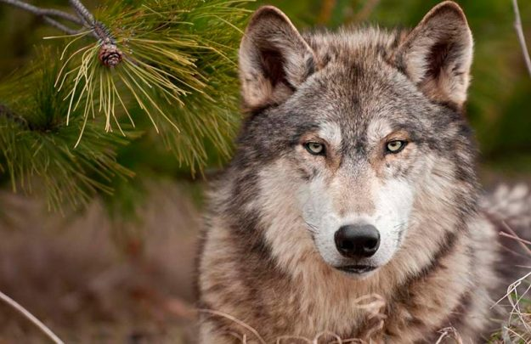

Etymology
Old English wulf, of Germanic origin.

The Iberian wolf is a subspecies of grey wolf that lives the northwest of the Iberian Peninsula, which includes northern Portugal and northwestern Spain.
The Iberian wolf is slim, with white marks on the upper lips. Wolves usually have dark marks on their tail and front legs. This gives them the subspecies name of “signatus” ("marked").
The Iberian wolf lives in small herds. It eats boars, rabbits, roe deer, red deer, ibexes and even small carnivores and fish.

Question:
How do Iberian wolves live?

Answers:
- alone.
- in big herds
- in family.
- in small herds.

CHESTNUT.

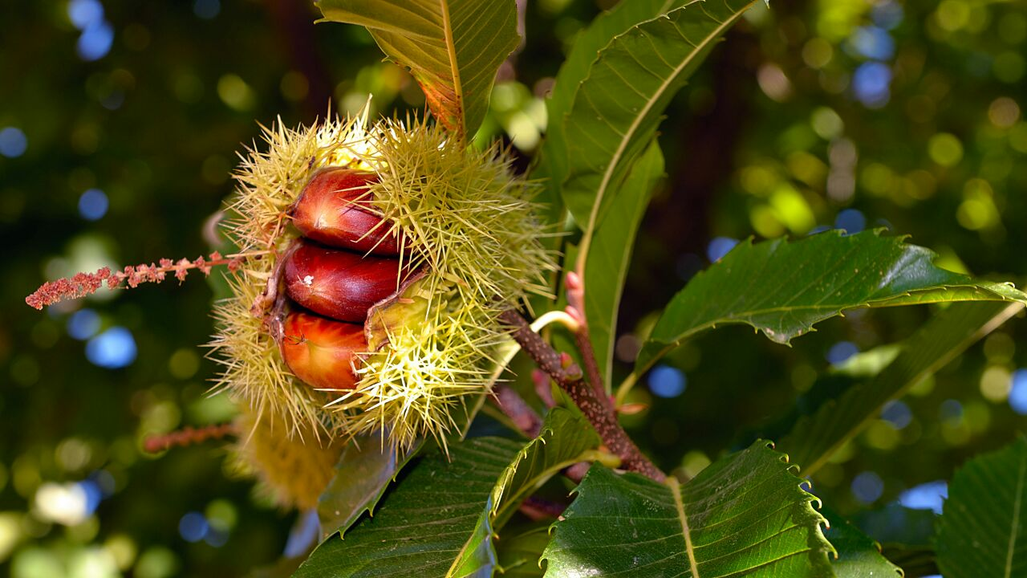

Etymology
Early 16th century: from Old English chesten (from Old French chastaine, via Latin from Greek kastanea ) + nut.

The chestnut is a tree which fruit, the chestnut, is edible. They are native to warm regions of the Northern Hemisphere.
The fruit is in a spiny (very sharp) cupule and contains one to seven nuts. The European chestnuts have good size, sweet taste and easy-to-remove inner skins.

Question:
How is the cupule where the chestnut is?

Answers:
- soft.
- spiny.
- rugged.
- elastic.

SPANISH BELLFLOWER.

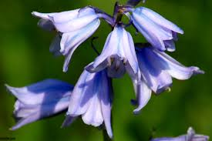

Etymology
Latin name ("campanula"), meaning small bell. Common names include bindweed and morning glory.

They are annual or perennial herbaceous vines and other with woody shrubs, growing to 0.3–3 m tall. The leaves are spirally arranged and the flowers trumpet-shaped, mostly white or pink, but blue, violet, purple or yellow in some species.

The genus includes over 500 species and several subspecies, distributed across the warm and subtropical regions of the Northern Hemisphere.

Many species contain white latex in the leaves and stems.
The flowers are blue to purple, sometimes white or pink.

Question:
What substance does its leaves and stems contain?

Answers:
- glue.
- latex.
- sap.
- resin.

ARBUTUS UNEDO

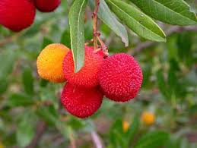

Etymology
From New Latin Arbutus (genus name), from Latin arbutus.

Arbutus unedo is an evergreen shrub, native to the Mediterranean region and western Europe, north to western France and Ireland.
The hermaphrodite flowers are white bell-shaped.
The fruit is a red berry with a rough surface. It is edible. The fruit is sweet when it is red.

Question:
What color is the fruit when it is sweet?

Answer:
- black.
- blue.
- green.
- red.

ROSEMARY.
(Sierra de las Nieves) South Spain
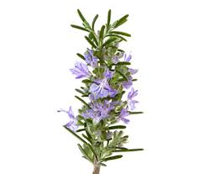

Etymology
Rosmarinus officinalis commonly known as rosemary.

The rosemary is a herb with fragrant, evergreen, needle-like leaves and white, pink, purple, or blue flowers. It is native to the Mediterranean territory. Rosemary grows on loam soil with good drainage in an open, sunny position. It is used to make essential rosemary oil. It can be used for cooking.

Question:
What colour are the flowers of Rosemary?

Answers:
- red.
- orange.
- green and pink.
- blue and purple.

PINE TREE.
(Ronda) South Spain

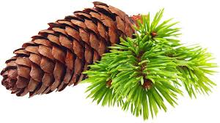
Etymology
The modern English name "pine" derives from Latin pinus.

Pines trees are long lived. Some can reach from 100 to 1,000 years. One of the oldest pines is found in Sweeden, in Fulufjället National Park. It´s 9.500 year old and regenerates itself through its roots. This has been investigated by experts studying its carbon footprint.

Pine trees are evergreen. Their needle form of leaves allows the trees to survive the abrupt changes of temperatures when water availability is little.

Question:
Where is the oldest pine tree of the world?

Answers:
- Sweeden
- California
- England
- Alaska

