APPLE TREE

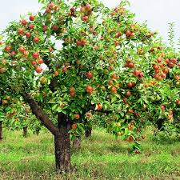

Etymology:
Old English æppel, of Germanic origin; related to Dutch appel and German Apfel

Trees or shrubs. Apple fruit - mostly spherical, green, yellow, red or yellow with blush. The fruits differ in taste, aroma, sweetness, consistency and appearance.
The largest apple producers in the world are China, the United States and Poland.

Question:
What country is the largest producer of apples in Europe?

Answers:
A. Poland
B. Spain
C. Romania
D. Turkey

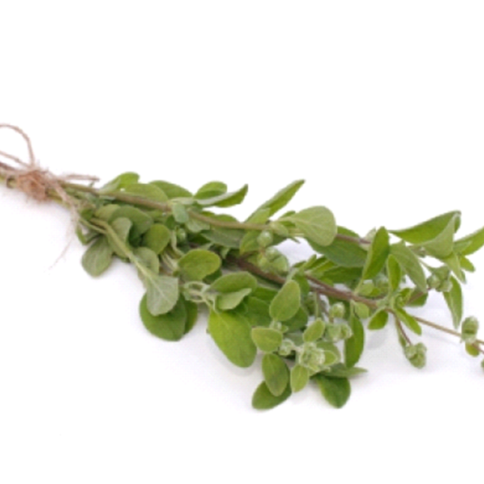
MARJORAM

Etymology:

Medieval Latin maiorana, a word of uncertain origin, probably ultimately from India (compare Sanskrit maruva- "marjoram"), with form influenced by Latin major "greater."

Marjoram - a spice added to meat and tomato dishes. It has got healing properties used in natural medicine. Marjoram is a proven way to runny nose, cough, stomachaches, digestion problems.

Question :
What is marjoram not used for?

Answers:
A. clothes
B. food
C. medicine
D. tomato soup

OAK

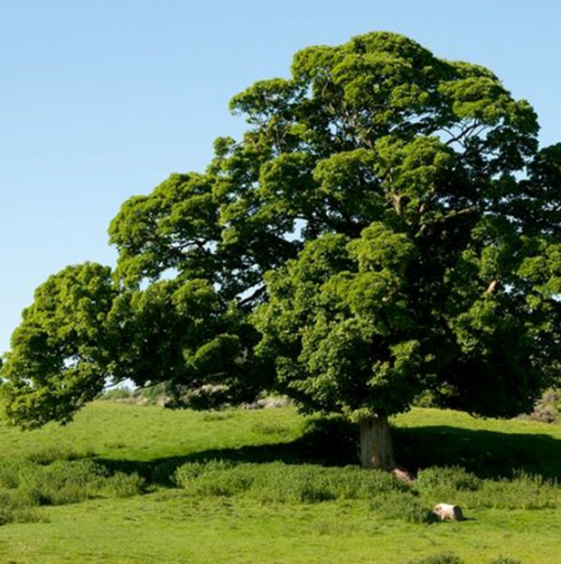

Etymology:

Etymology:

Old English āc, of Germanic origin; related to Dutch eik and German Eiche

A type of tree, rarely tall shrubs included in the beech family occurring almost exclusively in the temperate zone of the northen hemisphere and in the upper parts of the mountains of the tropical zone . The oak in Poland usually reaches a height of up to 50 m and a diameter of up 2 m . It lives on average 600-1000 years.

Question :
What age can the oldest oak tree be?

Answers:
a. 50years old
b. 100 years ols
c. 200 years ol
d. 1000 years old
LILY OF THE VALLEY

Etymology:
From Latin convallis (“valley”)

Lily of the valley (Convallaria majalis) is a highly poisonous fragrant flowering plant used in religious ceremonies, world celebrations, perfumes and gardens. Also known as the May lily, it means "chastity, purity, luck and humility."

Question:
In what month can you see the lily of the valley?

Answers:
A. in December
B. In May
C. in October
D. in January

BEETROOT
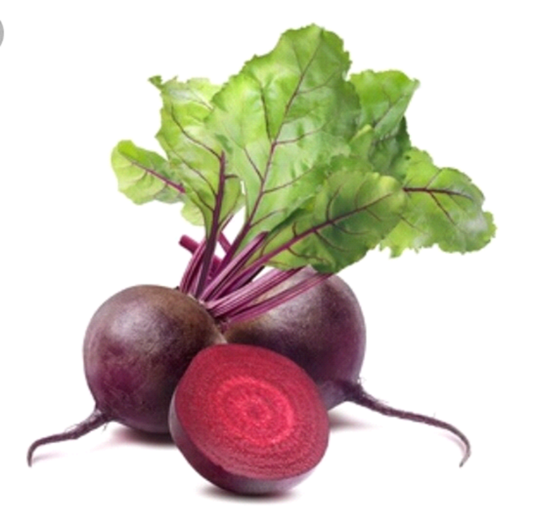

Etymology:

Old English bēte, of West Germanic origin, from Latin beta, perhaps of Celtic origin; related to Dutch beet and German Bete

Beetroots contain vitamin C, sugars, protein, carotene and a lot of mineral elements: iron, magnesium, potassium, calcium. For our health, it's better to eat raw beets, because the elements dissolve in water, which means that when eating boiled beets, we get rid of the most valuable ingredients.

Question:
When is a beetroot the healthiest?

Answers:
A. raw
B. boiled
C. fried
D. baked

BISON

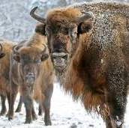

Etymology:

"European wild ox," from French bison , from Latin bison "wild ox," borrowed from Proto-Germanic *wisand- "aurochs" . Old High German wisunt"bison,"

Bisons are big animals with brown fur. They are eating plants The animal formerly was widespread on the continent, including the British Isles, but in 20c. survived in the wild only in a forest reserve in Poland.– 1635 in 2017.

Question:
What country do bisons live in the wild?

Answers:
A. Italy
B. Poland
C. Romania and Spain
D. Turkey

STORK

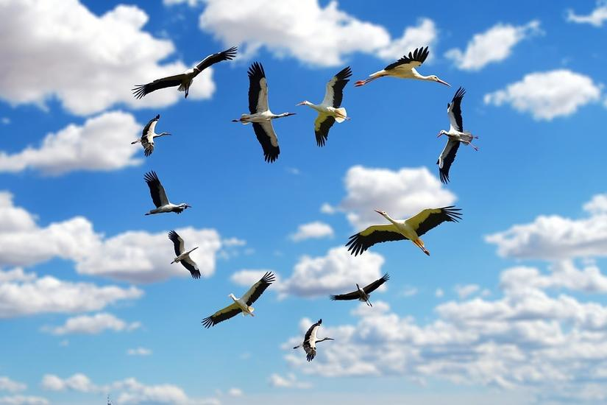
S

Etymology:
Old English storc "stork," from Proto-Germanic *sturkaz means „stiff." Perhaps so called with reference to the bird's stiff or rigid posture.

Storks are large, long-legged, long-necked wading birds with white head and body, orange legs and black wings.
The storks,while migration, avoid flying through seas. When they are migrating they fly near Gibraltar straits. Storks usually eat insects, frogs, moles and shrews.

Question:
What sea do storks fly over?

Answers:
A. the Black Sea
B. the Mediterranean Sea
C. the North Sea
D. the Baltic Sea

SEAL

Etymology:
The grey seal (Halichoerus grypus, meaning "hooked-nosed sea pig")

The largest of the Baltic seals. Its population is around 30,000.
It feeds on sand eels, cods and herrings. The average daily food requirement is estimated to be 5 kg (11 lb), though the seal does not feed every day and it fasts during the breeding season.

Question:
How much food should a grey seal eat daily?

Answers:
A. 1 kg
B. 3 kg
C. 5 kg
D. 7 kg

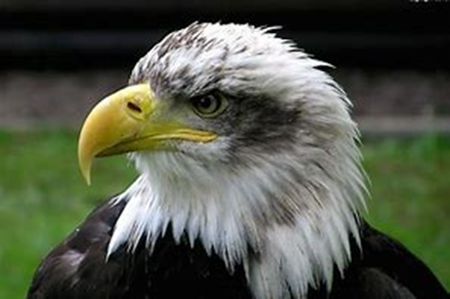
EAGLE

Etymology:
Middle English: from Old French aigle, from Latin aquila . aquilo meaning north wind.
Eagles are large, powerfully built birds. They are very fast and they have a very good eyesight. Eagles are usually hunting without landing. They can fly at speed of 150-190 km / h. When attacking a hare, fox, groundhog, or a young goat, its speed
reaches 320 km / h.

Question:
What is the highest speed an eagle can reach?

Answers:
A. 50 km / h
B. 170 km / h
C. 250 km / h
D. 320 km / h

BEAVER
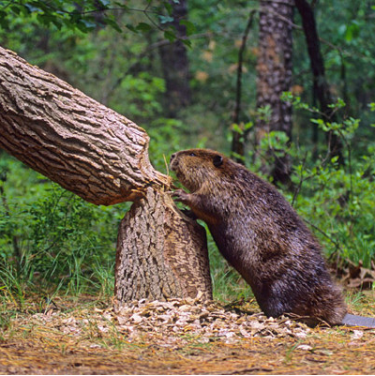

Etymology:

The word "beaver" comes from the Old English word beofor or befer (recorded earlier as bebr). The Proto-Germanic word *bher-meaning "brown". In Polish ‘bóbr’

Beaver is a large, primarily nocturnal, semiaquatic rodent. Beavers are known for building dams, canals, and lodges (homes). This population decline is the result of extensive hunting for fur, for glands used as medicine and perfumes.

Question:
What beavers are known for?

Answer:
A. Jumping on trees
B. Being a popular pet
C. Building their own houses and dams
D. Being agressive and wild animal

