DIPLOMA
For the pupils and the parents of
Grupa “PSZCZÓŁKI”
PRZEDSZKOLE MIEJSKIE nr 97 in Lodz/Poland
and their Teacher
ALINA WUJCIK
Congratulation for participation the International eTwinning Program
“Web 2.0 tools in Kindergarten”
2015-2016
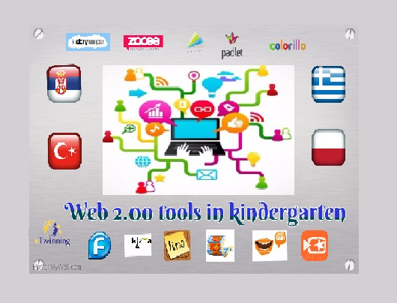
15 JUNE 2016

