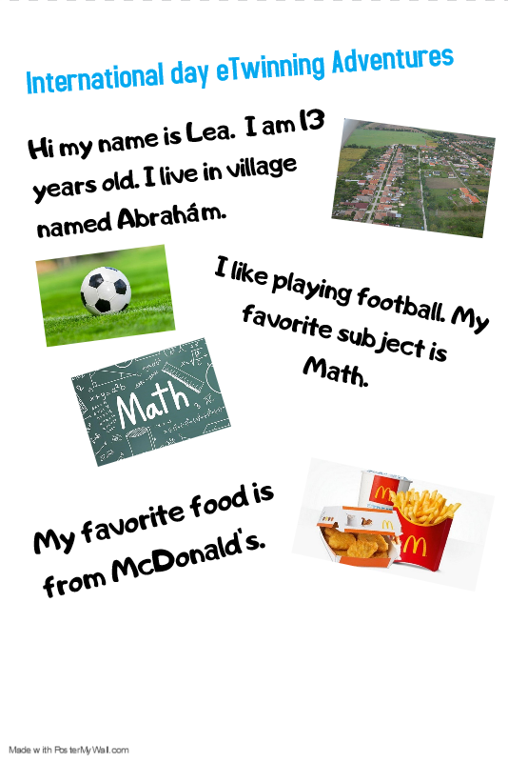

http://old.abraham.sk/index.php/sk/galeria/category/4-obec
https://www.badatel.net/9-hrozostrasnych-faktov-po-ktorych-nikdy-nebudete-jest-v-mcdonalde/
https://www.thestatesman.com/sports/covid-19-australian-football-league-resume-june-1502888960.html
https://www.fife.ac.uk/news/core-skills-and-success-you-do-the-maths/
https://www.123rf.com/photo_35874367_the-national-flag-of-the-united-states-of-america-the-50-stars-on-the-flag-represent-the-50-states-o.html

