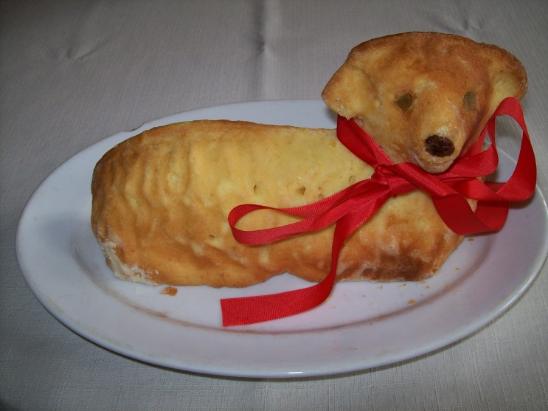
Easter lamb (Beránek)
Ingredients:
4 eggs (whites and yolks separated)
3/4 cup sugar
1 and 1/2 cup flour
1 package (12g) of baking powder
1 package of vanilla sugar
1 package (200ml) of whipping cream
butter for buttering the mould
flour for sifting the mould
Instructions:
Butter a middle-sized lamb-shaped mould and sift it with flour. Preheat the oven to 180°C.
Whip the yolks with sugar. Add flour mixed with baking powder and vanilla sugar. Pour cream and then carefully add the whipped egg whites. Pour everything into the mould and bake for 45 minutes.

