Dumplings with poppy (šúľance s makom) 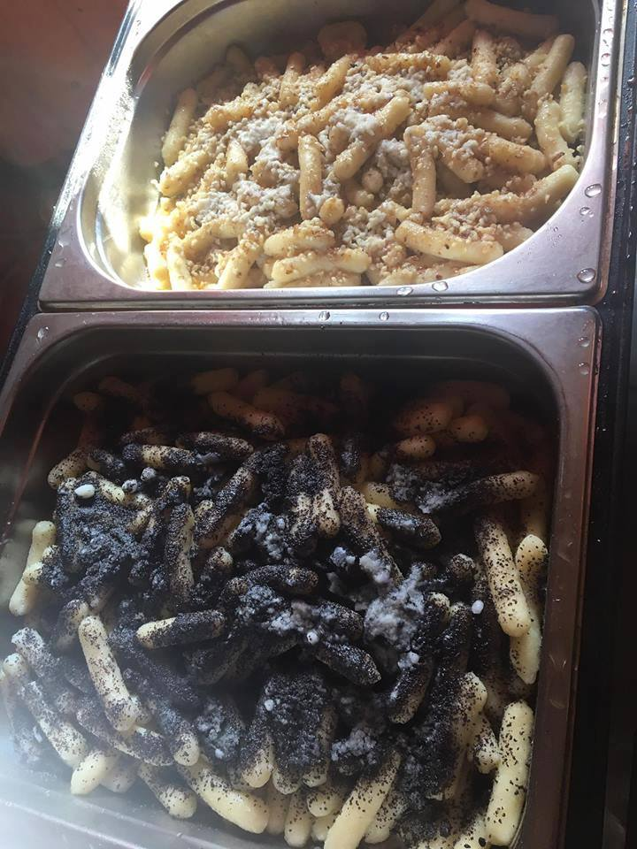
500 g potatoes
200 g flour
Salt
1 piece yolk
200 g poppy
70 g powdered sugar
50 g
butter
Water

We wash the potatoes, cook, peel and grate them.. Put on a plate, add salt, yolk, flour and water as needed.
Second

Thick dough is made and let stand it for 20 minutes. Then we divide it into more parts and form a thinner roller from each part. Then we cut into pieces.

These pieces are spread on a shredded plate and cooked in a larger quantity of salted water.

Remove dumplings with poppy and leave them to drip. Divide them on a plate, sprinkle with ground macaroni mixed with sugar and drop with melted butter.

Potato dumplings with sheep cheese and bacon (bryndzové halušky) 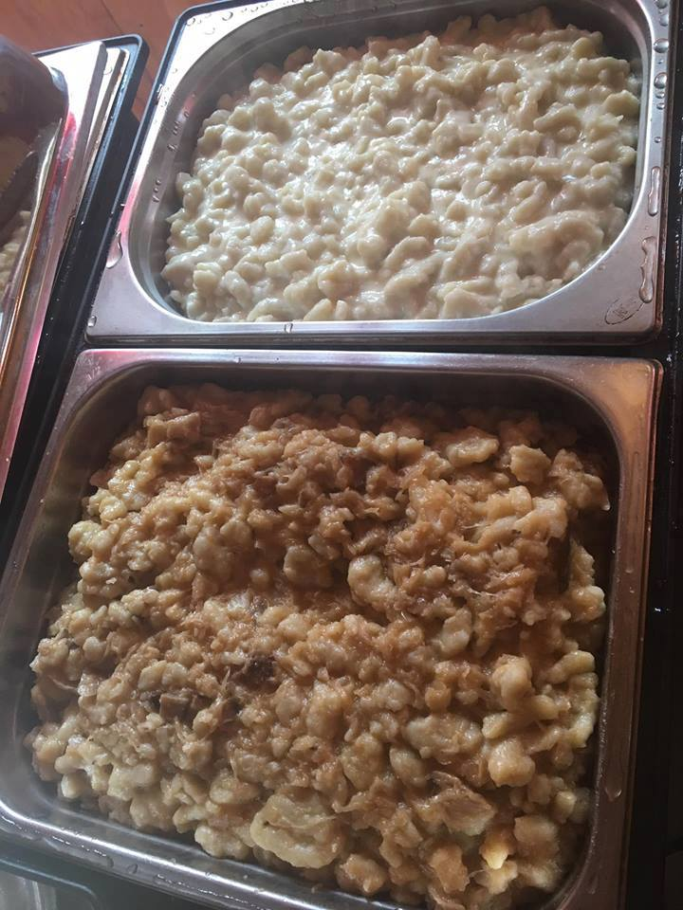 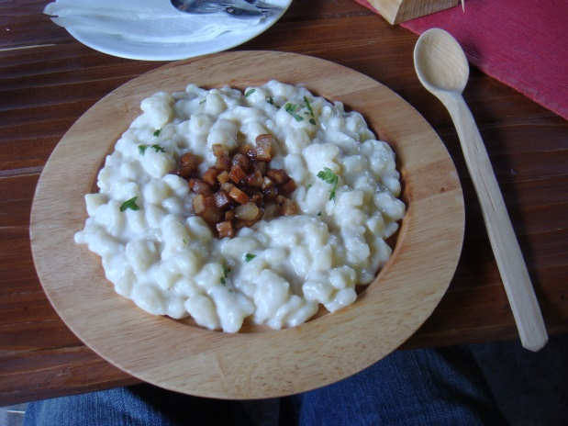

INGREDIENTS
4 pcs potatoes
1 teaspoon salt
300 g Semi-thick flour
250 g sheep cheese
200 g bacon

The potatoes are peeled and fine grated We add salt and the flour gradually according the potatoes. More waterproofed potatoes needs more flour. We cut the bacon into the slips and slowly roast on a mild fire. Dough is pushed into the boiling salty water through the equipment used to make dumplings. Dumplings are shaked occasionaly during the cooking. Let them cook for about 10-15 minutes until it rises to the surface.

Cooked potato dumplings are drained and 3/4 of them are put into a larger bowl, where are mixed with sheep cheese. Be careful, the dumplings must be drained over the pot and dont pour dumpling´s water. This will be used later in for the preparation of soup. We can add clarified butter and mix well. Sprinkle with bacon.

https://en.m.wikipedia.org/wiki/Bryndzov%C3%A9_halu%C5%A1ky

