Easter Lamb ( Veľkonočný baránok) 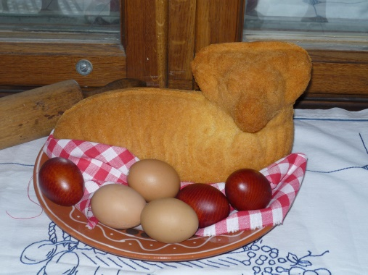
INGREDIENTS
4 pcs egg
200 g Semi-thick flour
200 g powdered sugar
1 piece DrOetker vanilla sugar
1 piece DrOetker baking powder
1/2 dl oil

Prepare form for a lamb. Form is greased and sprinkled with the flour, so that the lamb can be easily removed out of the form once it is baked.
White is whipped with the vanilla Dr.Oetker and powdered sugar. Add the yolks and whisk. Add the flour to the whipped cream mixed with the boiling powder and gently stir.
Dough is poured into the prepared form. Cover it with the another part and roast it. After baking let it open and let it cool down on the grid. Finally flour it with powdered sugar.

https://commons.wikimedia.org/wiki/File:Pe%C4%8Den%C3%BD_ber%C3%A1nek_z_Vyso%C4%8Diny.JPG

