Gingerbread (Perník)

Ingredients:
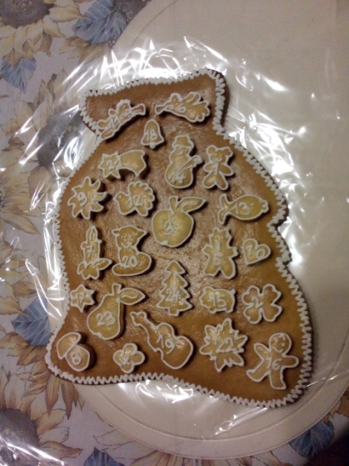
- 250 g honey
- 250 g sugar
- 150 g butter
- 650 g smooth flour
- 2 eggs
- 1 spoon of soda
- 1 spoon of rum
- 1 backing powder

Instructions:
- mix all ingredients together
- then give the pastry to the fridge for one day (at least)
- next day roll pastry to 4mm
- than cut out small pieces pastry with cookie cutter
- bake the gingerbread in the oven preheated to 180°C
- spread the baked gingerbread with the whipped egg

You can decorate the gingerbread with icing made from egg whites.

