Masaryk‘s sweet (Masarykovo cukroví)

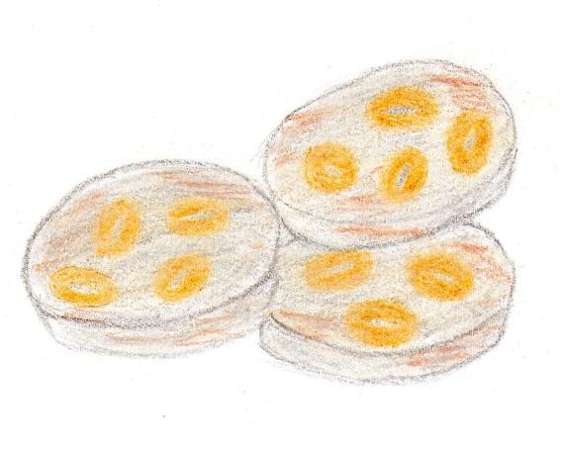
Ingredients:
200g smooth flour
150g butter
70g sugar
1,5 spoon of cocoa powder
1 yolk
100g nuts

Instructions:
Dip the whole nuts into water for 2 hours.
Make the dough from other ingredients.
Put the nuts into the dough and make rolls (diameter – 3 cm).
Put the rolls in the fridge for 24 hours.
Next day, slice them in rounds which are 1 cm thick.
Bake them until they get gold and the coat the hot slices (rounds) in icing sugar.

