Wafers’ pellets (Vaflové kuličky)

Ingredients:
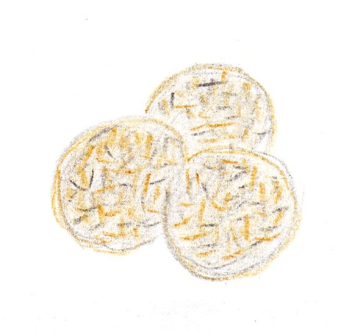
- 4 wafers - grate them coarsely
- 200 g icing sugar
- 2 spoons of milk
- 2 spoons of rum
- 20 g cocoa
- coarsely ground nuts and coconut

Instructions:
Mix everything with a fork.
Make small balls.
Coat them in nuts and coconut.

