Christmas cake (Vánočka)

Ingredients:
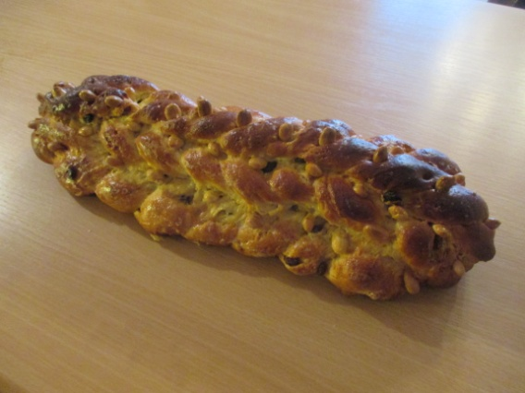
1 kg flour
butter 200 g
250 g caster sugar
84 g yeast
5 pc yolk
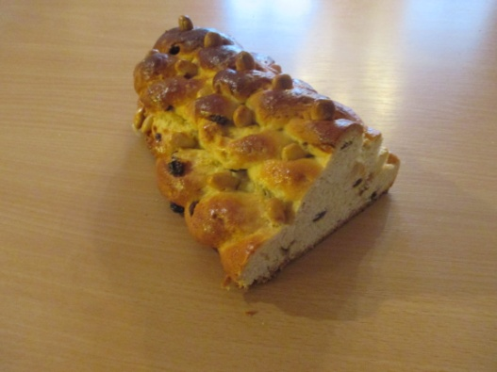
1 egg
140 g almonds
140 g raisins
a pinch of salt
lemon zest (from one lemon)
1 cup of milk

Instructions:
Mix all dry ingredients. Cut butter in. Add slightly beaten egg to warm milk. Stir in raised yeast. On floured board work the liquid into the flour mixture kneading the dough for 10 minutes. Let rise until double in bulk. Return on board, knead in almonds and raisins.
Divide dough in 9 parts. Roll each piece 20 inch strips. Make 3 layers of twists, the bottom one out of 4 strands, middle one of 3 strands and the top one of 2 strands. Grease baking sheet. Braid 4 strands loosely and place on baking sheet. Braid 3 strands loosely and place on top of first braid, twist 2 strands and place on top braid. Let cake rise again, then brush with mixture of 1 egg and 2 tablespoons milk. Sprinkle the cake with almonds.
Put the cake in the preheated oven (200°C), bake for 5 – 7 minutes, then reduce the temperature to 180°C and bake for 45 – 50 minutes.

If you like it you can watch the video how to make the Christmas cake:
https://www.youtube.com/watch?v=hdasc0CrgYs

