Bohemian barley with mushrooms (Černý Kuba)

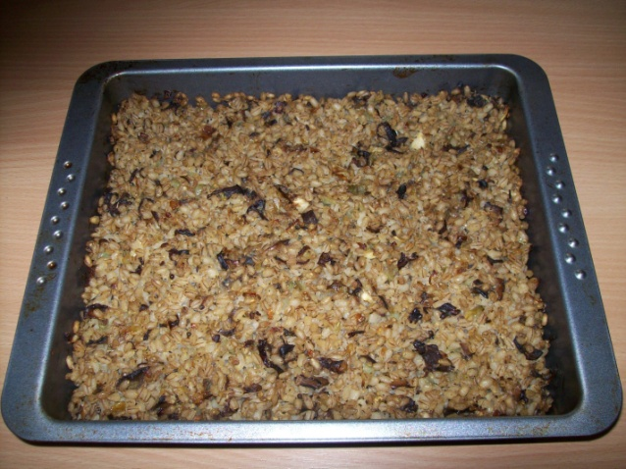
Ingredients:
- 250 g hulled grain (barley)
- 60 g lard
- ¾ litre of water
- 2 handful of dried mushrooms
- 1 onion
- garlic, marjoram, pepper, salt and caraway

Instructions:
Soak dried mushrooms in water for at least 2 hours, then squeeze them to get rid of extra water.
Rinse barley in cold water and cook in salted water until soft, about 20‑30 minutes. Drain and let in the sieve to get rid of water.
Cut onion in small pieces and fry on lard until brownish, add soaked mushrooms cut in bigger pieces. Stir shortly, then add garlic crushed with salt, caraway, marjoram and freshly ground pepper.
Grease the roasting pan, put in barley and mushroom mixture and mix them together. Smooth out and bake in preheated oven at 180°C for about 25 minutes until golden-brown colour.

