Bohemian Potato Pancakes
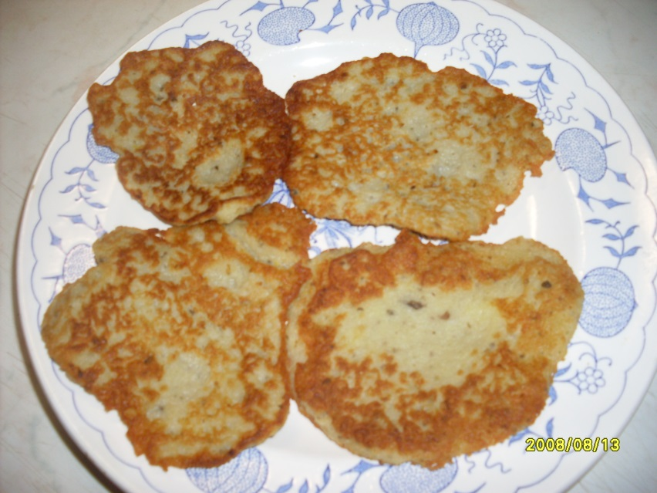
Ingredients:
1 kg potatoes
125 ml milk
120 g flour
3 eggs
4 cloves of garlic
3 tsp marjoram
100 ml oil

Procedure:
Wash, peel and coarsely grate potatoes. Heat milk and pour over the potatoes. Mix in flour and eggs. Finely dice cloves of garlic and add it with pepper and marjoram to the potato mixture. Fry the pancakes one at a time in oil allowing 4 – 5 minutes for each side. Serve hot, straight from the pan.

