Video script Spain
(A1: Make your real life awesome: Your FAKEbook, INSTAgram, TWITTerlife should never be better than your real one)
FAKE LIFE (NO VIDEO)
Storyline, characters | Location, surrounding | Dialogue | Setting, music, sound effects, props | Zoom | Time | Notes
Claudia is sitting on the bed and she grabs the cell phone from the bedside table, she puts on a pair of running shoes (from the closet) and takes a picture of her feet. | Claudia’s house  Her bedroom  At night |  | -Shoes  -Camera  -Camera | LS of the room with the girl  TS of the girl taking the slippers  BEV of of the girl making a picture to the slippers.  LS of of the girl going to bed. | 20” | LS TS BEV LS  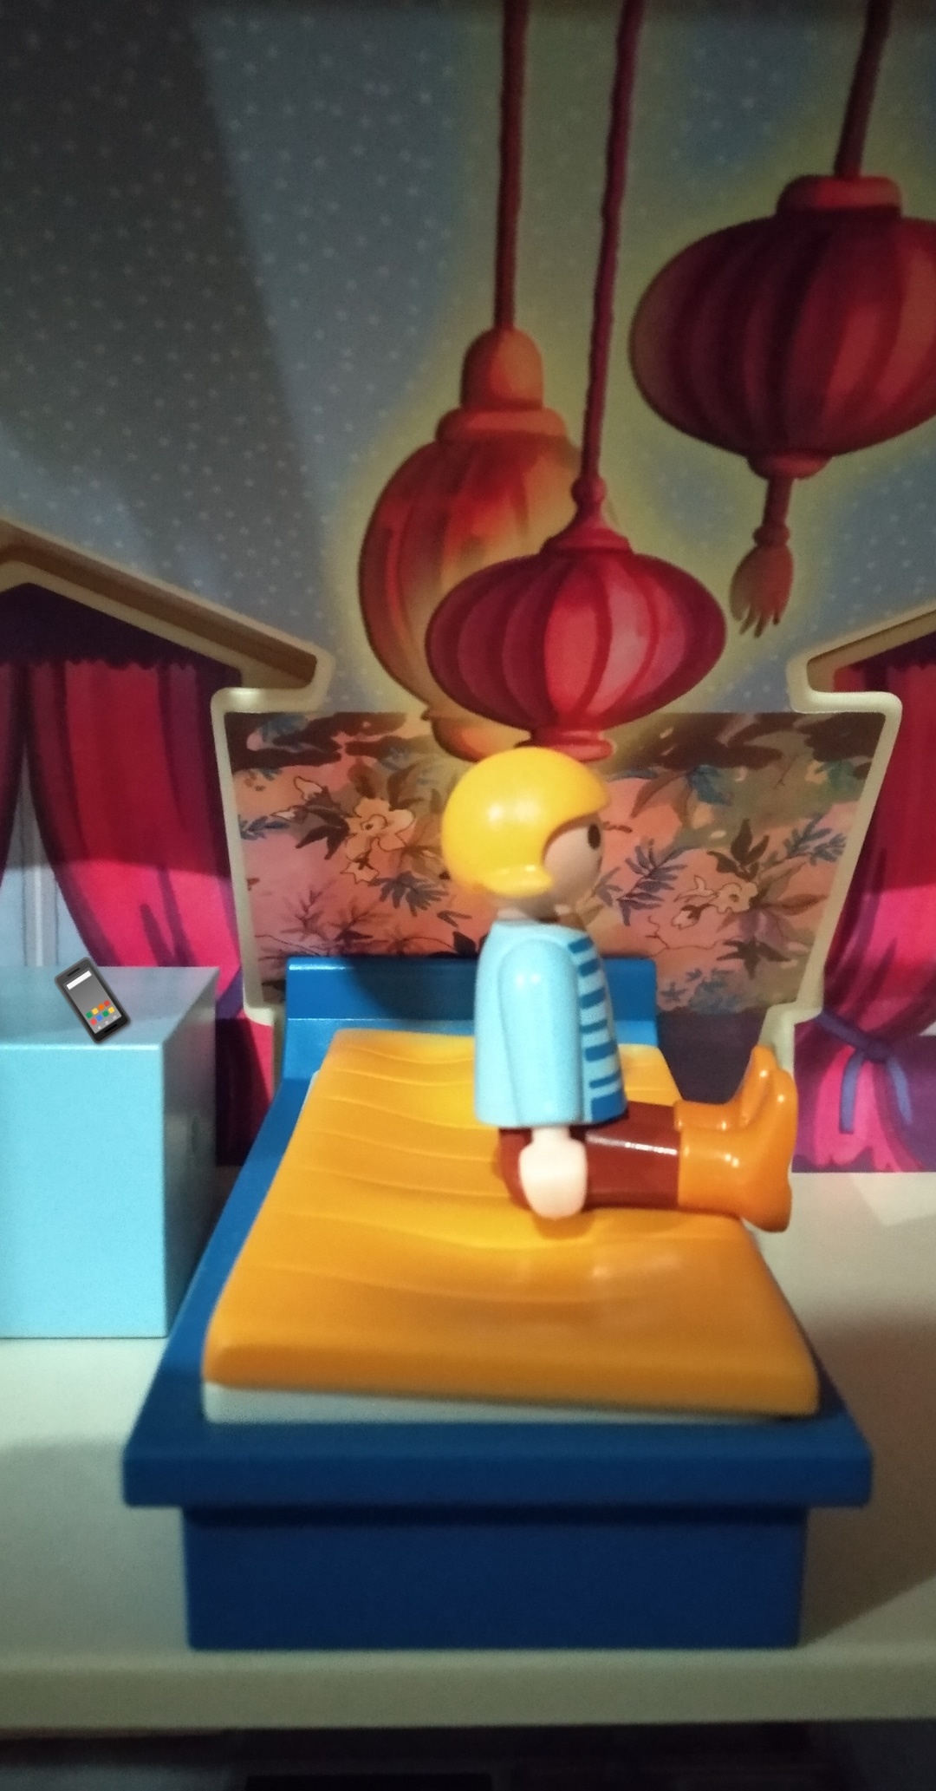 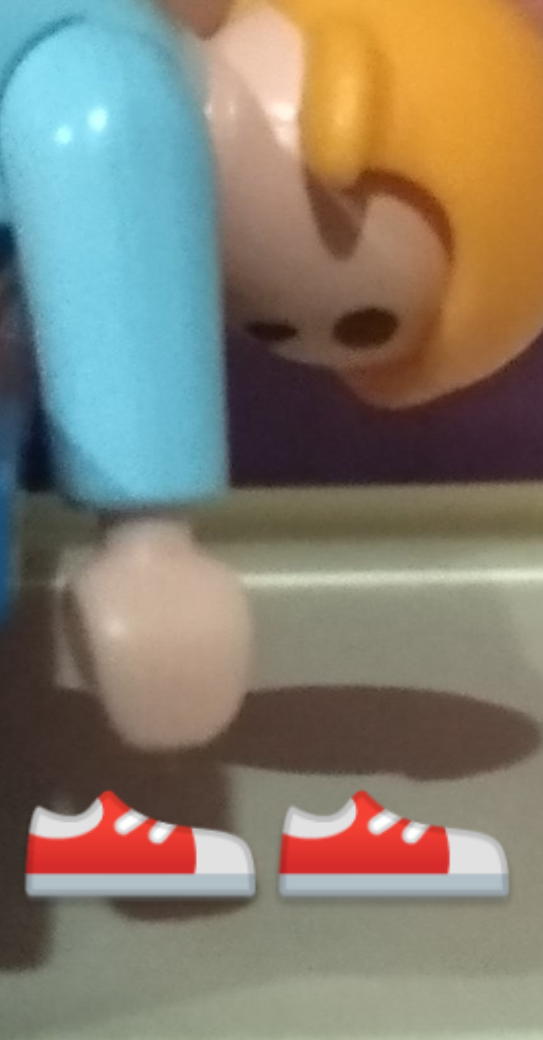 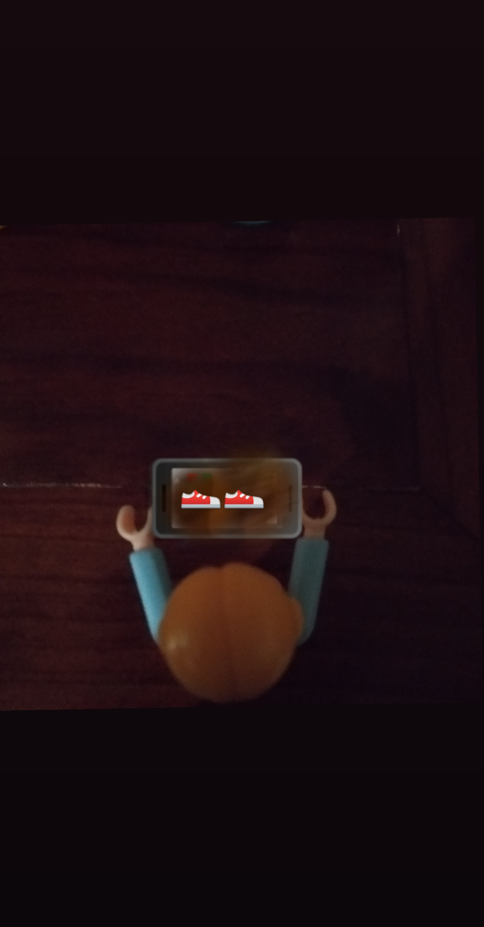 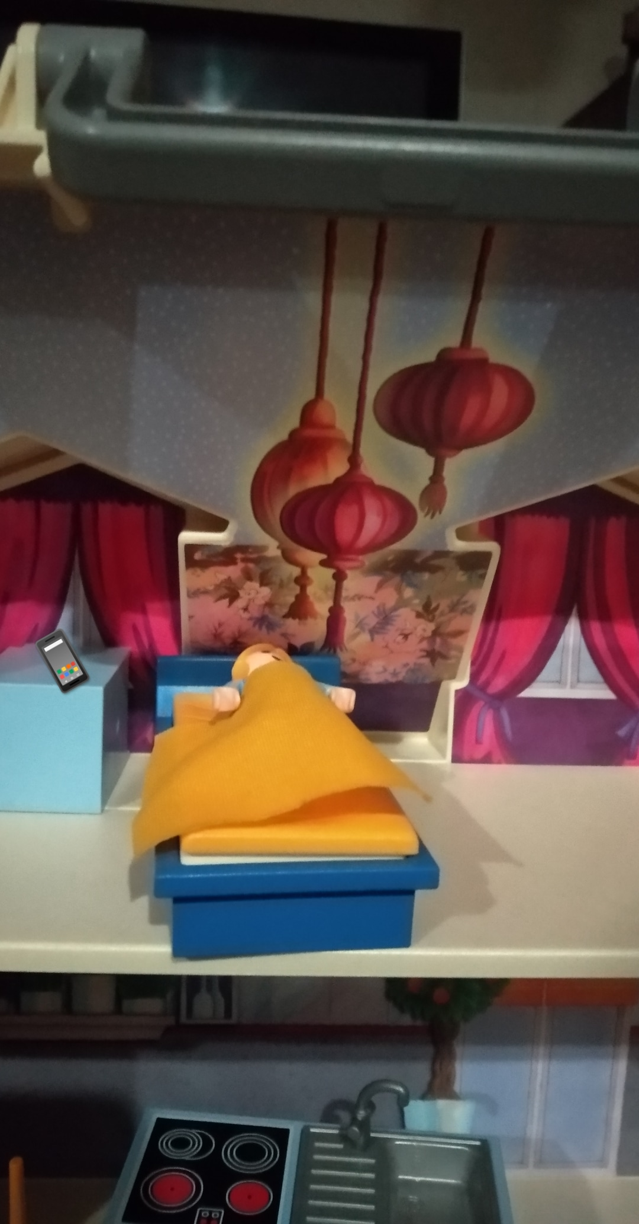
The mobile phone alarm (located on the nightstand) sounds and Claudia wakes up quickly to publish the photo (which she had done the night before) to instagram (so that her followers think she has left running).  (While Claudia writes) she writes:  go for a run #FitnessGirl #HealthyLife.  Claudia publishes the picture, yawns and goes back to sleep | Claudia’s Bedroom (Next morning)  7:00 A.M. |  | -Mobile phone alarm  -Beep: Uploaded completed  -Mobile Keyboard  -Yawn | TS of the mobile phone alarm ringing.  OSS of the girl uploading the pictures.  LS of the girl going to bed. | 25” | TS OSS LS  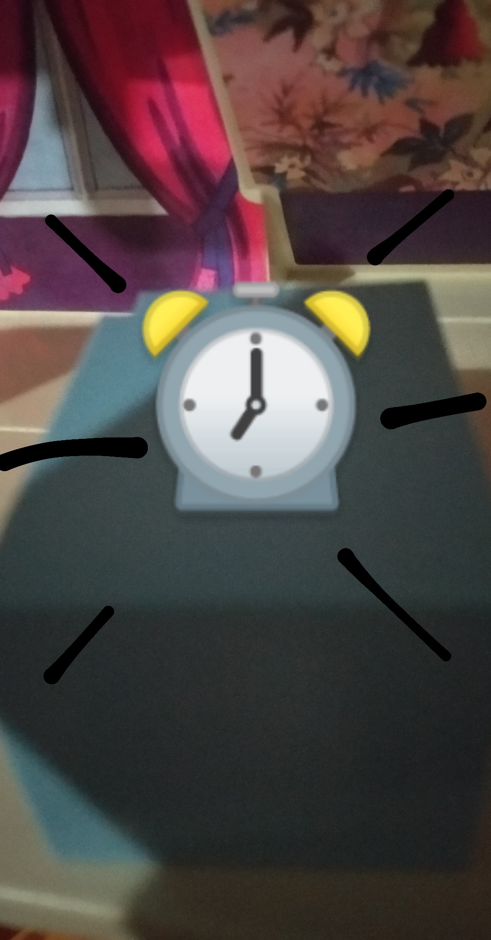 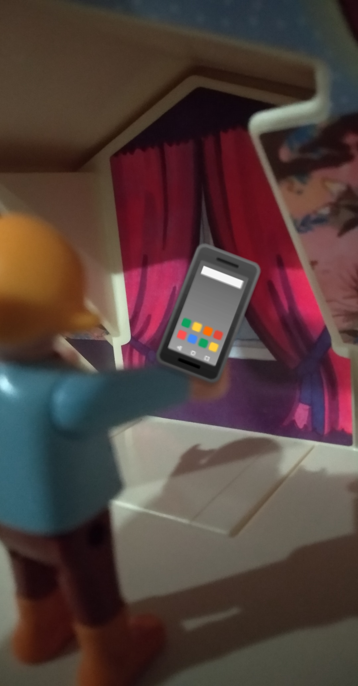
She is applying makeup and combing to post a photo on instagram, pretending to go to a party with many friends.  Claudia writes: tonight party! #PartyHard  After this, Claudia removes the makeup (cleanses) and, discouraged, goes to the sofa. | Cut to: Claudia's house bathroom at night - 9:30 P.M |  | makeup | Zoom IN the mirror (applying makeup)  TS of the mobile with the photo uploaded.  LS of the girl cleansing.  AS of the girl sitting on the sofa (sad) | 30” | Zoom IN TS LS  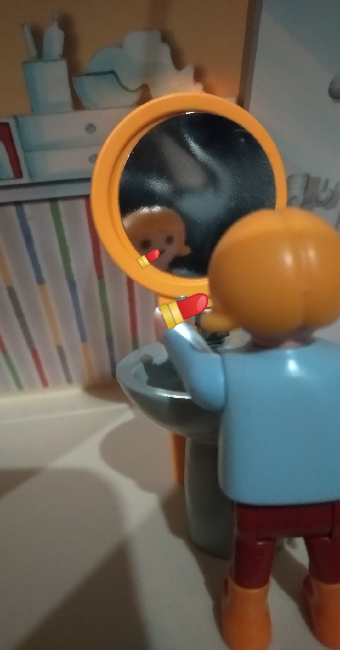 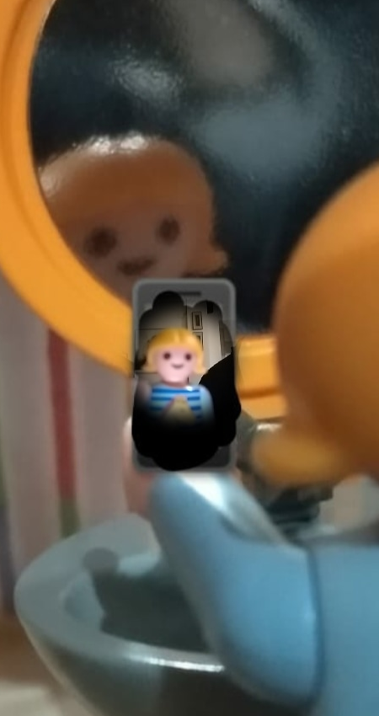 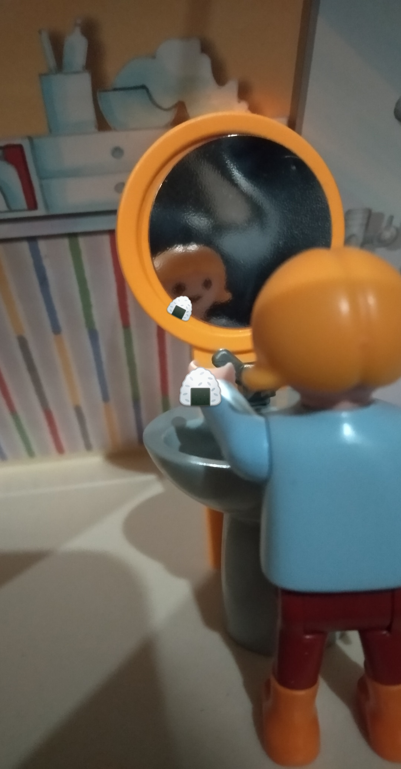
LS: Long shot / TS: Tight shot / BEV: Birds Eye View / OSS: Over-Shoulder Shot / AS: American shot / CU: Close Up
Video script Spain
(A1: Make your real life awesome: Your FAKEbook, INSTAgram, TWITTerlife should never be better than your real one)
REAL LIFE (YES VIDEO)
Storyline, characters | Location, surrounding | Dialogue | Setting, music, sound effects, props | Zoom | Time | Notes
Natalia appears putting on her running shoes, then picks up the keys and leaves the house. | Natalia’s house  Her bedroom  7:30 am |  | Keys, shoes, sport clothes | TS of the alarm clock ringing.  LS of Natalia sitting on the bed.  TS of Natalia taking the shoes | 30” | TS LS TS  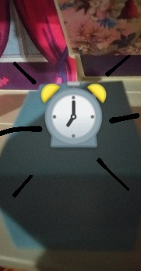 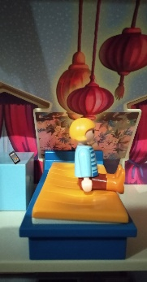 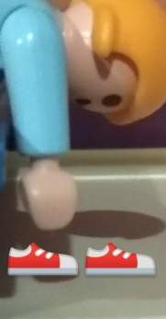
While he is running he meets his friend, who also happened to run and they both go together to train. | On the street |  |  | LS of Natalia running | 15” | LS
Natalia is putting on makeup and combing her hair since she has arranged to meet with her friends at 10 o'clock (she spends half an hour more and she’s late) (they knock on the door) and she takes the bag and goes out with them to the disco.  (the camera records the face of happiness of all). | Natalia’s house  Her bedroom  9:30 pm |  | Makeup | OSS of Natalia putting on makeup.  LS of her friends ringing the bell.  LS of Natalia and her friends at the disco.  CU of Natalia and her friends (face of happiness) | 45” | OSS LS LS CU
LS: Long shot / TS: Tight shot / BEV: Birds Eye View / OSS: Over-Shoulder Shot / AS: American shot / CU: Close Up

