Sharing Methodologies, Attitudes, Responsibilities and Thinking (SMART)
School magazine (VERSLÓ)
Hilda Torres
1. Introduction
The main objective of this document is to present a guide for the preparation of a magazine or newspaper, edited and published by the students of Versló (Commercial College of Iceland). This guide is one of the interdisciplinary projects that were developed within the framework of the SMART project activities.
The guide includes, in the first place, a brief review of how the idea of creating a student magazine came about in the Commercial College of Iceland (Versló), after the objectives of that publication will be presented, then the steps that are needed will be detailed. for its preparation and publication and finally, the importance of this publication for the committee of students in charge of this project will be discussed.
2. Need to create a publication
The first publication of the magazine of the Commercial College of Iceland (Verslunarskólablað) is located in 1931.
In that year, it was a new director of the school, Vilhjálmur Þ. Gíslason. The school had moved to a new large building. This director promoted a lot the social activities of the students within the school, which increased that same year.
In the autumn of 1932 a young student named Hjálmar Blöndal proposed in a forum the need for students to have the possibility of publishing a journal where they wrote about topics of interest to them.
The first magazine known as Verzlunarskólablað was published on February 25, 1933.
The first issue of the magazine had 32 pages and was the largest magazine that had been published on the activities of students at school. From this publication, 500 copies were sold at 50 cents.Its acceptance was very great, that all the copies were sold in all the bookstores in Reykjavík. Since the first publication, every year this magazine has been published, except in the years 1934 and 1955.
The financing of the magazine has been achieved through advertising from the first copy to the copy of this year. This student magazine has evolved since its first year at the same time that society, students and their school have become today the largest publication in the country.

3. The magazine VÍ85
The student magazine is a time capsule. It tells the daily life and the most pleasant moments of the students of the school Versló in the year in which each issue is published. Because of this, many students keep a copy for many years, after graduation, memories book
The publication of the current journal aims to include articles on various current issues, both the student community and the Icelandic society, in general. In this way, it is possible to capture the interest of people to read this magazine.
In recent years many copies of the VÍ magazine have been published, this year the student committee in charge of the magazine decided to publish 900 copies, which would be enough for the student community and other extra copies for libraries and other public places.
On March 15, the magazine was published for the academic year 2018 - 2019 and has the name of V85.
4. Edition and publication
The edition and publication of the magazine requires enormous work, dedication, commitment and discipline.
The first step is to choose the editor of the magazine and three people more representatives of the school.
When these 4 people are chosen, they summon the students of Versló to a series of interviews that aim to form the committee responsible for the publication of the same.
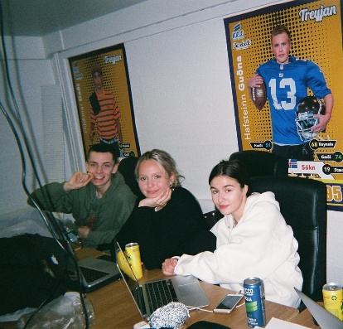
Foto 1
First meeting of the committee members of the magazine

The committee selection and training process lasts about 10 days. The committee begins its functions at the beginning of the school year. Among its first functions is to distribute the different tasks and projects within the committee members:
a) The functions of the treasurer and the director of marketing.
b) The role of the other members of the committee, such as conducting interviews and photographs.
c) The editor of the magazine will be discussed and meetings will be held with the publisher who will be responsible for the publication.
d) And then with the other members of the committee, they will be assigned the activities that will begin to take place from the fall to Christmas.
Thereafter, committee members will meet once a week to evaluate their activities.
In January the entire committee will be dedicated to finding funding for the publication and to finish all the material that will be included in the magazine.
During this time, committee meetings will be at least twice a week or more often, if required.
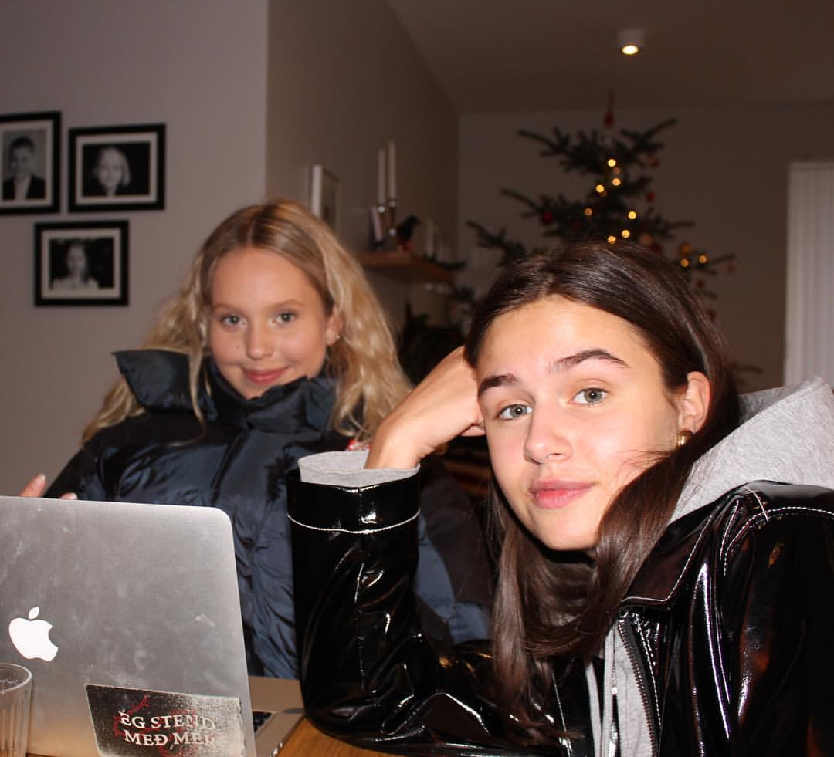  Foto 2  Work sessions | 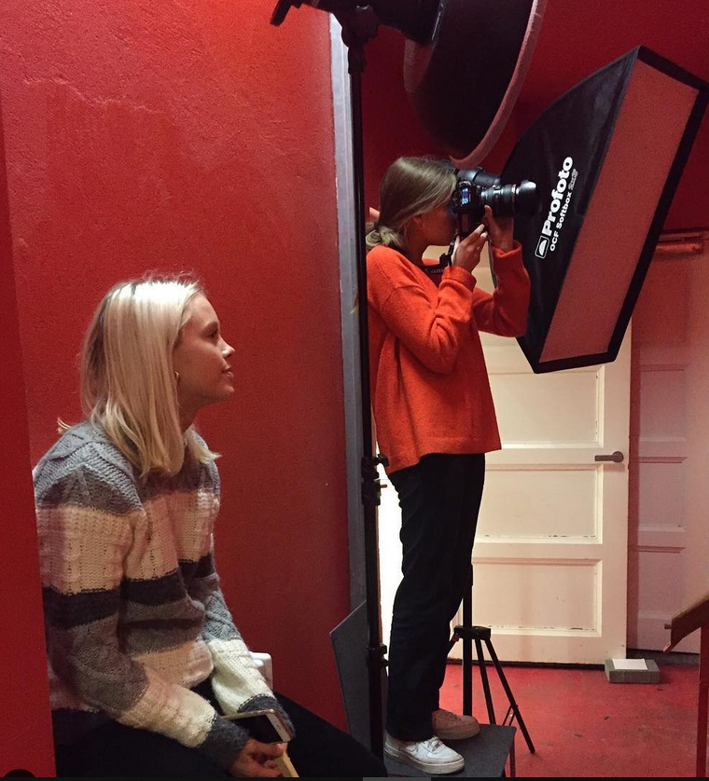  Foto 3  Photo sessions
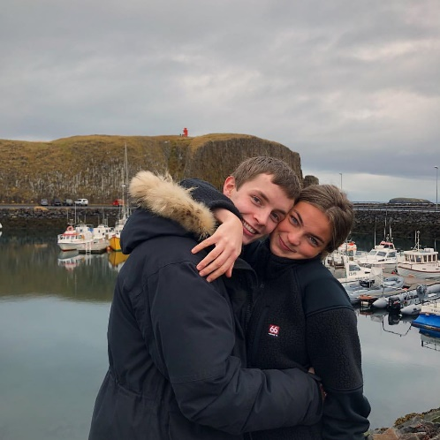  Foto 4  Coexistence among the editors of the magazine | 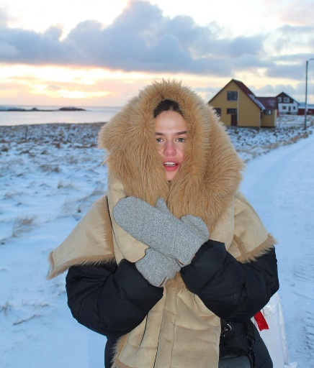  Foto 5  Working on some photos for the magazine

Subsequently, the first revision of the material for the magazine will be made, for its correction and finally it will be taken to the printing press.
Before the final printing, the student committee has a week where the students prepare a series of events to amuse their classmates and prepare the day the magazine will be presented.
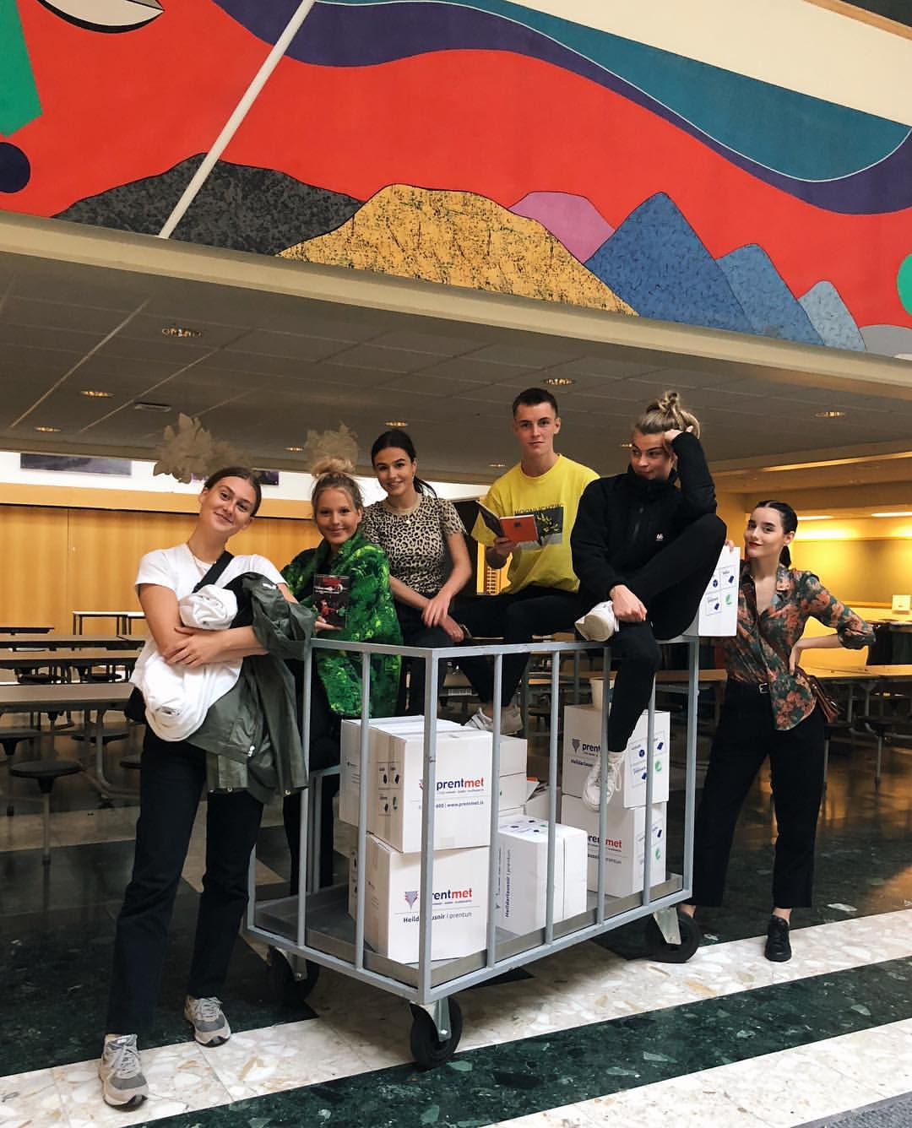
Foto 6
The first issues of the magazine arrive at school
On the day of the presentation of the magazine, usually in the month of March, there is a special celebration where all the students and the school staff meet in the main auditorium in a grand ceremony to officially present the magazine.
So, that day is very important for students and for school. The student committee in charge of the magazine, ends with all the feeling of anxiety and stress that have lived up to this moment. This feeling becomes happiness and pride to have in their hands copies of the magazine and distribute them among students, teachers and other interested people.
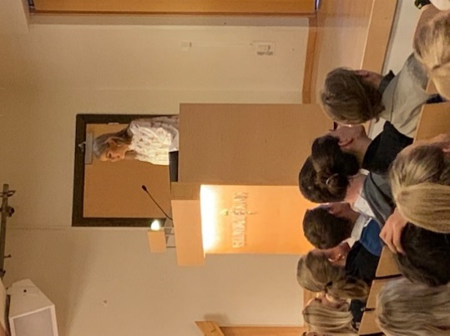  Foto 7  The official presentation of the magazine | 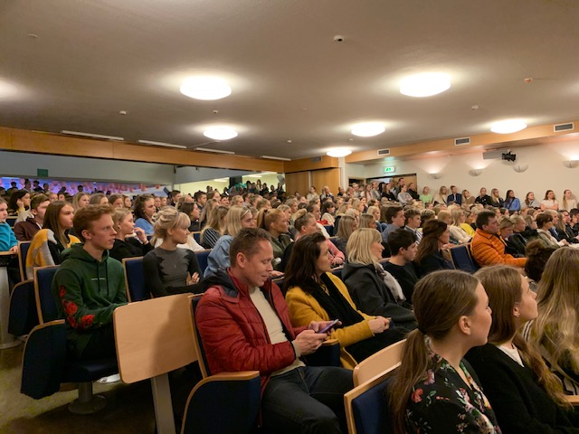  Foto 8  The public attending the presentation of the magazine
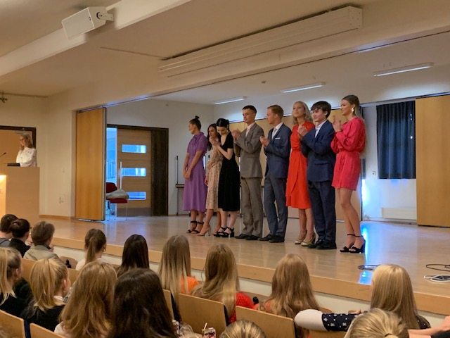  Foto 9  El comité de la revista compuesto por 8 estudiantes | 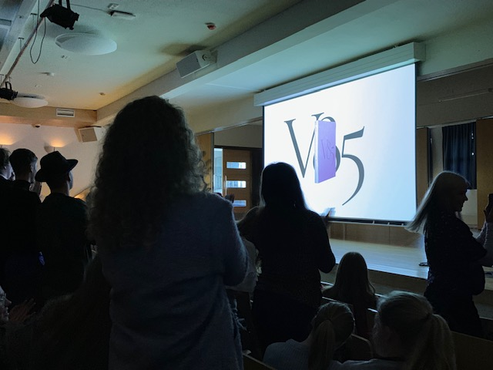  Foto 10  Se revela el secreto: el primer ejemplar de la revista V85

5. Results
Problems always arise in the realization of a project of this magnitude, for example, people work in different ways, different opinions with the editor of the magazine and committee members, censorship, financial situation and others. All kinds of problems that, even, cannot always be solved.
It is important that there is a good relationship between the members of the committee, therefore, extra activities are organized to strengthen the coexistence between them: trips, parties, meetings outside the hour of work, meals and other type of coexistence.
The students, members of the committee, are proud of their work and in their opinion "it is worth all the hard work dedicated to the publication and we would like to do it again. "
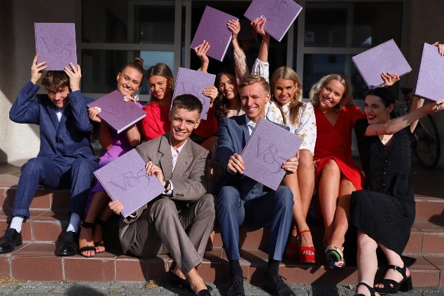  Foto 11  Happiness with the publication | 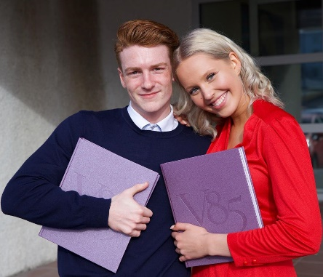  Foto 12  Work done

The importance of this project lies not only in the fact that the participating students join a committee that is responsible for editing and publishing a journal, but also that they organize, plan and learn to work as a team and individually in a project that allows them to develop their skills and work on what interests them, as an extra activity while they are studying. It is a professional job that allows them to have an invaluable experience before finishing their student education.
For them the publication of the magazine is a challenge, but also a satisfaction and why not, a way to develop professionally before finishing their studies and entering the job market. It is part of their professional curriculum.

