tgSharing Methodologies, Attitudes, Responsibilities and Thinking (SMART)
Musical (VERSLÓ)
Hilda Torres

1. Introduction
This guide deals with one of the interdisciplinary projects that were developed within the framework of the SMART project activities. The main objective of this guide is to describe the way in which the students of the Commercial School of Iceland (Versló) propose, organize and present a play or a musical in one of the theaters of the city of Reykjavík.
The guide fulfills one of the main objectives of the Erasmus + SMART project, which is to demonstrate the way in which Icelandic students carry out an extra-academic activity, which they have presented and explained to their Spanish colleagues with those who participated in the project.
The guide will show how this activity arose among the students of Versló, how they are organized through a committee and how this committee works step by step until the presentation, this time it is a musical.
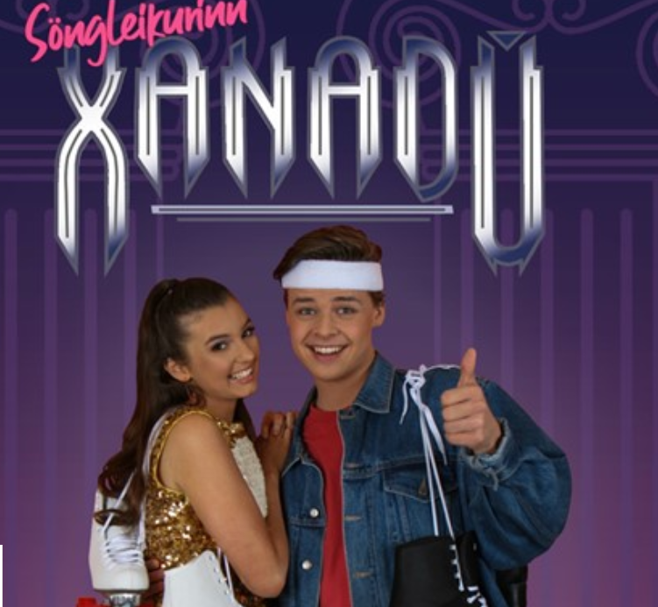
Foto 1
The musical presented by the Icelandic students in 2019

2. The annual celebration of the students of Verzló: Nemendamót
The students of the Versló school have once a year the call Nemendamót that is the annual celebration of the students of Verzló. This celebration contemplates a series of activities, such as conferences, lunches, dinners, sports activities, annual party and, in particular, a very important one that is to attend a theatrical work or a musical that some of their classmates present to you in a theatre of the city. This activity is the highlight of Nemendamot.
3. Planning, elaboration and presentation of the musical.
This year at the annual student celebration, the students decided to present a musical to other classmates. But, besides that, they had to decide the theatre where they would make the presentations, and most importantly, they decided who would participate and who would do it. Next, the process of making the musical is presented.
a) Election of the student committee in charge of the musical.
Every academic year the students of Versló have the opportunity, according to the student association, to present their candidacy to participate in different committees that will be responsible for organizing different social activities for them and for themselves. In this way, the student who has the interest and ability to participate in a certain committee, proposes that his / her other classmates choose it with their vote.
Among these committees, there is the organizing committee for the annual celebration of school students (Nemendamot). After the vote, the president of this committee is elected.
After being elected the president of Nemendamót, a call will be made to elect the other members.
The students invited to participate are in charge of any organization of the annual celebration, of the logistics and the staging of the musical.
b) The organization of the musical.

At the end of the school year and the work of the school, the members of the new student committee elected for the new period, meet in a first meeting to prepare all the activities they are in charge of.

Subsequently, there is a meeting to arrange the musical that will be presented in the spring of the new school year. The date varies according to the academic calendar, but it is usually at the end of February. Thus, after submitting many proposals, another meeting is held with the artistic director, the choreography director and the musical director that the members of the committee have chosen, to convey their ideas and reach a common agreement.

It is worth mentioning that, on some occasions, the director comes with a proposal and the student committee can approve it.
When the musical has finally been decided, the students in charge of making the video for the promotion of the work (videonefnd) will be discussed, which will elaborate the promotion "trailer". For this, the place for the realization of the video, the director and the editor thereof will be chosen, as well as the students who will perform and dance on this tape. The video will be shown immediately in the fall.

In the fall, the selection of the students who will participate in the staging in the theatre will also begin. Sometimes they are the same students who have already participated in the promotional video or they are different students, everything depends on their talent of each one to participate in both events.

Apart from choosing the cast of the work, it is also necessary to choose the logistical staff, among other students, that is, the students who will be in charge of the costumes, the make-up, the hairstylists, the electricians, the illuminators, the set designers, the designers of the program and also those responsible for the promotion and sale of tickets for the theatre.

In general, it is a huge project where school students can find a role according to their attitudes and preferences.

When this part of the project has been completed, it is necessary for all team members to get to know each other well. To do so, the organizing committee invites everyone to attend a party or travel together.

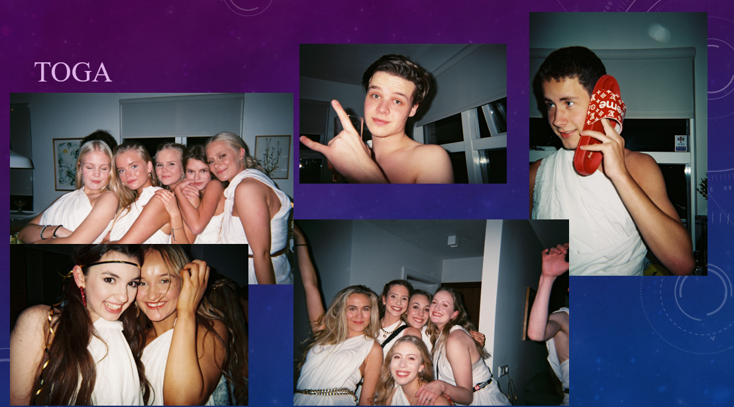
Foto 2
The students who participate in the musical, in a tunic party

c) Acting in the musical

Once the committee has been formed and the cast and crew of the musical are chosen, in September and October the actors' exercises begin, then with the dancers and then with the singers and the choir, all separately. At the end of the school exams at the end of November and the beginning of December, the whole group is assembled to put together the musical.
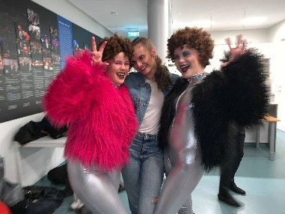
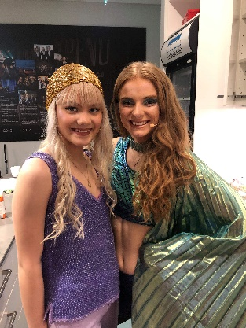
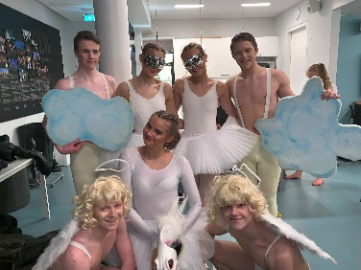
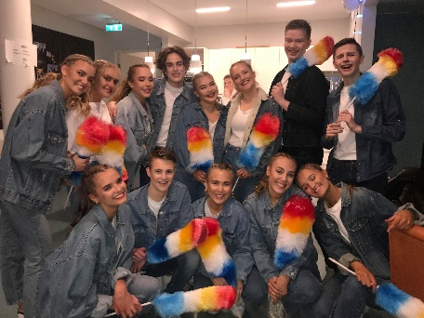
Foto 3
Costumes

On the other hand, the other group (costumes, scenographers, makeup artists, etc.) are working to prepare the big day, the day of the general rehearsal, which is usually the first Thursday of February.

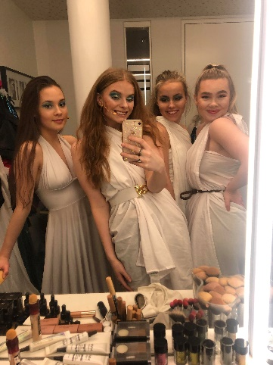
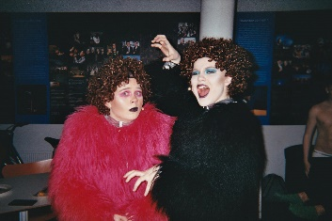
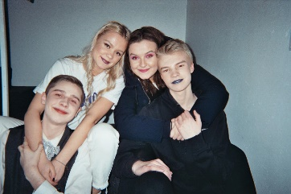
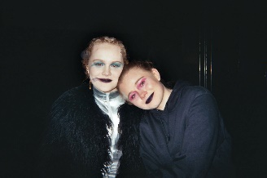
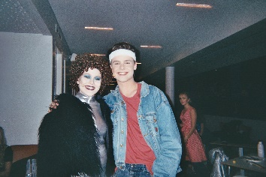

Foto 4
Makeup tests

d) General rehearsal and premiere

One day after the general rehearsal, the first representation is carried out for a group of students and another for the rest of the students of Versló. This division has to be made because the theater where the musical will be performed, sometimes does not have the capacity for all students, teachers and their families. It is worth mentioning that in recent years there have been 3 presentations in the theater on different days.

It must be mentioned that the first presentation must coincide with the day marked for the celebration of the annual Nemendamot student party. With this event begins the first phase of the same and continues with a dance to end this celebration.

This is a picture of the group of actors, singers and dancers that participated in this year's latest musical. It can be mentioned that between 60 and 70 students were those who participated in this group and many others in the logistical support group, in total about 200 students are those who participated in the musical.

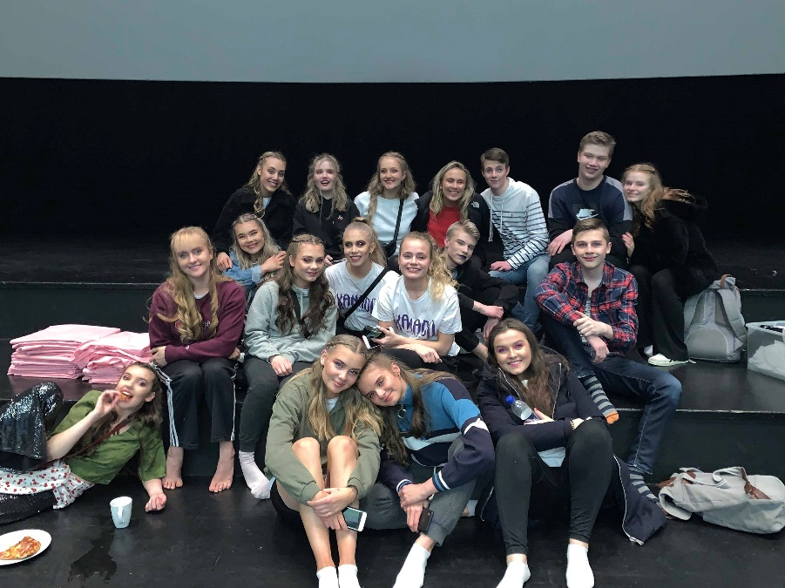
Foto 5
Some actors

e) Presentations to the general public
t is worth mentioning that after having made the presentations for the students of Versló, for the teachers and their families, the musical is presented to the general public, in the same theatre where it was premiered.
These musicals have been very famous among students of primary and secondary schools. It has come to have 10 to 20 presentations for the general public and on some occasions it has been necessary to lengthen its presentation in the theatre, due to the large number of attendees.
5. Results and evaluation
The realization of the musical requires an enormous amount of work, dedication, commitment and discipline on the part of the students who are chosen or who decide to participate in it.
This activity is, of course, a very productive activity for those who are part of the committee, since they learn a lot about the organization, production, execution and promotion of the musical becoming, for them, a great experience of great academic and work value for their curriculum. This same experience is also valid for all students who take part in the cast and the logistics of it.
Problems always arise in the realization of a project of this magnitude, for example, people work in different ways, have different opinions first about what work or musical they want to present, then they have to find the director and the artistic director and present their proposal to later reach an agreement. This also teaches them to work as a team with people who have a lot of experience and learn from them.
It is important that there is a good relationship between the members of the committee, therefore, extra activities are organized to strengthen the coexistence between them. trips, parties, meetings outside of work, meals and other type of coexistence forming a great relationship and integration between them.
One of the most important points that must be highlighted is the fact that students learn to combine their studies with extracurricular activities, performing social activities that they are allowed to do in school.
The importance of this project is also that students learn to work as a team and individually in a project that allows them to develop their skills and work on what interests them, as an extra activity while they are studying. It is a professional job that allows them to have an invaluable experience before finishing their student.
For many of them this work is a challenge, but also a satisfaction and why not, a way to develop professionally before finishing their studies and entering the job market. It is part of their professional curriculum.

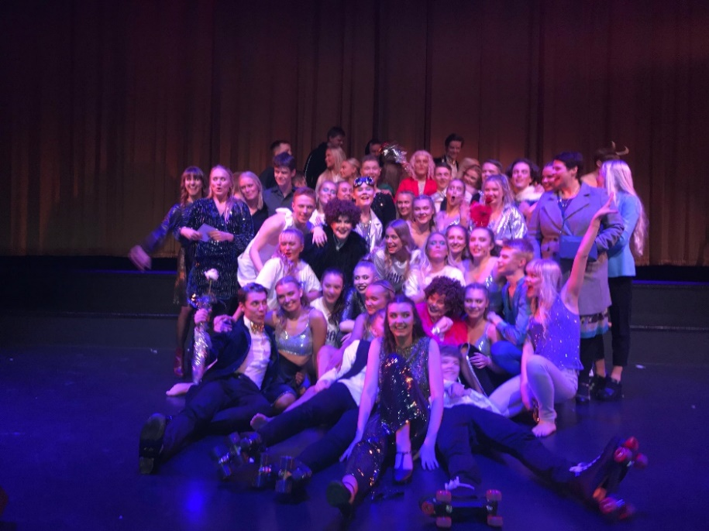
Foto 6
The musical

